Oct. 13th (Thursday)  Basics on Offense and Defense | - Warm-ups and Team Message (15 min.)  - Team Theme – Season Outlook – Expectations (5 min.)  - Fundamentals: Triple-threat to Crossover to Layups and short/mid Shots (10 min.)  - Offense: 5-Man Out Progressions (20+ min.):  - On-ball pick movement/progressions (teach on whiteboard->show on court->walk-through)  - Off-ball pick movement/progressions (teach on whiteboard->show on court->walk-through)  - Hand-off movement/progressions (later practice)  - Back-door movement progressions (later practice)  - Give-N-Go movement/progressions (later practice)  - Offense: Pick-N-Roll and Pick-N-Pop Basics (2 v. 2) (10 min.)  - Option 1: Pick works = roll pass or drive (or drive and dish if help comes)  - Option 2: Picked player fights high = drive or roll pass (or drive and dish if help comes)  - Option 3: Picked player fights low = pop shot, roll pass (or drive and dish if help comes)  - Option 4: Defense Switches = Pick-N-Pop (or drive, pop shot, drive/dish)  - Offense: Off-Ball Screen Basics (3 v. 3) (10 min.)  - Option 1: Pick works = pass to v-cutting player for mid-range/curling player in lane for layup  - Option 2: Picked player fights to outside = v-cut high, then 45 cut into lane  - Option 3: Picked player fights inside = v-cut high (possible give-n-go on backside 45 cut from passing player)  - Option 4: Switch = v-cut high->pass to high->pass to roll (or direct pass to rolling player to lane)  Coaching Points for Picks:  - Patience on pick (both players need to wait for full contact)  - Communication (talk it up: “yep”, “coming”, “I got you”)  - Observe (read the D for a one-count, then choose next action)  - Show: Want the pass? Show where you want ball!  - Stress bounce passes – not lobs  - Find your space! (“When in Doubt, Space it Out!”)  - Off-ball Player Movement  - Work through progressions of where players go if initial pick does not work  - Players rotate through high, picking/rolling player rotates to corner to fill empty spot.  - Start another offensive concept right away! Ball position doesn’t matter – space matters! Communication matters!  - Defense (15-20 min.):  - 1 v. 1 Close-outs (5 min.)  - Pass ball to offensive player on perimeter – defensive player starts in middle of lane and closes out  - Progression:  - Basic closeout (dead ball)  - Danger closeout (ball handler has dribble)  Key Coaching Points:  - Hands mirror ball - if dead ball hands go high and big. If dribble is there, be Spiderman with one hand up to block shot on ball side, and low hand for crossover on non-ball side.  - Choppy and squeaky feet – wide base, no clicking of heels  - Balanced and low – on toes, weight centered  - Close the gate (back to basket and square to ball handler’s hips) – don’t allow a dribble lane  - Shell/Help Defense Basics (5 v. 0, the 5 v. 5 Strategy) (10-15 min.)  - Perimeter passing drill to teach “shell” or “house” defense  - Depending on ball location, each player is either in a “Ball”, “deny” or “help” position to protect the lane  - Have each player shout what position they are in  - Start with 5 v. 0 and move into 4 v. 4 or 5 v. 5 with soft defense – then make it a competitive game where offense gets a point if they get the ball into the lane.  Key Coaching Points  - Operate as one functioning unit to protect the lane (“Don’t let them break our shell!”)  - “Our shell is only as strong as the distance between the players next to us – the further away our teammates are, the weaker our shell is and we need to support their weak side.”  - 1 pass away = one step from offensive player (2 passes = 2 steps, etc.)  - 1 pass away = deny with hands near passing lane;  - More than 1 pass away = “help” by sagging off with “pistols” or “pigeon eyes”  - Pigeon Eyes/Pistols = seeing your player and ball in your peripheral vision (“point your pistols”)  - Never stop moving! As ball moves, so do you!  - Communication! (“Switch”, “Help”, “Pick right”, etc.)  - 4 v. 4 (or 2 v. 2) Scrimmage (10 min.)  - Final Conditioning or Free Throws and Team Message (5 min.)

Oct. 18th (Thursday)  Team Strategy Offense, Fast Break, Press Break | - Warm-Ups  - Rebounding 101  - 2 feet->2 Hands->Chin->Pivot outlet  - 1 v. 0 jumping/rebounding drill (toss ball to players) – player jumps, rebounds and passes to outlet player at hash  - Progression:  - Bounce ball off of backboard  - Shoot (and try to miss)  Key Coaching Points  - 1 step to jump off of two feet – hands at chest area, then push them high  - Grab ball with 2 hands, ball to chin with elbows out – then turn to outlet  - Boxing Out  - 1 v. 1 drill on basics (defense starts out soft, then move into competitive once they get hang of it)  - Toss ball off of backboard to practice box out, to rebound, then outlet  - One player at hash mark (near sideline) to call for outlet on rebound  Key Coaching Points  - BBBB Method:  - Find a BODY (use hands, eyes, but then get hands wide and at chest) “Get Big”  - Use your BUTT (get low in order to jump off of two feet – bump butt  - BOX out  - Then….find the BALL…then jump using 2 to 2 to Chin to Outlet  - “Shot!!”  - On rebound, outlet player is goes to hash and calls for ball: “Running” “Let’s go” “Ball”  - Outlet player has hands up to receive pass “Show me your diamond” (palms out forming a diamond with fingers)  - 2 v. 2 competition drill  - Box out->rebound->outlet  - Offensive player shoots with soft defensive hand in face (or coach) – on any rebound we outlet  - Fast Break 101 (5 v. 0, then 3 v. 3, then 5 v. 5)  - Building on Rebound->Outlet concept – now it’s time for the whole team to run!  - Work in progression of 3 other players to start fast break. Find a lane!  - Teach basics of taking lanes depending on position and spot on the floor at rebound/outlet  - 1 = outlet option; 2 = outside lane on same side as 1; 3 = wide opposite side of 1; 4 and 5 trailing on sides of key  - 1 = at hash mark and move up middle of court favoring one side or another = make defense choose  - Scoring Options:  - Push up to 2 down the wing = layup or midrange or bounce pass to 3 or 4 who is 45 cutting on back side  - 1 drives and kicks to 3 = cutting to hoop or corner  - 1 pulls up and passes to 4 = trailing on right/left side towards free-throw line, then cut to hoop  - 1 pulls up or drives, passes to 5 = trailing on left side/right side cutting towards hoop if there, otherwise top of key or other open space.  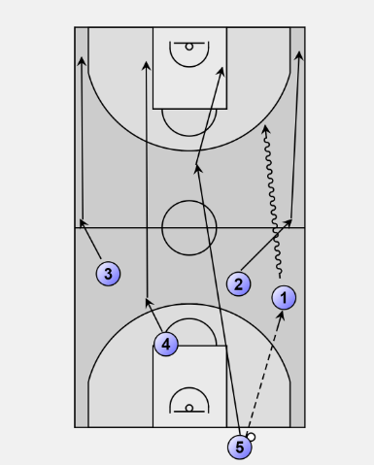  Key Coaching Points:  - On rebound, EVERYONE runs with eyes on ball (do NOT turn your back!)  - Run, but not out of control or too fast. Be ready to accept a pass and shoot/drive  - Communicate using voice and hands: Say you want “ball” or “yep” or “cutting”…then SHOW the ballhandler your hand where you want the pass (i.e., show her: lead me, or I’m spotting up).  - Fewer dribbles = faster down the court; Faster passes = keep defense from setting up  - GOAL = break their shell before they can set it  - Full Court Press Break 101 (5 v. 0)  - 1-1-2-1 Basics  - On inbound, make sure the backside mid-court player (2 or 4) that is on opposite side of ball has a 45 cut towards key  - In-bounder (the 3) is the “support” trailer, and 2 is the “up the court” option  - 5 man is at the opposite free throw line area.  - Time permits, walk through 5 v. 5  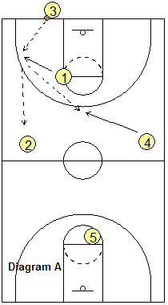  - 1-1-2-1 Alternative  - 3 inbounds to 1 near free throw line->2 and 4 stay tight to sidelines and move towards 1  - 1 has three options to pass to:  - If #3, then 1 moves up court and force the D to go after #3 or #1  - If #2 or #4 on the sideline/corner, D has to choose and #1 can be sideline with #3 moving center and a 2 to 3 to 1 pass gets you out of half court  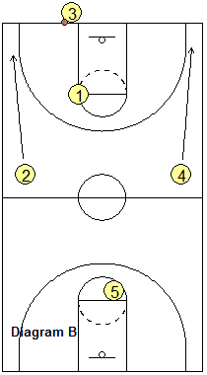  Coaching Points:  - No dribble unless you have to  - Eyes up  - Come back to the ball as a receiver  - Quick decisions  - Inbounder can run baseline if after basket!  - Avoid corners of death  - If trapped, don’t put ball above head – stay low, triple threat, step through defense towards pass  - 5-Man Out Review  - When in doubt, spread it out!  - PG needs to communicate with eyes, voice and hand signal  - Main go-to fundamental: pick-n-roll/pop; off-ball screens; give-n-go; backdoor, etc.  - Scrimmage remaining time
Oct. 19th (Wednesday) | JOINT PRACTICE/SCRIMMAGE:  Collaborate with coaches to determine what to work on:  - 5-man out offense  - Shell Defense  - Press Break
Oct. 25th (Tuesday) | - Warm-Ups  - Shell Defense (3 v. 3 and 4 v. 4)  - Rebounding to Fast Break Drill (4 v. 4)  - Press Break Drill (5 v. 5)  - Scrimmage/Games
Oct. 26th (Wednesday) | - Warm-Ups  - 5-Man Out Progressions (20 min. – choose 2 of these?):  - On-ball pick movement/progressions  - Off-ball pick movement/progressions  - Hand-off movement/progressions  - Back-door movement progressions  - Give-N-Go movement/progressions  - Defensive Shell Drills (5 v. 5)  - Out of Bounds Stack Drill (5 v. 0) then (5 v. 5)  - Press Break Drill (5 v. 5)  - Scrimmage/Games  - Cover nuances of actual game play (i.e. tip formation, subs, being on the bench, etc.)
November 5th - EAGAN TOURNAMENT

