The 2025 Porter Parent Football Association (PPFA) Newsletter – Playoff1
The LTHS Porter Parent Football Association (PPFA) is a volunteer group dedicated to enhancing the football experience for players. Our goal is to foster a positive, memorable environment for each player, achieved through support for both the players and coaches. The PPFA funds its efforts through various fundraising initiatives, including spirit wear, player sponsorships, and volunteering.
- Twitter @LockportFootba1 - Facebook @ LTHSFootballBoosters  - Lockportfootball.com
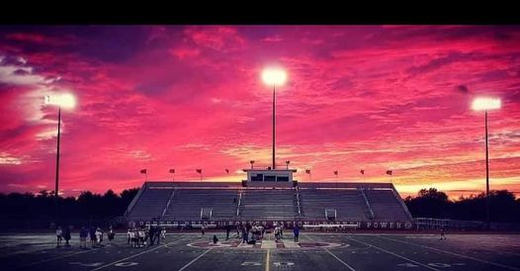Every Week
Varsity Players Pasta Dinner – Every Thursday @ Cooms Corner, but breakfast will be served this week (see below).
Playoff1 Breakfast (Cooms Corner): Sat 11/1 @ 9:30am **Parent Volunteer and/or Drink Donation**
** Ask-a-Porter ** - 10Q with Nick Moerman
Game Schedule/Results
Varsity: Porters @ Sandburg: Sat 11/1 @ 6:00pm Game Preview
Porters over Neuqua Valley on 10/24 (41-17) Game Recap Game Photos
Sophomore: Porters over Neuqua Valley on 10/24 (43-12)
Freshman A: Porters A over Neuqua Valley on 10/23 (x-x)
Freshman B: Porters B over Fenwick on 10/25 (x-x)
News and Notes
PPFA Board Meeting: 11/18 (Tuesday) @ 7:00pm – LTHS (Porter Room)
Save-the-Date: 11/1 – State Playoffs (1st round)
11/7 – State Playoffs (2nd round)
12/8 – Varsity Banquet (tentatively)
**Lost and Found** Missing a PPFA 2025 Newsletter? Click HERE

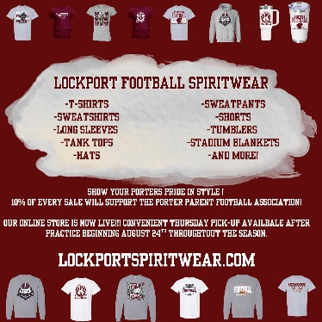
Order your 2025 Lockport Football Spirit wear HERE
Helpful Links
Spirit Wear Game Digital Tickets IHSA Football Info 8to18

