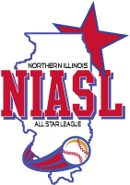
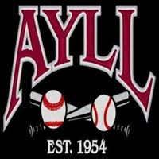

ATTENTION All 2019 AYLL
Mustang and Bronco Players, Coaches, and Parents!
"Are you interested in playing part-time travel baseball (N60) in addition to the regular AYLL in-house season?"

Program: AYLL’s 2019 Part-Time Travel Baseball (N60)
Mission: To provide players from our in-house program the opportunity to play in a part-time travel program during the regular in-house season; This program is perfect for those players interested in playing more competitive baseball in addition to their in-house league.
Age of Teams: Mustang (ages 9-10), Bronco (ages 11-12) teams are dependent on player & coach interest
Player Selection Process: All Mustang and Bronco players who are registered for the AYLL in-house baseball program have the opportunity to try out for their respective N60 team.
Number of Players per Team: At the discretion of each individual N60 coach
Length of Season: April through the end of June; The part-time travel season coexists with the regular in-house season.
Game Schedule: 1 or 2 games per week. Most games will be on Fridays or Sundays with the exception of tournaments.
Tournaments: Each N60 team will participate in one or two weekend tournaments during the season (dependent on player & coach interest).
Uniforms: Each player will receive a jersey and hat.
Cost per Player: $*225.00 (cost is in addition to AYLL’S in-house league fees)
*For teams that opt to participate in additional tournaments and/or indoor practice time, cost per player will be higher than the base fee.

N60 Registration and Tryouts Schedule
N60 Registration for the 2019 season will close on Dec 31, 2018.
Tryouts are scheduled for January 27, 2019 at 1 p.m. Location TBD.

Interested in Playing Part-Time Travel Baseball (N60)?
If interested in having your son/daughter participate in N60, or if you are interested in coaching, please contact: AYLL’S N60 Director -Jon Kotloski @ Jpkotloski@hotmail.com by December 31st.

