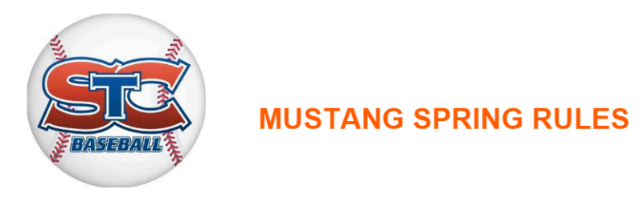

Introduction/Explanation of the Rules
Mustang is a crucial step in the development of the players, as this is the introduction to a style of play more reminiscent of actual baseball. Kid pitch is introduced, and direct on-the-field coaching is dialed back. This is the last age at which scores are not reported. With that being said, these rules are meant to foster an environment of development while still being fun and competitive for the players. Coaches are strongly encouraged to work together before games to discuss any issues or questions about rule interpretation.
General Rules
- A 5 run per inning rule is in effect or 3 outs; whichever comes first. This is an increase from the 4 run per inning limit in Bantam.
- Time Limits: All games have a 90-minute time limit or 5 innings.
- No playoffs, no championships, no kept scores.
- 40’ pitching distance.
- Infield fly rule, bunting, stealing, passed balls, overthrow advancement is prohibited.
- Except for reasons of ailment, a player cannot be on the bench for consecutive innings.
- Home team third base dugout, visitors have 1st base dugout.
- Level 5 Compression Balls will be used throughout the season.
Batting
- All players will bat in a continuous batting order, except for reasons of ailment.
- Bat size maximum 2 ¾ is allowed.
- Bunting is not permitted in games, but it can be practiced.
Fielding
- No player plays the same position more than two (2) innings per game and not in consecutive innings.
- Managers and coaches may be on the field (two coaches max) when on defense to assist players with position playing. Managers and coaches should remain in the outfield if on the field.
- The defense may field ten (10) players, four (4) outfielders, and one (1) pitcher.
- Defensive coach has priority over a disputed call.
Baserunning
- A runner may not advance until the ball is batted into play.
- Runners may advance only on a ball hit into fair territory or when a defensive play is made on the runner.
- No base advancement on overthrows.
- Players may advance an additional base if a batted ball enters the outfield ON THE FLY. On very close calls where a ball is struck very solidly, the defensive coach can communicate to the offensive coach acceptance that the batter attempt to take the second base. The purpose of the doubles rule is to reward excellence in hitting, not to punish poor fielding.
- Feet first sliding is encouraged on close plays at any base except first base.

Pitching
- Kid Pitch
  - The pitcher must wear a batting helmet.
  - No player can pitch more than 1 inning in a game.
  - The coach (standing behind the pitcher) of the team hitting will call balls and strikes.
  - After 3 strikes or 4 balls, whichever comes first, play will then move to coach pitch.
  - No strike outs or walks from kid pitch.
  - If a pitcher struggles with the strike zone on 4 consecutive batters (or in the coach’s discretion), the coach has the option to substitute in a new pitcher for that inning, or the coach can step in and complete the pitching duties for that inning. This is meant to keep the game at a reasonable pace of play, and it will also help pitchers from being taxed by throwing too many pitches.
  - While there is no official pitch count, coaches are directed to keep an informal eye on the amount of pitches thrown by a pitcher in a given inning. If the coach sees signs of fatigue, they should enact the procedures outlined above.
- Coach Pitch
  - The coach will throw five (5) pitches; a hitting tee will then be used.
  - Coach pitches are should be delivered from the knee position.

