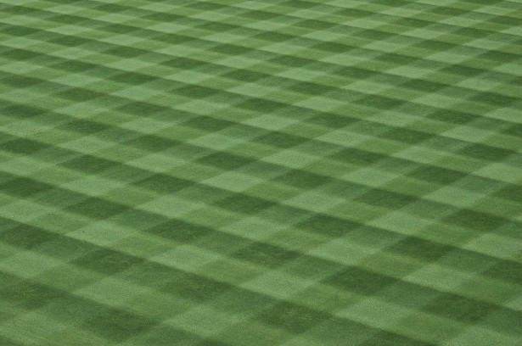

Café Lafa

Stand Hours –2017 Season

Mon, Tues, Wed, Thur – 5pm – 8/8:30pm
Fri – 5pm – 9/9:30pm
Sat – 7:30am to 9/9:30pm
Sun – if more than 2 games & tourneys

