Passing: NEVER USE THE TOE!
Warm up
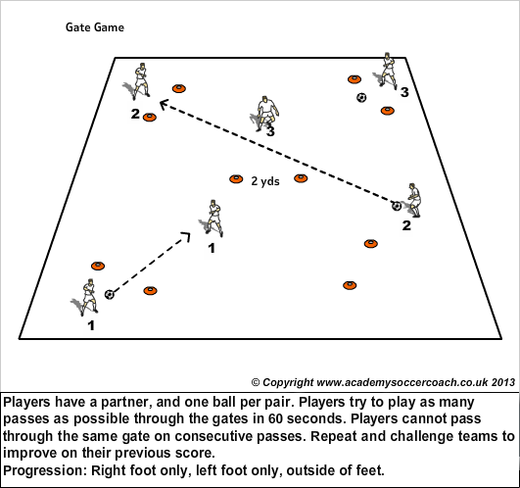
To improve technique, in pairs pass the ball using inside of the foot.
Coaching points: Use inside of the foot (arch or where the logo is on the shoe) and following through. Hit the middle of the ball. Non kicking foot should be next to ball.
Make it a game. How many passes can you do in 30 seconds.
Receiving the ball: Heel down, toe up.
Do the above game again to see if they have improved.

Activity 1: Groups of 4, in an area 20x20. Get the players moving around with one ball passing it between them. Try and get the players to take 2 touches. If they are really good they may want to try one touch.
Coaching points: Be in front of the player when receiving the ball. Get the player who wants to receive the ball to call the name of the person who has the ball.
Activity 2: Keep ball. Groups of 5. 4v1. 1 minutes games. How many times can the defender get the ball. Each player has a turn at being a defender.

