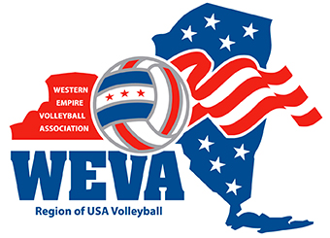
Western Empire Volleyball Association
Twelve/Eleven/Ten and Under Serving Standards
WEVA’s goals and objectives for growing the game at the grass roots is making the game of volleyball a fun environment where athletes can develop their game and their success and/or contributions on the court when they play in tournaments. Based on that philosophy, the following serving guidelines will be utilized during WEVA sanctioned events.
Before clubs register for events outside the WEVA region, club directors are encouraged to find out their specific guidelines for serving so the team can be prepared. Some regions may ask all players to serve from the end line resulting in that possibly being part of your decision in regards to attendance at those events.
For Traditional Events:
Club teams that are looking to compete at National Qualifiers during the season or the USA National Championships in the post season, the expectation would be for players to serve from behind the end line. By doing this, it will successfully prepare those players for the atmosphere required at those events.
Coaches will discuss prior to the match what guidelines will be utilized for the match and advise the officials working the match. No specific line will need to be put down on the court. The coaches know each player’s ability and can advise each player their expectation for where the serve needs to be made from (behind the line or stepping in to where they can achieve success – no closer than the attack line). All players who are jump serving will be required to do so from behind the end line. When a player has success from one part of the court, they must take a step back to serve from there which continues over the course of the match going further and further back with success at a prior spot. Coaches and the region are there to support the success of the athletes and promoting the growth of the game.
An exception will exist for the girl’s BID Qualifier and the Boy’s Region Championships due to the events being a qualifier for participation into the USA National Championships. This will be determined, if teams are accepting a BID or plan on attending their respective Nationals. If plan is to attend USA Nationals, during pool play and the championship division of the event, those teams must serve from behine the end line. For the consolation matches and/or the silver division, players will be allowed to utilize the standard set forth by the region allowing players to step into the court to serve.
Triple Ball Events:
No discussion necessary prior to matches. The coaches know each players ability and can advise each player their expectation for where the serve needs to be made from (behind the line or stepping in to where they can achieve success – no closer than the attack line). Coaches and the region are there to support the success of the athletes and promoting the growth of the game.
This is typically their first exposure to the sport and therefore is developmental in nature. It is all about seeing the athlete succeed in their overall skill development so they continue to LOVE the game.

