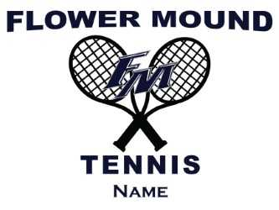

FLOWER MOUND TENNIS
YARD SIGN ORDER FORM

Congratulations, your child is on the FMHS Tennis Team! Share this great accomplishment with your family, neighbors and friends by placing a yard sign in your front lawn/garden. The sign cost $60.00 and includes a sturdy metal (aluminum) sign, with iron stake for secure placement into your lawn/garden. See example above.

Parent Name: ____________________________________

Address: ________________________________________

City: _____________________ State: ___________ Zip Code: __________

Telephone: ________________ Email: _____________________________

Yard Sign Size: 18” x 24”

NAME ON SIGN: _______________________________________________

You may put the players Last Name Only, First Name Only, or First & Last Name. The names must fit within the single-line name area. Longer names may require smaller font size than shown in the example above. Consider using a first name for very long last names.

COST: $60.00
Please, complete this form and make your checks payable to “FMHS Tennis Booster Club”. The deadline to order is September 21. Once sign orders have been placed, they should be ready in 2 weeks and can be picked-up at the FMHS Tennis Courts.

Parent Signature: ___________________________________

Order Date: ________________________________________

