Registering for WYSA’s Recreational Program in the new GotSport System.
Table of Contents
Step 1 - Access the Registration Program 2
Step 2 - Creating a new Account 2
Email Already Exists Errors 4
Step 3 – Player Profile Information 4
Player Emails 4
Step 4 – Adding Additional Parents/Guardians 5
Email Conflicts with Additional Parents/Guardians 8
Step 5 – Registration Questions 10
Step 6 - Payment and Vouchers 11
Step 7 – Check out 12
Step 8 – Payment 13
Step 9 - Confirming your registration is complete 14
Registrations not submitted 14
Step 10 - Registering additional players 14

Step 1 - Access the Registration Program
You will click the link to register from our website or from an email you received. If a parent plans to coach in this program, we recommend that parent who is coaching setup the account and register the player/s using their email address. This will make it easier for that parent to later register as a coach. Further down in these instructions we cover an alternative method if you are registering a player, but their other parent will be coaching. See Step 4 Parent Section below.
https://system.gotsport.com/programs/3665U0647
Once you have accessed the registration link above or from our website or email, you will land on a user account page specific to this program and you will see the following screen.
If you already have a parent account in the new GotSport System you will login using your email/UserID and password, then skip Step 2 and proceed to Step 3. If you have a player that is playing in the Indiana Fire Juniors Travel, Youth, MLS or ECNL programs then you should already have a GotSport Account.
If you do not already have a parent account in the new GotSport System, you need to create a parent account first.
Then you will add your players as family members under your parent account.

Step 2 - Creating a new Account
Click the CREATE AN ACCOUNT LINK from the login window.
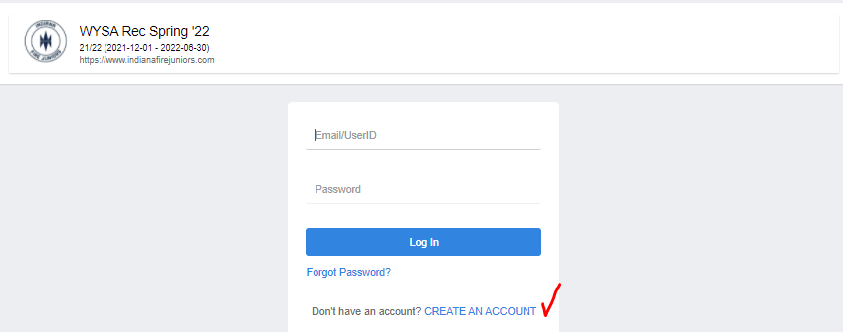

On the next screen you MUST choose I am registering my child or someone else. YOU are not registering yourself to play recreational soccer. This step will create a parent account for you and add this player as a family member under your parent account.
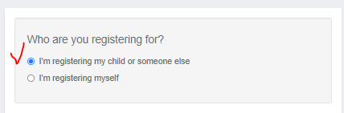
Registrant’s Information - The Registrant is the player not the parent.
Enter the PLAYERS First Name, Last Name, Date of Birth and choose their gender.
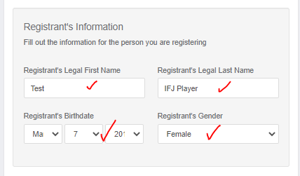
Your Information – this is the Parent information. Complete all fields including the Date of Birth.
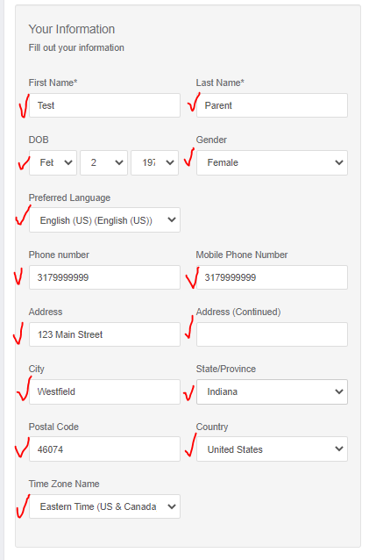
In the last section you will enter the email address you want to use to access your parent account. DO NOT enter a player’s email address in this field. Then you will create a password and click the BLUE SIGN UP button.
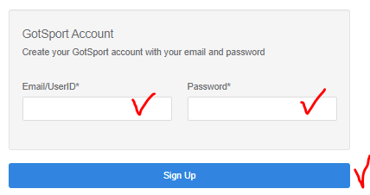

Email Already Exists Errors
If you get an error that says the email address already exists, then that email address is already attached to another account. You must log in using that email address and the associated password. The Login Screen has a Forgot Password Link if you need to reset your password.
After you click Sign UP you will see the family members you just created. You and the player you are registering. Now you will click the Register button beside the player’s name. Make sure you do not click the register button beside your own name.
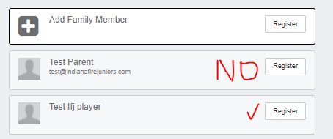

Step 3 – Player Profile Information
Once you click the Register Button you will be into the registration program and will then complete the remaining details for this player.

Player Emails
**VERY IMPORTANT** Do not enter anything in Player USER/ID Email address field. Remember players are records under your account and if you enter anything in the Player UserID/Email address field in a player record the system will create a separate account for the player. Players DO NOT HAVE individual accounts.
The contact email address will default to the email address you entered when you created your parent account. We recommend you leave that alone.
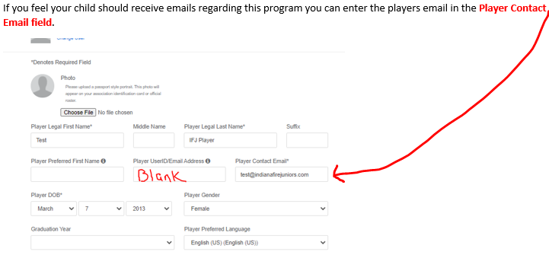
Confirm your phone and address information is correct and click the blue SAVE button to continue.
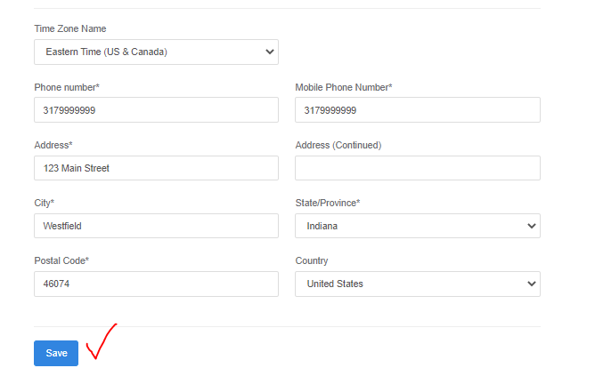

Step 4 – Adding Additional Parents/Guardians
You will see yourself listed as parent/guardian of this child. If you want to add your spouse, you can do so on this screen. We recommend that you do add your spouse especially if they may be a volunteer coach in this program. You will need to enter an accurate email address for your spouse that is different from yours and does not exist in the GotSport System. If your spouse later wants to register to be a coach, they MUST use the email address you enter here to access their account. This process will not create them a password so later if they want to register in the coach’s program, they will need to choose the FORGOT PASSWORD LINK on the login screen. When they need to access their account to register for a program, they will see this pop up.
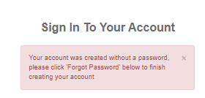
Your spouse could create their own account during their coach’s registration, but you will be unable to then add them as a parent/guardian for this player using their email address. As a result, they will not have access to the players information and the team they coach from the same login.

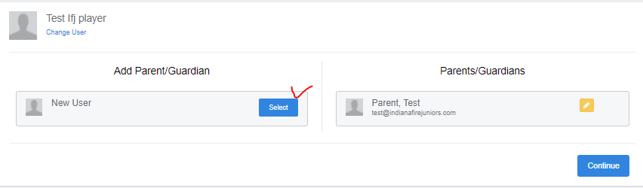
Complete their information and click the Blue Save button. BE SURE to UNCHECK the NCSA box as that is an advertisement and is not necessary. Click NO.
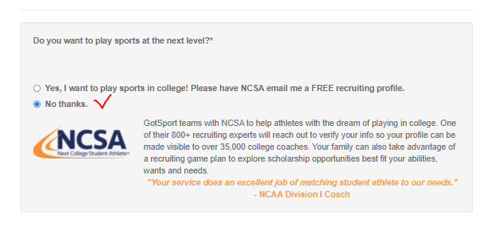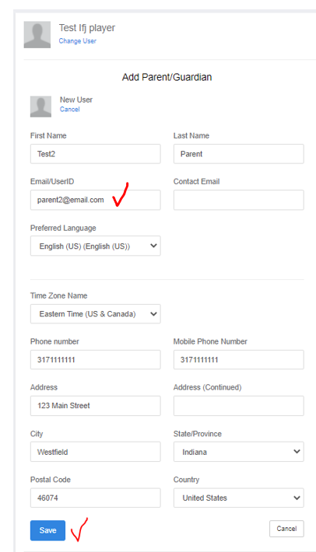

If you successfully added a parent if you will receive this pop-up screen.
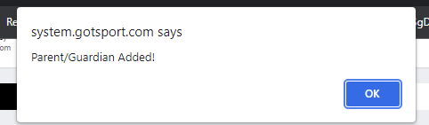

Email Conflicts with Additional Parents/Guardians
If you entered an email address that is already in the system, and you are not also a family member on that account you will receive this message.
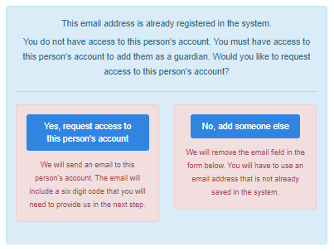
You should click YES if you want this parent to have access. This will generate them an email to them with a code that you will have to enter on the next screen. THEREFORE, it’s best to do this when both parents in the same location.
The email comes from no_reply@gotsoccer.com and will look like the below example.
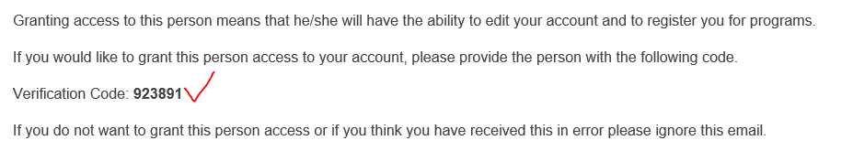
Enter the code in the pop-up Window then Click the Blue Save Button
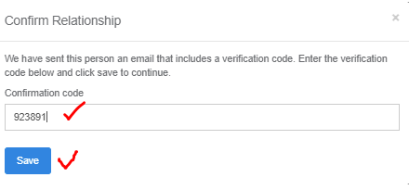
When you have completed adding any additional parents click the Blue Continue Button.
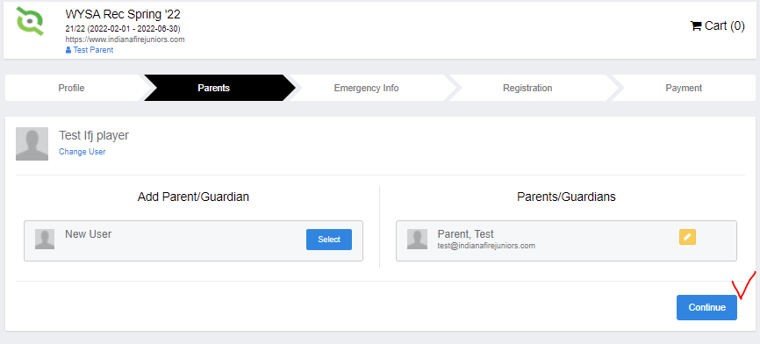

Step 5 – Registration Questions
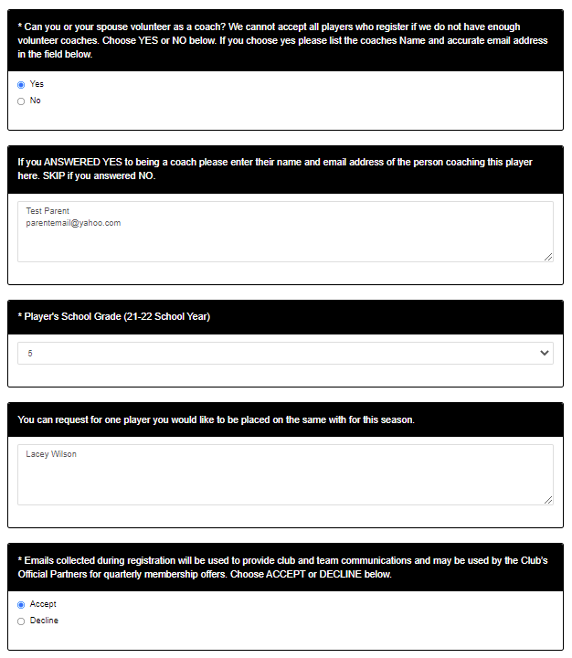

Now scroll down and read the registration agreement text and sign at the bottom with your mouse or touch screen.
Then click the blue Save (Page 1 of 1) button.
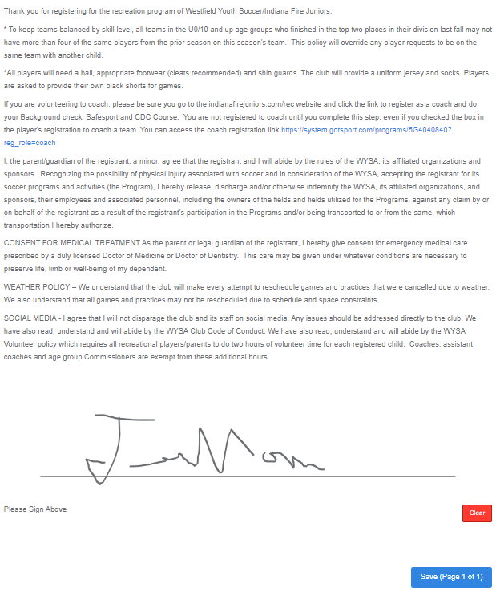

Step 6 - Payment and Vouchers
Choose the fee group that matches your players grade in school for the 21-22 School year. You will have the option to choose a younger age group to allow players who have never played before to start at a lower level. The director will have to approve a player playing down before it is official.
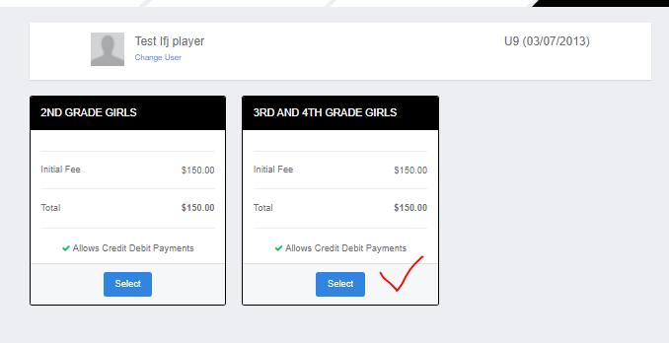
Vouchers
If you have been provided a voucher code to use with this registration you will enter it the code after you have clicked Select on the fee group screen above. Enter the Code then click Apply then click continue.
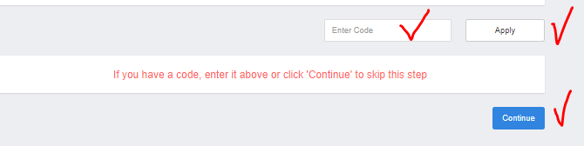

Step 7 – Check out
On the next screen click Blue Check out Button. If you want to change your plan you can click the Select Different Plan button to return to the prior screen and choose a different option.
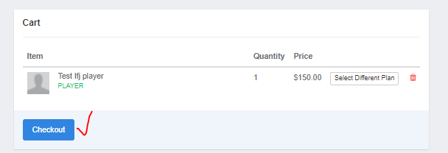

YOU ARE NOT DONE YET SO DO NOT CLOSE YOUR BROWSER YET!

Step 8 – Payment
Paying using a Visa, Mastercard of Discover Card
Enter your card information – number, expiration date and Cvc Code then click Yes, I agree and then click pay.
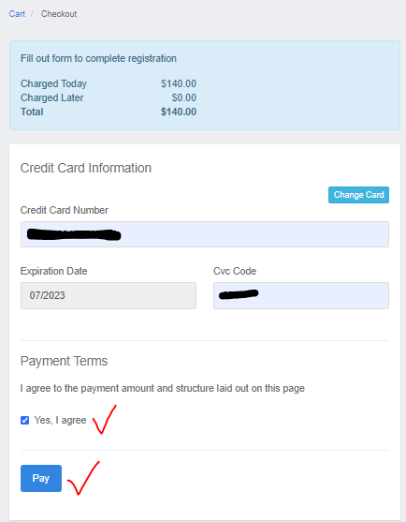
Note – if you entered a voucher code in Step 6 that covers the full cost of the registration you will not see the screen above. You will come to a summary screen and to submit the registration you must click the blue Register button.
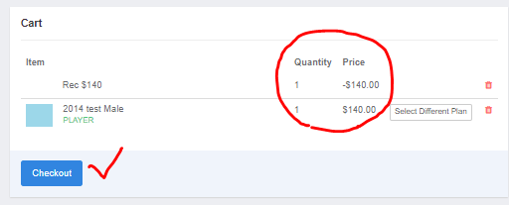

Step 9 - Confirming your registration is complete
Once you click pay you will come to your account dashboard. In the upper menu bar click Program Registrations.
Here you can confirm the player is now registered in the program. If either the completed or submitted columns so a red X this player is NOT registered.
The screenshot below shows what you will see under Completed and Submitted if the player is registered.
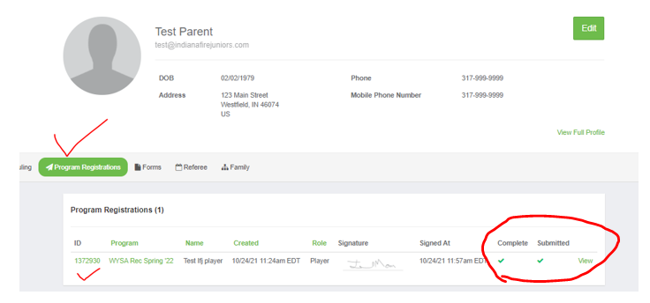

Registrations not submitted
This is what you will see if they player is NOT registered, and you need to the green Orange continue button to complete it.
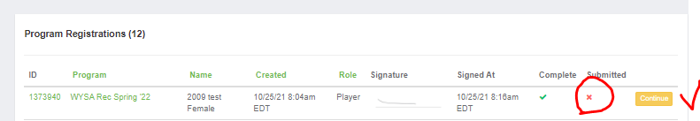

Step 10 - Registering additional players
Return to the registration link on our website or in an email you receive and click it to register another player. You will see yourself and any other parent you added during the first registration now listed on your main screen. Then you will click the Register button beside Add Family Member to register another player.
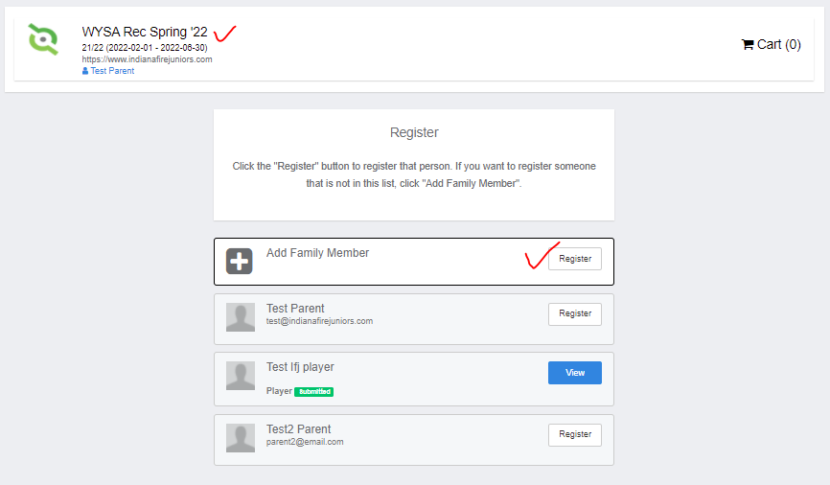
Then you will repeat all the steps above Starting with the Profile Section.

