Go to SportsEngine Hq

- Open the “Competition” menu
- Select “Sports Management”
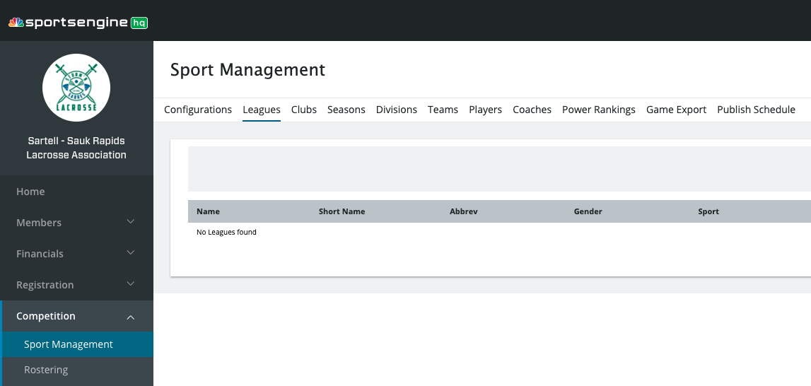
- Open the “Seasons” tab
1
2
3


- Click on the “New Season” icon in upper right corner
- Label with Sartell-Sauk Rapids Lacrosse Spring or Summer and year
6
4
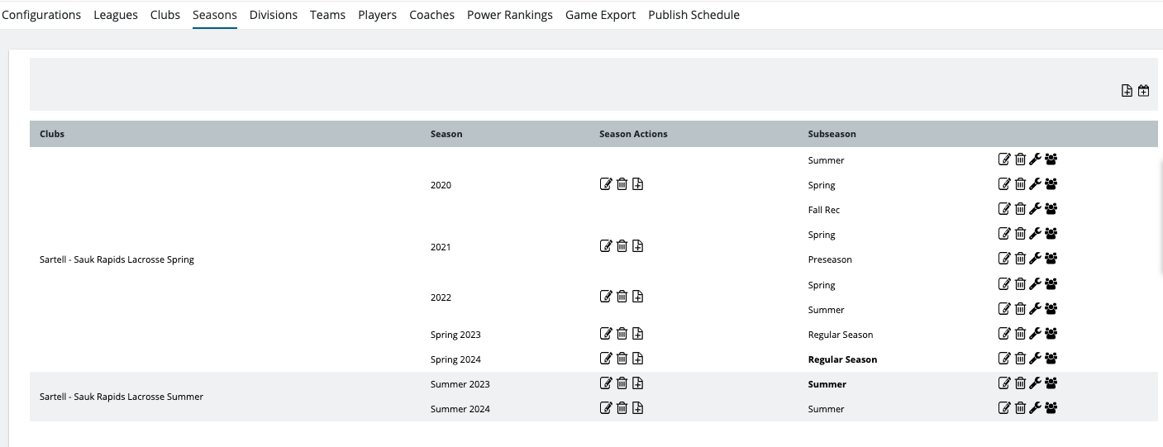
- Click the “Add Team” icon and complete pop up options
  - Select an existing team
  - Choose team from drop-down menu
  - Do this for each team level needed for season
  - Complete by clicking “Create Team Page”

