 2018-19 Fundraising Agreement
The registration fee for High School wrestling is dedicated to coaching salaries, facilities and travel. We use fundraising as our primary means to support out of town travel expenses, uniforms, equipment, the banquet and senior collages.

Fundraising: All parents / wrestlers are required to participate in fundraising and there are 3 ways to complete your fundraising obligations. Please check the box below that you are willing to commit to:
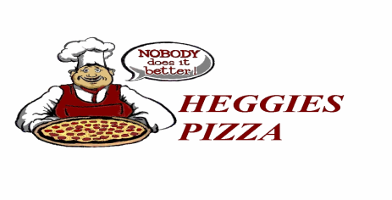 |  | 
Heggies Pizza – We partner with Heggies Pizza to sell pizza locally throughout the community. Heggies gives us special pricing which allows us to earn money while selling a product that essentially sells itself. Orders are due on or before 1/4/19. Here are the options:
- Wrestlers need to a minimum of 35 pizzas
- Families with more than one wrestler need to sell 50 pizzas total

Corporate Sponsorship – As an option to selling pizza, a wrestler may elect to find a new corporate sponsorship. Sponsoring companies will be included in the high school program and on our web site. Tonka Wrestling is a 501c3 entity, so all donations are tax deductible.
- Obtain a new $225 (minimum) or more corporate sponsorship

Buyout / Donation – We understand that fundraising is time consuming and you may have sold other items for another sport or activity so we offer a buyout provision.
- Wrestlers donation is $150
- Families with more than one wrestler’s donation is $200

Fundraising Events – We often have fundraisers that pop up in and out of season and wrestlers are encouraged to participate. Events in the past have included:
- Cub Brat stand or Bagging
- Chipotle Night
- Tournaments

Wrestlers Name: _______________________________________

Parent signature: _______________________________________

