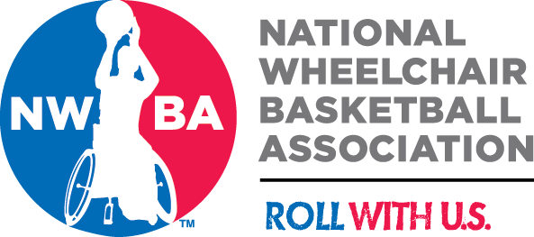
NWBA Hall of Fame Nomination Form
CATEGORY:
NOMINEES NAME:
CONTACT INFORMATION (phone, address, e-mail):
AGE:
EDUCATION:
BIOGRAPHY:
(Please attach Letter of Nomination (Word Format) that includes the following):
A. Competitors Category:
- • Team Affiliations and Longevity in NWBA
- • Player History and Distinctive Playing Record (Stats, Awards)
- • Membership on Championship and US Teams
- • Superiority of Basketball Skill Respective to Classification
- • Unique Achievements and Positive Influences on the Sport of Wheelchair Basketball
- B. Non-Competitors:
  - • Length of Service to the NWBA
  - • Capacity to the NWBA (Coach, Administrator, Official, Supporter)
  - • Define and prioritize significant Contribution to the Development of the Sport of Wheelchair Basketball.
  - NAME OF PERSON NOMINATING (phone, address, e-mail):
  - AFFILIATION:
  - LETTERS OF ENDORSEMENT:
  - (Please include the following):
Three or more Letters of Endorsement (Word Format) from individuals, familiar with the nominee, who can personalize, substantiate, and define their significant contribution to the NWBA and the Sport of Wheelchair Basketball.
Please e-mail the ‘Letter of Nomination’ and the ‘Letters of Endorsement’ to:
Frank T. Burns, Chairman – NWBA Hall of Fame Committee ftburns@hotmail.com (Subject-NWBA H of F Nomination)

