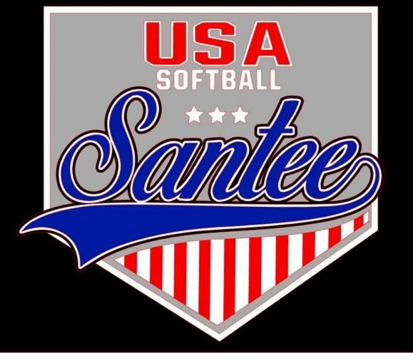
MINUTES TO BE APPROVED AT THE NEXT BOARD MEETING. THESE MINUTES ARE NOT CURRENTLY POSTED AND SHOULD NOT BE DISTRIBUTED UNTIL APPROVED BY USASSCS BOARD.
Board Meeting Minutes July 1, 2024
Location: Santee City Hall
Attendees Shown with Marked Box
President | Jay Strandberg | x | Field Prep | Kevin Hopkins
1st VP/ Field Prep/Uniforms | Erik Ruiz |  | Field Prep | Trevor Henton
2nd VP | Kelli Timanus | x | Field Prep | James Timanus | x
Treasurer | Tiffany Lynch | x | Field Prep
Secretary/Safety Coordinator/Head Scorekeeper | Bryan Scholar | x | Field Prep | Brad Allen | x
Tax Advisor | Lori Britt |  | Field Prep/Equipment | Shane Frary | x
Player Agent | Lance Craw | x
UIC/Parliamentarian | Felicia Leca |  | Head Team Parent Coordinator | Dana Hisaw | x
Field Scheduler/Fall Ball Coordinator | Chris Klima
Webmaster/Social Media/All-Star Coordinator | Alexis Ruiz |  | Picnic Coordinator/Pictures | Kat Vecchione | x
BOTH Tournament Coordinator | Kayleigh Ponciano-Ahue | x | Snackbar #1
Sponsorships | Kylee Scholar | x | Snackbar #2
Awards | Janis Aiello | x | Social Media Coordinator | Sophia Vigil | x

Meeting called to order: 7:11 PM
Meeting Minutes
Brad Allen motioned to approve minutes from June 2024. Kylee Scholar seconded the motion.
Meeting rule – One Topic at a Time
Financial Update (Tiffany L)
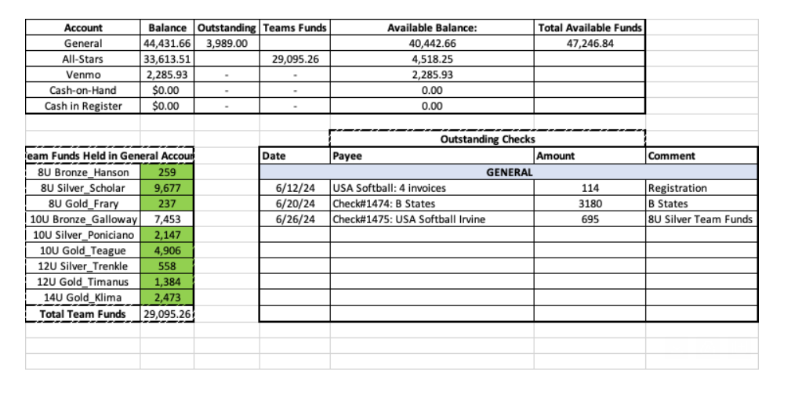

Board Positions Updates
- James Timanus voted in as uniform coodinator
- 2 field positions open
- 2 snack bar positions open

Ideas for the future to consider:
- Adding each seasons standards and expectations to the website
- Bryan and Jay to set 2024-2025 schedule by end of September

Fall Season
- Registration open July 22 – Aug 18
- Add volunteer application form linked from registration
- Take team mom question out
- We will have fall rec option and fall competitive option
- Cost is $225/player

Rules Committee – to meet on July 22 and bring rules ideas back to board
- Bryan Scholar
- James Timanus
- Kayleigh Ponciano-Ahue
- Brad Allen
- Felicia Leca

Meeting Adjourned: 9:10 pm
Next Meeting: Aug 12

