Black Hills Bagels | 10% off total purchase
Offer Black Hills Bagels one coupon per customer per day.
Redeem at 913 Mt. Rushmore Road or 1720 Haines Ave. Rapid City SD
Serving locally roasted coffee, desserts and expresso bar. Please see web site for full menu. www.blackhillsbagels.com or 605-399-1277 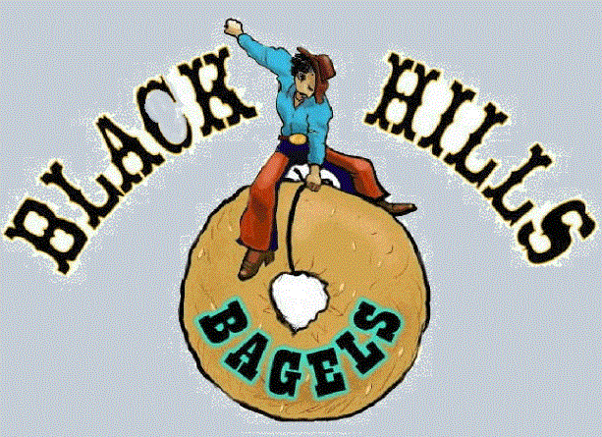

Black Hills Bagels | 10% off total purchase
Offer Black Hills Bagels one coupon per customer per day.
Redeem at 913 Mt. Rushmore Road or 1720 Haines Ave. Rapid City SD
Serving locally roasted coffee, desserts and expresso bar. Please see web site for full menu. www.blackhillsbagels.com or 605-399-1277

Receive promotion when you buy one of equal or less value
Redeemable at any participating Black Hills Bagels
Expires: Date
website

Black Hills Bagels | 10% off total purchase
Offer Black Hills Bagels one coupon per customer per day.
Redeem at 913 Mt. Rushmore Road or 1720 Haines Ave. Rapid City SD
Serving locally roasted coffee, desserts and expresso bar. Please see web site for full menu. www.blackhillsbagels.com or 605-399-1277

Receive promotion when you buy one of equal or less value
Redeemable at any participating Black Hills Bagels
Expires: Date
website

Black Hills Bagels | 10% off total purchase

Offer Black Hills Bagels one coupon per customer per day.
Redeem at 913 Mt. Rushmore Road or 1720 Haines Ave. Rapid City SD
Serving locally roasted coffee, desserts and expresso bar. Please see web site for full menu.
www.blackhillsbagels.com or 605-399-1277

Receive promotion when you buy one of equal or less value
Redeemable at any participating Black Hills Bagels
Expires: Date
website

