Topeka Select Gunners 07-08
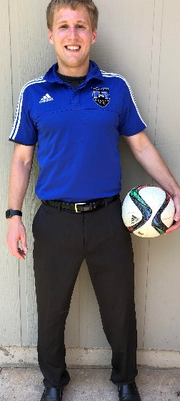
Coach: Thomas Hunt, PT, DPT
Thomasgerald.hunt14@gmail.com
402-619-6310

Experience:
US Soccer “D” License
Doctor of Physical Therapy
Four years coaching experience
Played Collegiately at Briar Cliff University (NAIA)

Why I should coach your son:
-Formal player evaluations at the end of the Fall and Spring seasons
-Feedback to parents regarding individual player development on a weekly/monthly basis
-Video Recording of most games on Youtube [weather depending]
-Player and parent educational videos on Youtube
-Cost effectiveness, I want you to get the most value for your money spent.
-Emphasis towards “winning the way which prepares them for High school and beyond” not “winning at all costs”
-Each player plays both offense and defense

Philosophy:
“I greatly believe soccer is similar to life in many ways, teaching my players the values of hard work, commitment, and teamwork by emphasizing the development of foot skills outside of practice and putting the team first. I also strongly encourage my players to watch as much professional soccer as possible as I believe there is much to learn from watching the game played at the highest level.”

