New To Softball??!!
Equipment List:
1.Defensive Facemask 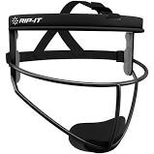
2.Glove 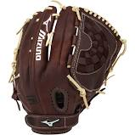
3.Softball Bat (USA/ASA stamped) 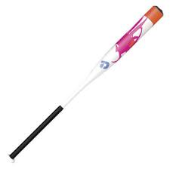
4. Helmet with face mask and chinstrap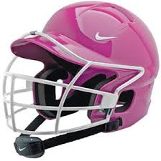
5. Cleats 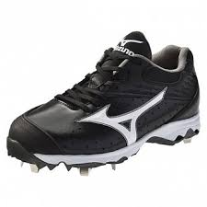
6. Black softball pants 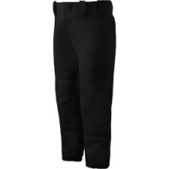
7. Socks and belt (dependent on team colors)
8. Optional: bat bag 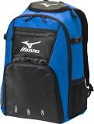, batting gloves, balls for practice at home (11inch 6u,8u,10u) (12in 12u/18u)

