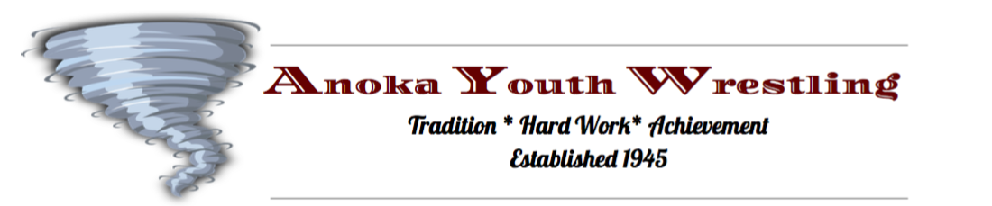

June 25th, 2019

Dear Anoka Youth Wrestling Parents,

We have exciting news! Anoka Youth Wrestling is celebrating 75 years of tradition, leadership and success!! Established in 1945, our organization has a rich history of success proven by 5 Olympians, 40 State Champions (9 of the 40 were multi-year State Champions), Minnesota’s youngest Olympian and we have produced more Greco-Roman athletes who later became World Team members and/or Olympians than any other location in the country.

Our program would not be successful without each and everyone of you! Currently, we are looking for local businesses to help sponsor our program. Your mat sponsorship helps support our program’s mission which is dedicated to preparing children for life’s experiences through the sport of wrestling. In addition, your contribution will assist us to provide qualified adult leadership to train our youth wrestlers and will be put towards the purchase of new wrestling equipment for the program and the maintenance of our existing wrestling equipment.

Over the past few years, with sponsorship and fundraising efforts, we have been able to purchase new score clocks, mat slings for a mat lift system and we have also assisted the Anoka High School wrestling program with the purchase of new wrestling mats.

The Anoka Youth Wrestling program is set up under the Anoka Ramsey Athletic Association, which is a 501 ( C ) (3) non-profit organization.
The sponsorship levels are as follows:

Platinum Sponsor: $600
- Mat sponsorship for tournament(s)
- Prime location mats
- Bean Bag Tournament Board Sponsorship
- 1 Paid team for the bean bag tournament
- Logo on Anoka Youth Wrestling T-Shirts
- Logo advertised on our website

Gold Sponsor: $400
- Mat sponsorship for 1 tournament (state qualifier)
- Name on Anoka Youth Wrestling T-Shirts

Silver Sponsor: $200
- Bean Bag Sponsor – Includes Bag Board Sponsor, Team fees for bean bag tournament entry
- Name on Banner, used at tournaments
Friendship Sponsor: $100
- Name on banner which will be used at tournaments

Please see attached document for information regarding The Bean Bag Fundraiser and Event.

Please share this information with others within the community who may consider supporting our successful program.

We hope you’re able to contribute and thank you for your consideration. Please reach out to Angie Bizal, commisoner of Anoka Youth Wrestling at anokayouthwrestling@gmail.com
Go Anoka Wrestling!

Sincerely,
ARAA Youth Wrestling Board of Directors
Anoka Ramsey Athletic Association
Youth Wrestling Tax ID: 41-1591033

