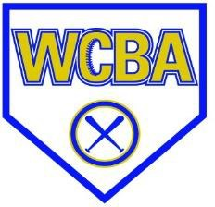

2025 West Central Baseball Association

10U & 12U Early Bird Tournament

We will continue to offer a Competitive Division and a Recreation Division this year in each age group. Each Division will be capped at 8 teams so get your Registrations in early to get your spot. Each team will be guaranteed a Minimum of 3 games. Please make sure to specify below under the Division line weather you wish to sign up for Competitive or Recreation. (Note: The Recreation Division is for non-traveling teams only)

Age Group & Dates

10U: Saturday May 10th, 2025
12U: Sunday May 11th, 2025

Fee
10U $300 & 6 game balls
12U $300 & 6 game balls

Registration Fee payable to:
West Central Baseball Association
PO Box 152
Hartford SD, 57033

Or:

Venmo: @westcentralbaseballassociation

Phone: 605-941-5256 (Andy Lueth) 605-929-0310 (Joe Hanisch) 605-421-0872 (Tyler McCoy)
Email: wcbassoc@gmail.com

Team Name: Age Group:____________________

Division:_________________________________________

Head Coach: Phone:

Association/Organization:

Address:

City: State/Zip:

Email:

