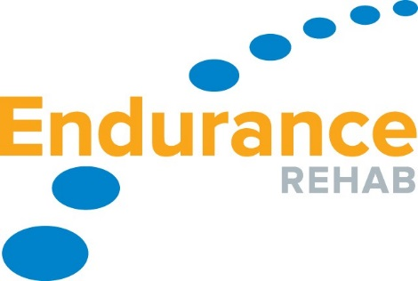
STEPS TO FOLLOW WHEN INJURY OCCURS
- CONTACT ENDURANCE REHAB PHYSICAL THERAPIST IMMEDIATELY FOLLOWING INJURY.
  - TXT MESSAGE IAN CHAPPLE, P.T 602 614 4911
  - TXT MESSAGE BRANDON PENAS 602 502 4451

- IAN OR BRANDON WILL SET UP AN INJURY CONSULT TO DETERMINE PLAN AND TREATMENT OPTIONS:
  - REFERRAL FOR PHYSICAL THERAPY
OR
  - DOCTOR REFERRAL (SEE NEXT PAGE)

Preferred Doctor Referral List
Concussions and Concussion Management and General Sports and Family Medicine: These are sports medicine physicians, not surgeons, they can get athletes in quicker and can evaluate injuries and order imaging/testing as necessary. If its not an emergency these are the best physicians to start the process.
- Erik Dean 480-889-1838 SCOTTSDALE
- Charles Peterson and Brent Rich ASMC 888-499-1015 MESA
- Erik Bowman (Phx Childrens) 602-933-1000
- Matt Anastasi (MAYO) 480-342-6800
Knee and Shoulder Injuries (surgeons)
- Gary Waslewski, Doug Freedburg and Amon Ferry ASMC 888-499-1015
- Amit Sahasrabudhe 480-889-1838 (MESA)
- Anikar Chhabra Mayo 480-342-6800
- Tim Bert 623-873-8565
Fractures/Trauma (ie/ Clavicle fracture)
- Jeff Vaughn, David Bennett and Jen Burns (Phx Childrens) 602-933-1000
- Amit Sahasrabudhe 480-889-1838
- Peter Mitchell ASMC 888-499-1015 FOOT and ANKLE only
Hip (Joint issues, adductor, hamstring tears, etc.)
- Gary Waslewski ASMC 888-499-1015
- Tim Bert 623-873-8565
Spinal Injuries (neck and back)
- Brad and Susan Sorosky 602-840-0681
- Anthony Lee 480-442-0880
- Children’s – Dr. Bennet 602-933-1000

If you have a problem getting an appointment please contact Endurance Rehab so we can help facilitate an appointment.

