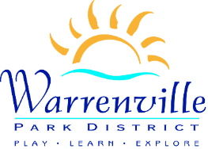


Stay up-to-date when adverse weather affects the events that are important to you through the Rainout Line.
You can choose to:
- Sign up for text or email alerts
- Download the app to your smartphone
- Call the hotline number for a recorded update
To sign up and learn more, see the details below!

Email and Text Alerts
Subscribe to email and/or text alerts by clicking on the link: Rainout Line Text & Email Alerts
Manage your text and/or email subscriptions by selecting the activity/facility categories and establishing the length of time you want to receive notifications. You will automatically receive a text or email notification when there has been a change to those events/programs/facilities/camps.

Download the App
- Download the FREE Rainout Line App on your iPhone or Android.
- Once you have downloaded the app, search for Warrenville Park District. Click the star to the right of our name to make this your favorite. Favorites always show up first when you access the app in the future.
- Tap on our name and on the next screen, click the stars next to the events/programs/facilities/camps you want to follow first by making them favorites.
- The green circle means a program is “a go” as planned. The red stop sign means the program is canceled or there has been a change. You can click on the item to see more detail.

Hotline Phone Number
You can call the Warrenville Park District Rainout Line at 630.454.6033 and select the extension number for automated updates.

Social Media
Facebook and Twitter pages will continue to be updated as normal.

Warrenville Park District | 630.393.7279
info@warrenvilleparks.org | www.warrenvilleparks.org

‌ ‌ ‌

