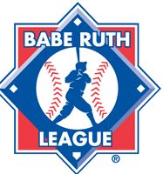
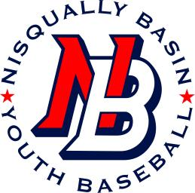
Nisqually Basin Youth Baseball
Representing Yelm and Surrounding Communities
Parent Code of Conduct
- I hereby pledge to provide positive support, care, and encouragement for my child while participating in Nisqually Basin Youth Baseball League.

- I will encourage good sportsmanship by demonstrating respect and positive support for ALL players, coaches, officials, parents, and fans at every game, practice, or other NBYB activity.

- I will place the emotional and physical well being of my child ahead of any personal desire to win.

- I will insist that my child play in a safe and healthy environment.

- I will support coaches and officials working with my child to provide a positive, enjoyable experience for all.

- I will demand a drug, alcohol, and tobacco-free environment for my child and I understand that these substances are not allowed at any NBYB games, practices, or events.

- I will remember that youth baseball is for the children and not the adults.

- I will do my best to make youth baseball fun for my child.

- I will encourage my child to treat other players, coaches, officials, parents, and fans with respect regardless of race, sex, creed, or ability.

- I understand that dogs are not allowed at any NBYB games or practices and I will abide by this rule.

- I will help my child enjoy the youth baseball experience within my personal constraints by assisting with coaching or officiating, performing field maintenance, or whatever I am capable of doing, as well as being a respectful and sportsman-like fan and spectator.

- I will not make any alterations to league-issued apparel or equipment. I understand that if any alterations are made I may be held financially responsible for replacing those league items.

- I understand that a violation of this code may result in the suspension or termination of my child's participation in the Nisqually Basin Youth Baseball League.

___________________________________________ ____________________
Parent #1 Signature Date

___________________________________________
Printed Name

___________________________________________ ___________________
Parent #2 Signature Date

___________________________________________
Printed Name

