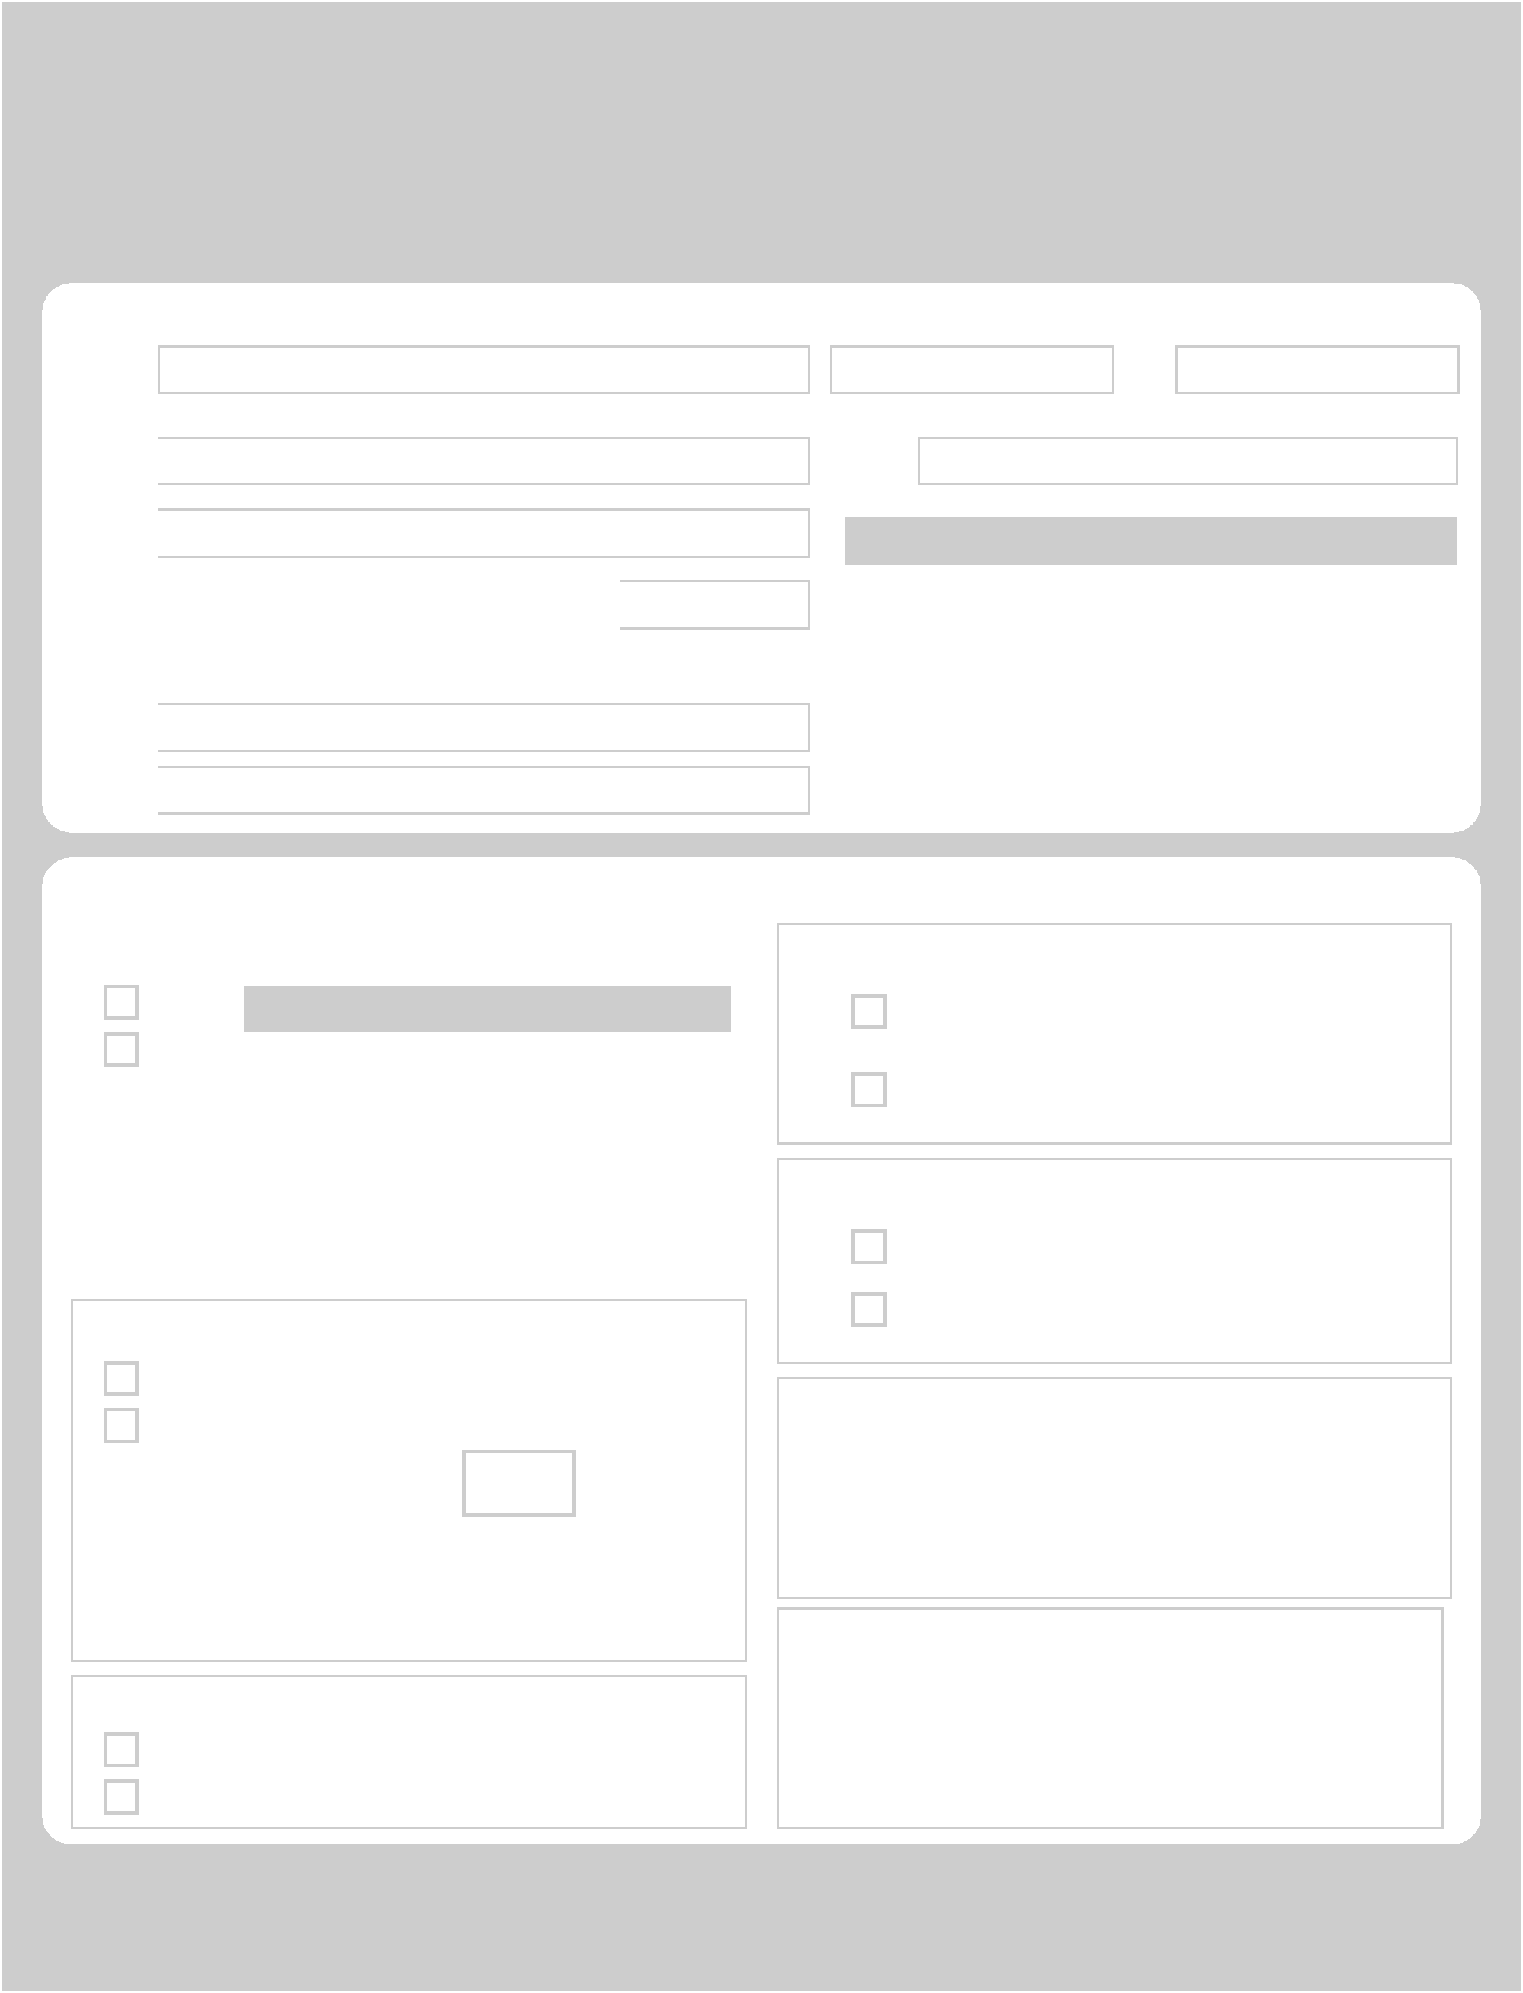
Hampton Roads Junior Whalers
2020-21 Host Family Billet Information Form


Host Family Information…

Name

 |  |  | Last Name
Address
Street Address 1
Street Address 2
City |  |  | State |  |  | ZIP Code
Email 1
Email 2
Host Family Questions…
 | 1. Do you have any children?
 | YES |  | If YES, Please Provide Names/Ages
 | NO
 |  |  | Name |  |  |  | Age

2. Do you have any pets?

YES

NO

a. If YES, how many? b. What kind of pet(s)?

3. Does anyone in your family smoke?

YES

NO

Please return this questionnaire via Email…

• brad@chilledponds.com

•Address To: Jr. Whaler Billeting Program

&

First Name - Father First Name - Mother

School
Zone
High School Name / City

Host Family Telephone Contacts
Home: | ( | ) | -
Father (Work): | ( | ) | -
Father (Cell): | ( | ) | -
Mother (Work): | ( | ) | -
Mother (Cell): | ( | ) | -

4. Player Transportation…

I can provide transportation for the Player to/from the home rink.

The player must provide his own transportation or have his own car.

5. Player Accommodations…

The player will have his own room.

The player must share a room with one of our children.

- Family Interests/Hobbies… (Please List)

- Special Requests… (Please List)

Jr. Whaler Billeting Contact…
Brian Osmundson at 757-377-4997
osmundsonbrian@gmail.com

