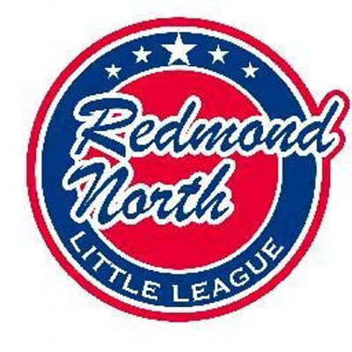

October 8th 2018 Meeting Minutes
Attendees:
Ellen Reed
Alec Weintraub
Bill Bieber
Krystal Klein
Scott Miller
John Kim
Kathy Duncan
Tiffany Gore
Josh Sattler
Meghan Dosch
Mike Sessions

Initial Business

Alec opened the meeting welcoming the new board members.
Board positions were decided for the upcoming 2018 /2019 RNLL Board. Clarification is needed on whether Scheduler is a Board position or not. Alec to confirm.
President Alec Weintraub
Vice President Bill Bieber
Treasurer Krystal Klein
Player Agent Ellen Reed
Secretary To be confirmed (Kathy Duncan or Tiffany Gore)
Safety Officer Mike Sessions
Registrar Josh Sattler
Umpire in Chief John Kim
Scheduler Meghan Dosch
Fundraising Meghan Dosch
Webmaster Scott Miller
Training Coordinator To be confirmed (Kathy Duncan or Tiffany Gore)

Redmond Ridge Hours

The usage hours for Redmond Ridge need to be reconciled with King County. Any unused hours can be rolled forward. Meghan and Alec to work with King County on this.

Financial Report

The financial report is due this week. Steve M is to finalize and liaise with Krystal Klein. Josh queried what the registration costs should be for the 2019 year and how much of an early bird discount could be offered in order to reduce late registrations.

Interlock Games

A discussion was held on Interlocking games with Eastlake Little League. Alec recommends extending the program with Eastlake for the Majors teams. It was noted that Redmond West may have the same idea as they will also be short on Majors teams.

Discussion to be had with Eastlake on pre-season game results counting and differences in local rules to be reconciled, if possible.

Rule Changes for AAA

Following some issues during last season’s AAA games, it was recommended that rule changes be implemented for AAA. Alec to speak with District 9 in this regard during the week. Changes suggested are pitching rules, implementing a coach pitch following 3 straight walks by a pitcher, following which the pitcher can be allowed back on. Coach pitch can not be walks, resulting in either a hit or a strike out. A discussion followed in relation to stealing, particularly stealing home. A deadline of next meeting was set for recommendations for these rule changes.

Constitution changes

Alec is to look at constitution adjustment to add in new board positions.

Softball Registration

Softball registration must take place through RNLL this year and not directed to Redmond West. A discussion was had in relation to linking with Eastlake Softball or even having a Redmond North Softball team instead. Meghan Dosch to reach out to a softball parent, John O’Gara, to discuss possibility.

Extended Board Positions

The following extended board positions were confirmed:

All Star Coordinator Josh Sattler
Equipment Manager Mike Sessions
Mariner Day Coordinator Sheryl Snow
Player Evaluation Day Joel Tyler
Score Keeping Director Ellen Reed
IB Coordinator Kathy Duncan

A discussion was held on not attending the SeaTac All Star tournament and holding a tournament at Redmond Ridge during the 2nd weekend in June. Board very much in favor. Josh would like to have All Star parents commit hours to helping out at the Redmond Ridge Tournament.

Joel Tyler was nominated to be Player Evaluation Day Coordinator. A discussion took place on the possibility of a change of location for evaluations, such as SBA or high school gyms. Alec to call SBA and Josh to reach out to Steve to confirm cost for evaluation day at Redmond Ridge.

A discussion took place in relation to simplifying the uniform coordinators role.

Recommendations are requested for the following open extended board positions:
Corporate Match Coordinator
Facility Manager (Hartman)
Facility Manager (Redmond Ridge)
Logo Wear Coordinator
Photo Day Coordinator

2019 Registrations

Registrations for 2019 will open in November, prior to the next board meeting.

Webmaster

Confirmed that we will be staying with Sports Engine and not changing to Blue Sombrero this year. To be looked at again next year.
Little League International has their own background check which should be much easier this year and save the league money. Mike to look into.

Umpire in Chief

Incentives for Junior Umpire program to be continued. We will continue to use Umpires Northwest for the rest of the games. Ellen to look into possibility of having Junior Umpires on field during warm ups on Little League day!

Miscellaneous

Helmets – Alec to bring up new C-Flap Helmets at the District 9 meeting. A number of companies are already producing and are available for 2019 season. Little League should be issuing a statement in this regard shortly.

Batting Facility – in for permit. However we are not getting a great response from King County. Expected construction Spring 2019.
Field Size – a discussion was had in relation to the fence on JR Field. Suggested a field size of 220. Board approved.

Next Meeting

Suggested the 3rd Monday of the month for board meetings.
Next meeting will be Monday 19th November, 7-9pm at Ixtapa.

