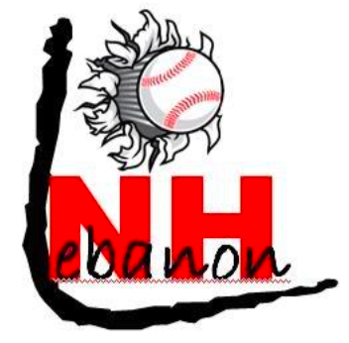
Lebanon Youth Baseball Association

Dear Local Business Owner,

The Lebanon Youth Baseball Association is holding our annual sponsorship pledge for the 2017 season and we are seeking contributions from local businesses. We are currently accepting donations in the following forms:

Team Sponsorship | Team Sponsorship provides one of the league’s 16-20 teams with uniform jerseys, hats and stirrup socks that make the kids look and feel like big leaguer’s. A name of your choice is printed on the back of the jersey and a team photo will be provided to your business. Team Sponsorship is $400 and is limited to the number of teams that need a Team Sponsor. Please e-mail Lori Richardson to check availability, lorilynn_16@yahoo.com
Sign Advertisement | Sign advertisement at sporting events is a traditional way that a business can reach a large number of local customers on a repeated basis. A 4 x 6 sign is hung on the outfield fencing of Smith or Logan Field for the regular season and summer tournaments. New signs cost $400 (of which the league makes little if any profit). Renewal for existing signs is only $250 annually.
Team and Sign Package | We are offering discounted pricing for team sponsors wishing to renew a sign. The total cost to sponsor a team for the 2017 Season and have a sign advertisement on the outfield fence is $550 for one sign and $750 for two sign renewals.
League Donation | Of course, the league will humbly accept any donation of cash, equipment or services that your business is willing to give. League donations will be listed on our website on the Donations page.

Please note that team sponsorships and advertising space may be limited. Final acceptance of all donations, sponsorship and advertising requests are subject to final approval by Lebanon Youth Baseball. Thank you for your support of baseball in our community.

Sincerely,
Lebanon Youth Baseball
PO Box 905
Lebanon, NH 03766

2018 LEBANON YOUTH BASEBALL SPONSORSHIPS

Dear Lebanon Youth Baseball:

Please accept my pledge of the following donation to Lebanon Youth Baseball (Place “X” next to your choice):

Team Sponsorship: ($400/each) please indicate preference below*:

Intro______ Rookie League_______ Minor League_______ Major League_______

Sign Advertising**: ($400/each new sign or $250/each sign renewal) No. of signs

Field Preference*: Smith Field
Logan Field

Team/Sign Package: ($550 includes 1 Team Sponsorship and 1 Advertising Sign)
Please indicate team and field preferences above.

($750 includes 1 Team Sponsorship and 2 Advertising Sign)

_ [ ] Gold Member Donation $1000 or more**
[ ] Silver Member Donation $500 **
[ ] Bronze Member Donation $250 **
[ ] Other- Donation in the amount of $

Donation of equipment or services (You will be contacted for more information.)

*Lebanon Youth Baseball will make every effort to accommodate the requested preferences, but reserves the right to modify the requested age level or field location based on availability.
**Please send a digital copy of the logo you would like LYBA to use to Jason.r.gunn@dartmouth.edu

Payment for my pledge:

Is enclosed in the form of a check payable to “Lebanon Youth Baseball.”

Should be invoiced to: [Name]
[Address]
[Phone]
_____________________________________ [Email]

Please return this completed form, any donation check and/or inquiries to:

Lebanon Youth Baseball
P.O. Box 905 Lebanon, NH 03766

For additional contact information, please visit our website at www.lebanonyouthbaseball.com.

