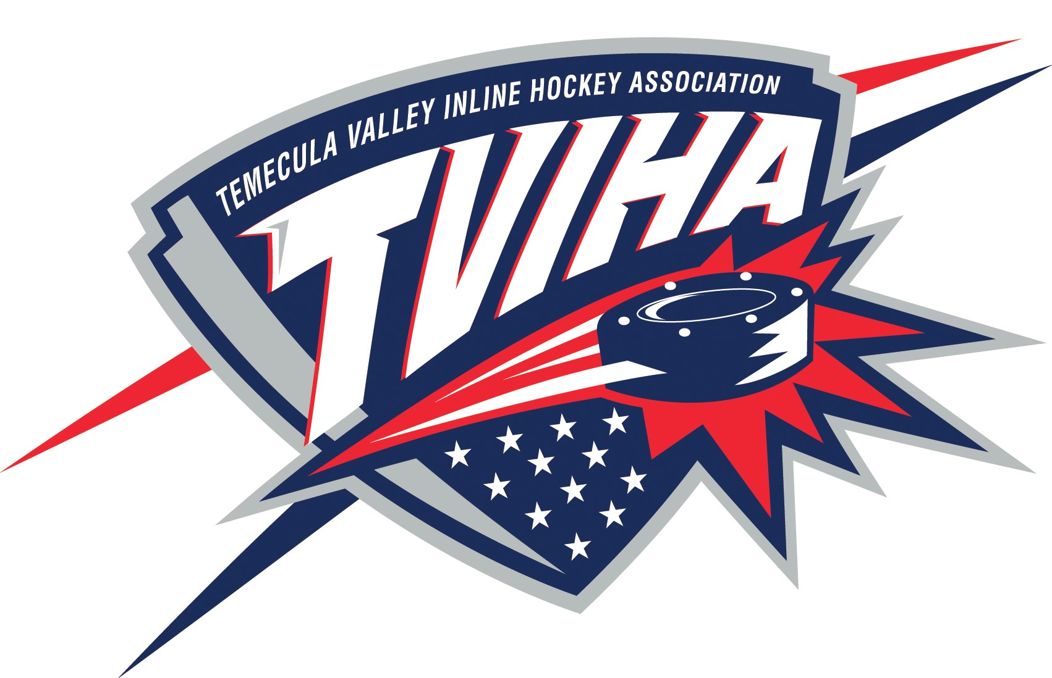

Temecula Valley Inline Hockey Association
Regular Meeting Minutes
December 5, 2017

- Call to Order & Establish Quorum:
- President, Tom Bilek, called meeting to order at 6:41pm.
- The following people were present: Alysha Stichter, Gina Downey, David Bowman,
Bobbie Platek, Tom Bilek, Sonja Johnson, Katie Worley, Brandon Mackenzie, Mike DeCello, Sheldon Ivesto, Tim Farley, Brayden Platek, Mike Betsch.

- Reading and Approval of Minutes
- October meeting minutes- A motion to approve the minutes was made by David Bowman and approved by Katie Worley.

- Treasurer’s Report: Alysha Stichter
- October and November checks were reviewed and approved.

- Fall 2017 Recreation League
- Although the Fall season was really competitive and evenly balanced, we were dealing with frequent fair play issues due to coaches not properly changing players. Smaller teams may be a solution, however that would require more coaches.
- Saturday play may need to be considered for the Spring Season.
- The scorekeepers did better this season, which resulted in better stats.
- Consistency among the referees is important and all rules need to be clearly communicated to the coaches. Referees calling out “loose” may not be in the best interest of the league. It may be good for referees to provide short explanations of calls to newer coaches.
- BOD and referees need to jointly decide if games are postponed or rescheduled when games are at or near 95 degrees.
- Protection of goalies is a priority that should be discussed further with referees.
- It would be beneficial to have meetings with all coaches attending and possibly referees as well. This would give coaches a forum to voice concerns.
- Respecting the authority of the referees is essential to a successful league.
- A coaches meeting is needed before the season to make sure everyone is on the same page. Attendance is very important.

- School Leagues:

- Board of Directors still needs to receive a complete of all assistant coaches.
- Need to be careful about having a district team like we do in Murrieta currently. We do not expect a problem but it is something to monitor.
- BOD needs to approve school league coaches.
- Coaches meeting for school league is scheduled for Tuesday, December 12, 2017.

- Warriors:
- Jerseys were ordered for new players, will be ready by next week and Bobbie will be getting matching pants. All Warrior teams have played very well. There is talk of maybe starting a 16U, or even 18U division.

- Adjournment:
- Meeting adjourned at 8:34pm.

