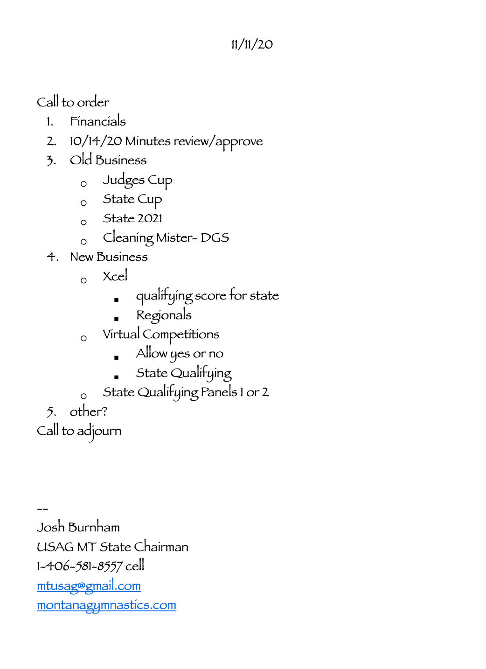

SAC - MT
Meeting Minutes
November 11, 2020

Call to Order: Josh Burnham (SACC) called to order the regular meeting of the SAC-MT at 8:50 p.m. on November 11, 2020.

Roll call: Josh Burnham, Jeanine Henneford, Denis Berry, and Sharon Mozer.

Announcements:
- Financials - $16,058.66 in the SAC-MT account.

- To approve the Minutes from 10/14/20.
Motion: Jeanine Henneford
Second: Denis Berry
PASSED

Old Business:
- Judges Cup - December 4-6, 2020. The Gallatin Co. Health Dept. approved LMG to host Judges Cup. Number of athletes per session will be minimized from 40 to 30. Coaches meeting will be via virtual conference a week before the meet. Athletes will enter through the side door, and spectators will enter through the front door. There will be two spectators per athlete allowed. Masks must be worn at all times to follow the mask mandates with the exception of athletes when warming up and competing. There will be two coaches per event allowed.

- State Cup - January 8-10, 2021.
- Kelley of Mismo will draft a rotation schedule as soon as all entries are submitted.
- Awards are as follows: Level 2-5 and Xcel B/S/G will receive ribbons on individual events. AA medals will be awarded to everyone.
- Entries are estimated around 300 athletes.
  - Bronze (29) Silver (47) Gold (36) Platinum (13) Diamond (1)
  - Lvl 2 (25) L3 (48) L4 (47) L5 (30) L6 (44)
  - L7 (24) L8 (25) L9 (8+) L10 (3+)

3. State 2021 - Due to restricted numbers from the state mandates related to Covid-19, WDP and Xcel State Championships may need to be held on separate weekends.

4. Portable Misting Spray (DGS) is a reasonable idea to invest in, but at this time the board
believes that individual gyms already have in place their own cleaning/disinfecting system. The board will hold off on purchasing the misting spray.

New Business:
- Xcel
  - Athletes do not have to attend the state meet in order to participate in Xcel Regionals. However in order to attend Regionals per the Regional Admin Committee (RAC), athletes need to score at some point during the competition season the following:
    - Gold - 35.5AA Platinum - 34.5AA Diamond - 33.5AA IES - 8.75 on Event

  - To have the Xcel State qualifying score for all divisions a 31AA.
Motion: Denis Berry
Second: Jeanine Henneford
PASSED

- Virtual Meet
a. To propose that virtual competitions cannot be used as state qualifiers.
Motion: Denis Berry
Second: Sharon Mozer
PASSED

b. To not allow virtual competition to replace “in-person” competition for the 2021 State Championships.
Motion: Denis Berry
Second: Jeanine Henneford
PASSED

- The board will not propose new changes to the judging panel for a state qualifying meet. As for now, the state will follow the R&P, requiring a 2-judge panel for Level 5 and up, and for Xcel Gold and up.

Adjournment:
To have the meeting be adjourned. The meeting adjourned at 11:02 p.m.
Motion: Jeanine Henneford
Second: Sharon Mozer
PASSED
Next Meeting: December 9, 2020
Minutes submitted by Sharon Mozer

