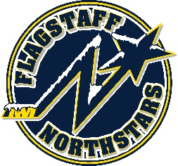
Flagstaff Youth Hockey Association
BOARD OF DIRECTOR’S MONTHLY MEETING AGENDA
June 22, 2022

Topic: FYHA General Board Meeting
Time: June 22, 2022 @ 6pm
Location: 214 E Birch Ave or via teams: https://tinyurl.com/FYHA-General-Board-Meeting

Approval of Minutes:
Reports:
- President’s Report- Travis Joralmon:
- AAHA Hockey Director- Travis Joralmon:
- ADM Coordinator: Kris Walsh:
- Coaching Coordinator- Travis Johanson:
- Equipment Manager- Greg McLaughlin:
- Fundraising Coordinator-Paul Barton:
- Ice Scheduler-Brad Mihalik:
- Registrar-Charlie Knotts:
- Treasurer-Lauryn Sandoval:
- Webmaster-Gina Nabours:
- Managers-Brad Mihalik:
- Sponsorship- Stephanie Babbitt:

UPCOMING EVENTS:
- Summer Pond Hockey 5/31-7/28
- RMHS Summer Hockey Camp 6/20/22-6/24/22
- Northwestern Hockey Camp 7/18
- Dark Sky 7/22/22-7/24/22

OLD BUSINESS:

NEW BUSINESS:
- Game sheets
- Tournament Selection
- Color Reminder
- Uniforms
- User group meeting
- Fall Ice Schedule
- Travel Start Date
- Treasurer’s contract (executive session)

