TEAM INFORMATION PACKET



JULY , 202_

Town Boys' Baseball
' . ,
WELCOME LETTER
ADDRESS

Dear Coach/Manager,
On behalf of the TEAM Community Boys Baseball Committee and the Community Department, I would like to welcome you to Community, North Dakota, for the North Dakota AGE Year old State Babe Ruth Baseball Tournament.
Community is extremely pleased to be your host for this exciting sporting event and after you arrive in our fine community! Our Committee has worked extremely hard to make your stay a pleasant one, and this packet of information should be quite helpful in planning your trip to Community
Community is extremely proud of our tournament facility, as Facility/Stadium has hosted many District, State and Regional tournaments in both Babe Ruth and American Legion Baseball
I anticipate a tremendous tournament and would like to congratulate you and your team for qualifying for this Championship Tournament. If you need any assistance, please do not hesitate to contact me or any members of our Tournament Staff,· and we will assist you any way possible. I look forward to meeting all of you, and again would like to welcome you to Community

Sincerely,

Tournament Chairman Host Mailing
Address
Asst. Tournament Chairman Host Mailing Address

INDEX

Tournament information Tournament phone numbers Team information
Game conduct

General Tournament Guidelines Player Instructions Admission Prices
Tournament Master Schedule Tournament Bracket
Pitch Count Information

Video Board Instructions for Coaches Hotel/ Lodging information Team Document checklist

TOURNAMENT INFORMATION

TOURNAMENT HEADQUARTERS
The tournament headquarters will be located inside location. All teams are to check in 2 hours prior (at Complex Stadium) to your first game on July ??st At that time we will go over tournament procedures •and take your team documents. This will serve as your official tournament check­in.

OPENING CEREMONIES
Opening ceremonies will be held at Stadium prior to the last game of the day (approx. ?:00pm), on day, July st . All teams are to be in
uniform at Stadium at :00 sharp! We will be having a color guard and a special rendition of the National Anthem prior to the start of the game.

UMPIRES/ COACHES GROUNDS MEETING
The umpires will meet with the Coaches prior to their first game on July st

.

TOURNAMENT OFFICE
There will be a tournament office located inside Stadium (same as Tournament Headquarters). This will be available for all Tournament officials, Dignitaries, and to assist coaches and managers if any questions or problems arise.

MEDICAL ASSISTANCE

TEAM MATERIALS
All team documents should be with you at your team check-in. You will need:
~Birth documents or Babe Ruth 1.0. cards,
~Team accident and Liability insurance certificates
~Tournament team roster certified by League President,
~Babe Ruth League tournament letter of eligibility form,
~Consent for treatment forms,
~8" x 10" team photograph (4 copies) with players identified.

Please send me your team photograph (w/ players identified) and your Team roster By July ___ st, 202_ so that we can get to the printers for the tournament program!!!
RADIO/PRESS COVERAGE
The tournament will be covered extensively by the local news media. Phone numbers of the various local news media outlets are as follows:


BRAG ABOUT YOUR STADIUM

TOURNAMENT "HOTLINE" TELEPHONE NUMBERS
In the event of inclement weather or schedule changes, the information can be obtained by calling the following "HOTLINE" telephone numbers:
Office... (701) 701-____-______
Tournament Manager... 701-____-______
Asst. Tourn. Mgr............ 701-____-______
ND State Babe Ruth Commissioner. .. 701-____-______
PRACTICE FIELDS
Practice fields will be coordinated daily through the Tournament or Asst.
Tournament Manager, Fields available for practice will be at Field
Field (adjacent to Aafedt Stadium). Batting cages are available

SOUVENIRS AND CONCESSIONS
There will be a wide variety of concessions and souvenirs available at throughout the tournament. Souvenirs that will be available will be:

BAT BOYS
You may bring. your own bat boys if you wish-they must be in uniform and will be required to wear a helmet at all times-there will be no exceptions to this rule ! We will provide a bat boy for your team if you do not have one.

OFFICIAL TOURNAMENT WEBSITE
The official tournament website will be www.____________________________________________________________.com and you will be able to follow your favorite team with bracket scores posted daily. Also we will use “Tourney Machine” to update scores and brackets.

TOURNAMENT TELEPHONE NUMBERS

, TOURNAMENT MGR.........701- -
, ASST. TOURNAMENT MGR............•........701- -

, ND STATE COMMISIONER...701- - PARKS AND REC. OFFICE ......•.......701- -
STADIUM...........................................701- -
CHAMBER OF COMMERCE ..............................701- -
CONVENTIONNISITORS BUREAU......................701- -


TEAM INFORMATION
1.) All games shall be 7 innings, unless home team is leading after 6 ½ innings of play. In the event that a game is called before completion, the game will be resumed form the point of discontinuance. All decisions in regard to rescheduling will be made by the Tournament Task Force and/or Tournament Manager. The 10 run rule will be in effect for all tournament games after 5 innings.

2.) All teams are expected to reserve any hotel accommodations on their own. The availability of Hotels in COMMUNITY is no longer an issue, and should be readily available. If assistance is needed, you can contact the COMMUINITY Convention and Visitors Bureau (701- - ).
3.) Each player, coach and manager shall wear a different number on their uniform. The official Babe Ruth shoulder emblem must be worn on the left sleeve, THERE WILL BE NO EXCEPTIONS TO THIS RULE!!
4.) Upon elimination from the tournament, arrangements will be made for team check-out with the Tournament Manager and the Coaches/Managers. This departure from the tournament will remove all liabilities associated with this tournament from Babe Ruth League, Inc., North Dakota Babe Ruth Baseball and the local tournament committee
5.) This tournament is under the jurisdiction of the Babe Ruth Baseball, and the Tournament Task Force. The Tournament protest committee shall have final authority in all protests and matters not covered by official baseball rules, or Babe Ruth Baseball rules and regulations.
6.) At least one coach or manager from each participating team shall be required to be in attendance at all required meetings called by the Tournament Manager, preferably, the entire staff be in attendance whenever possible.
7.) Official Pitching rules of Babe Ruth Baseball will apply during this tournament competition. We will be using the approved pitch count program for this tournament so please make sure you are familiar with it.
8.) Host families will not be used at this tournament level
9.) All teams will arrive as a complete group, and will depart as a complete group. Any players who do not arrive with the team at check-in may not be able to participate. Babe Ruth League, Inc. and North Dakota Babe Ruth Baseball will have final authority.

GAME CONDUCT
1.) The umpires will enforce all rules and regulations covered in the Official Baseball Rules and the rules and regulations of Babe Ruth Baseball.

2.) The game will be kept moving at all times. No unnecessary delays or mound conferences will be permitted.

3.) ANYONE-Players, Managers, or Coaches acting in an unsportsmanlike manner will be removed from the playing field and facilities immediately.

4.) Coaches and Managers shall wear uniforms consistent with Babe Ruth Baseball. No coaching shorts or players shorts, no ragged shirt tails, etc. will be permitted. Tournament Task Force will have final approval of all uniforms worn by teams in attendance. The official Babe Ruth emblem will be worn by all participants on the left shoulder as per Babe Ruth rules.

5.) All equipment-bats, gloves, etc., shall be stacked neatly in their proper places at all times

6.) Bat persons shall be prompt in delivering discarded bats to their proper places at all times.

7.) Discarding bats and protective headgear in such a way as to cause personal injury to another player or spectator shall be deemed unsportsmanlike.

8.) Only Players, Coaches, Managers and bat personnel shall be allowed on the players bench and dugout. NO ONE ELSE ALLOWED!!!!! All bat persons shall have helmets while on the field.

GENERAL TOURNAMENT GUIDELINES

1, 1.) Sportsmanship will be stressed. Judgment calls by the umpires will not be questioned. If there is a discussion regarding a rule, it will be handled in a gentlemanly manner. Protests will be handled as prescribed in the Babe Ruth Rule Book. Players, managers, and coaches will not be allowed to talk to the protest committee during deliberations unless asked to do so.

2.) Smoking, chewing of tobacco or drinking of alcoholic beverages by any player, manager or coach will not be allowed on the field or in the dugouts. Teams that allow players to drink pop or eat food in the dugouts are required to clean the debris, immediately after the game is completed.

3.) Players, one manager, and two coaches and a bat boy are the only personnel allowed in the dugout during the game. Any other necessary personnel needed in the dugout will only be allowed with the permission of the Tournament Director.

4.) Managers, coaches and players are to remain in the dugout except when participating in the game or when time is called.

5.) Teams are not to verbally harass opposing pitchers, hitters or defensive players. Do not make any remarks to the opposition, or argue with the umpires. ENCOURAGE POSITIVE PLAY AT ALL TIMES!!!

6.) Catchers are required to wear masks and helmets when warming up pitchers before and during the game. All catchers are to wear protective cups. Only players may warm up the pitcher. A back-up catcher is to be ready to warm up the pitcher if the catcher is not ready to at the start of the inning. Pitchers will be allowed 8 warm up pitches between innings and a team will have 11 minutes to be ready to play between innings. A player should be assigned to pick up any balls used for between inning warm ups that are thrown to the backstop.

7.) Only players that are preparing to enter the game should be using the bullpen area during the game. Starting. pitchers are to use the bullpen for their warm up prior to the start of the game. They will be allowed to take 8 warm up pitches when they take the field. A player already on the field will be allowed the proper amount of warm ups as determined by the discretion of the umpires. Relief pitchers, coming off the bench, should have warmed up and will only be allowed 8 warm up pitches upon entering.

8.) All equipment must be kept in the dugouts at all times. NO EXCEPTIONS TO THIS RULE!!!

, ..

GENERAL TOURNAMENT GUIDELINES

9.) The home teams will occupy the 1st base dugout. No team is to occupy a dugout until the coin flip has taken place (after 1st round games). First round home teams are already determined, see tournament pairings.

10.) In the case of injury, the game will be stopped at the earliest possible convenience. Do not come on to the field until time is called, and the umpire signals you to do so.

11.) Make sure your team knows how to appeal plays.

12.) Teams will be allowed 10 minutes of infield practice prior to each game with the home team taking infield first. Infield practice will begin 30 minutes prior to the starting time of the game. You will be directed by the public
address announcer when you are to take the field. If you are late in starting, you will lose the time. If you run out of time, you will be advised to clear
the field by the public address announcer. The first game of the day and / or session will start on time. In the event that a game runs long, there will be approximately 35 minutes between games. As soon as the prior game is completed your players may play catch in the outfield. Approximately 25 minutes before the starting time of the game, an announcement will be made for the home team to start infield, followed by the visiting team.

13.) Players will be introduced before each game with the starters first, followed by the reserves, coaches, and managers. Players should line up on their respective foul lines in front of their dugouts, starting outside the batters’ box at home plate and facing their dugouts. Managers are asked to shake hands at home plate before every game, prior to the start.

14.) Make sure players, managers, and coaches, shake hands following each contest.

15.) Managers are to have lineup cards ready 30 minutes prior to the start of the game, with first and last names listed, with numbers and positions also. Reserves should be listed with first and last names, on the back of the card if not room on the front. You will be given lineup cards in triplicate, one for the pressbox, opposing team, and home plate umpire.

PLAYER INSTRUCTIONS

ll
Officials of Babe Ruth Baseball in North Dakota, and the hard working
tournament hosts have made extensive efforts to make certain your stay will be a pleasant one, both rewarding and educational. Therefore, we expect each participant to cooperate with the following regulations during the tournament.
ASSISTANCE
We want every participant to thoroughly enjoy the entire tournament experience. If you need any information or assistance, contact your coach or manager immediately. He in turn may rely upon the aid of Tournament Officials when necessary.
CONDUCT
Your conduct will be above reproach on and off the field. Any misbehavior or misconduct not only could cause your disqualification from the tournament, but could also disqualify your team as well.
SCHEDULE
Follow your team schedule at all times. Be at practice sessions and any other events on time. Be sure to check with your manager, if you are to attend any activity with your family, and get their permission.
APPEARANCE
As State Tournament qualifiers, we expect your dress to be neat. You may, of course, dress informally and comfortably.
HOST TEAM
Members of the host team are to be treated and are subject to the same rules and regulations as the other tournament qualifiers.
CURFEW
All players are to be in their respective housing, or motel, one (1) hour after last scheduled activity. If an event goes beyond 11:00 pm, all players shall return to their residence directly after the event is completed.
ILLNESS
In the event a player becomes ill, contact your team manager.
TOURNAMENT PASS
You are being issued a tournament pass that will allow you to enter the tournament at all times. If you lose it, you will be expected to purchase a ticket, even for games that you are to participate in. Keep your ID in a safe place and do not forget to bring it with you at all tournament functions. Your pass is for you only. and is not to be given to anyone else! Anyone transferring a pass to another person. will lose the pass for the remainder of the tournament.


TOURNAMENT ADMISSION

ll

TOURNAMENT PASS INDIVIDUAL $ .00
FAMILY...•.. ....•.•. $ 00

DAILY ADMISSION:
ADULT (PER SESSION) $ .00
STUDENT (PER SESSION) ..$ 00
YOUTH (UNDER12)......... $ 00

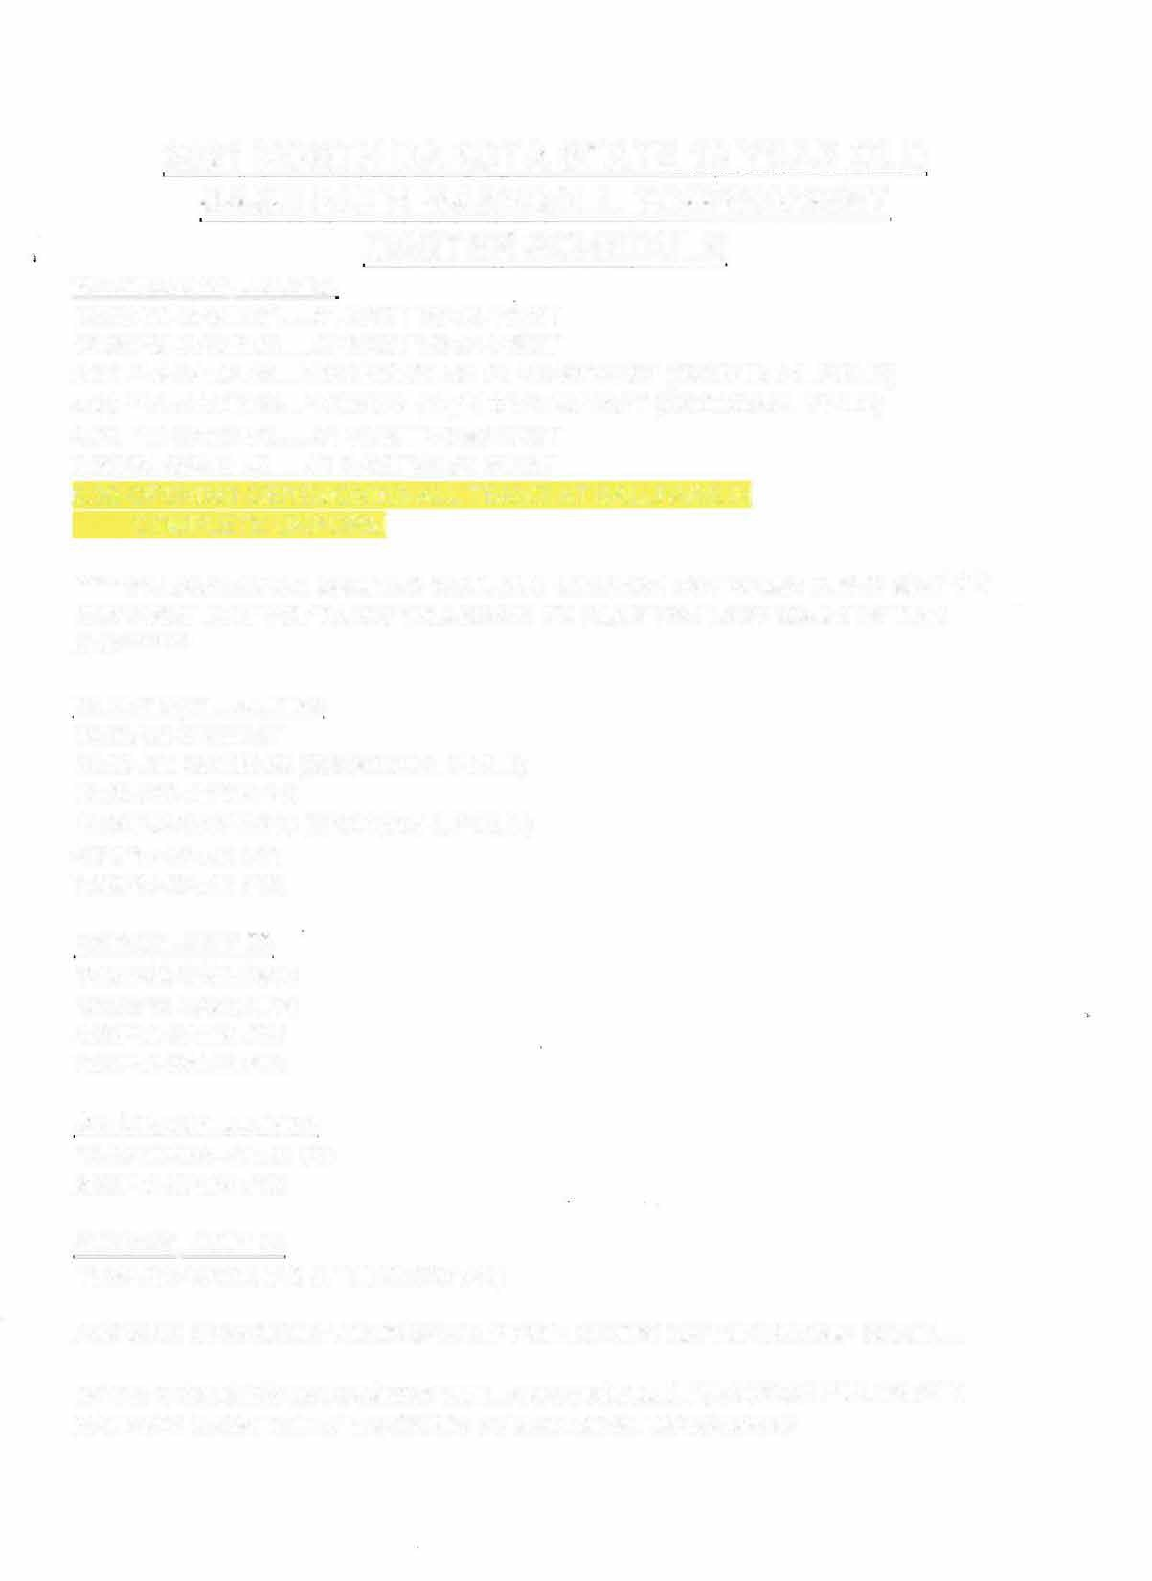202 NORTH DAKOTA STATE YEAR OLD BABERUTH BASEBALLTOURNAMENT MASTER SCHEDULE

DAY, JULY
10:00AM-GAME#1 #4 EAST VS#5 WEST
12:30PM-GAME#2 #5 EAST VS #4 WEST
2:00 PM-GAME#3 WINNER GAME#1 VS#2 WEST {GRONDAHL FIELD)
4:30 PM -GAME #4 WINNER GAME 2 VS#2 EAST {GRONDAHL FIELD)
4:30 PM-GAME#5 #1 WEST VS#3 EAST
7:30PM-GAME#6 #1 EAST VS#3 WEST
6:30-OPENING CEREMONIES-ALL TEAMS AT BALLPARK IN COMPLETE UNIFORM
****-PLEASE NOTE: GAME #S WILL NOT CHANGE, BUT GAME TIMES MAY ON THE FIRST DAY TO ALLOW WILLISTON TO PLAY THE LAST GAME OF THE
DAY***-**
THURSDAY , JULY __
10:00AM-GAME#7
10:00 AM-GAME#8 (GRONDAHL FIELD)
12:30 PM-GAME# 9
12:30PM-GAME#10 (GRONDAHL FIELD)
4:30PM-GAME#11
7:00PM-GAME#12

FRIDAY, JULY ___
10:00AM-GAME#13
12:30PM-GAME #14
4:30PM-GAME#15
7:00PM-GAME#16
SATURDAY, JULY __
12:00 NOON-GAME#17
2:30PM-GAME#18
SUNDAY, JULY 25
11:00 AM-GAME#19 (IF NECESSARY)

AWARDS CEREMONY IMMEDIATELY FOLLOWING CHAMPIONSHIP GAME. ...

NOTE: COACHES/ MANAGERS WILL ARRANGE ALL PRACTICE FIELDS AND BATTING CAGE TIMES THROUGH TOURNEMENT MANAGERS

Pinsert logo here

#4 East
Gl 10:00AM
21-Jul Aafedt
#5 West

#4 West
G2 12:30PM
21-Jul Aafedt
#5 East

#-- 1- -Ea---st-
GG 7:30PM
21-Jul Aafedt
#3 West

G3 2:00PM
21-Jul Grondahl
#2 West

#2 East
G4 4:30PM
21-Jul Grondahl

#3 East
GS 4:30PM
21-Jul Aafedt
#1 West

G7 10:00AM
22-Jul Aafedt

12:30PM
22-Jul Aafedt

202_ Babe Ruth __ Year old State Tournament DATES
COMMUNITY, ND
________Stadium

INSERT YOUR TOURNAMENT BRACKET HERE

Games#1-6 Games#7-12 Games#13-16 Games#17-18 Game#19

Aafedt
GlS Grondahl
4:30PM G#
- Jul L#
Aafedt

G18 2:30PM
24-Jul Aafedt

Game Schedule
Wednesdav. Julv 21 2021
Thursdav. Julv 22 2021
Fridav. Julv 23 2021
Saturday, July 24, 2021
Sundav. Julv 25 2021
Kev Aafedt Stadium Grondahl Field
Game number listed on Bracket
Loser of Game number listed on Bracket

Winner
�

G19:
��
!
11:00AM

Consolation Bracket
LG
GS 10:00AM
22-Jul Gll

G14 12:30PM
23-Jul

LlS

25-Jul

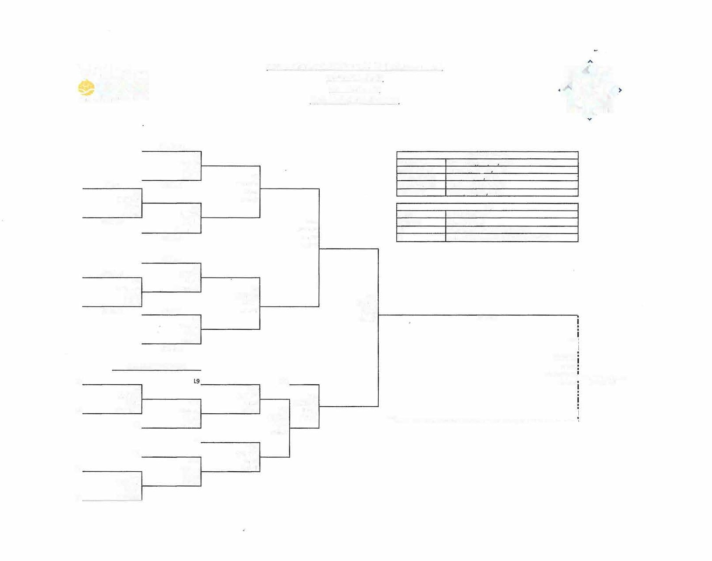L2

TOURNAMENT PITCHING REST REQUIREMENTS

l l

AGE | DAILY·MAX (PITCHES IN A DAY) | REST PERIOD
AGE | DAILY·MAX (PITCHES IN A DAY) | 0DAYS | 1 DAY | 2DAYS
7-8 | 50 | 1-20 | 21-35 | 36+
9-10 | 75 | 1-40 | 41-65 | 66+
11-12 | 85 | 1-40 | 41-65 | 66+
13-15 | 95 | 1-45 | 46-75 | 76+
16-18 | 105 | 1-45 | 46-75 | 76+


STADIUM VIDEO BOARD INSTRUCTIONS FOR COACHES

  - COACHES ARE TO PROVIDE WAIST-UP PHOTOS OF EVERY PLAYER NO LATER THAN JULY TH.

  - PHOTOS ARE TO BE TAKEN WITH A WHITE OR LIGHT COLORED BACKGROUND AND A CONTRASTING TEAM JERSEY.
  - WE WILL ADD A UNIQUE BACKGROUND OURSELVES.
  - SAVE EACH PICTURE WITH JERSEY# AND FIRST AND LAST NAME (EX: #12 JOE JOHNSON).
  - COACHES PICTURES CAN BE INCLUDED
  - PLEASE SEND A PDF OF YOUR TEAM LOGO ALSO FOR THE BOARD.

PLEASE NOTE: ALL OF THE HOME TEAM PLAYERS WILL BE ON THE BOARD AND WE WANT ALL OF YOUR PLAYERS TO HAVE THE SAME OPPORTUNITY. IF THEY ARE NOT-THE PARENTS HAVE A TENDENCY TO GET UPSET, AND I WANT TO BE CLEAR THAT IF ANY PARENTS COMPLAIN THAT THEIR PLAYERS ARE MISSING, WE WILL BE DIRECTING THEM RIGHT BACK TO THE COACHING STAFF FOR FAILING TO FOLLOW THROUGH WITH THESE INSTRUCTIONS!

WE LOOK FORWARD TO SEEING YOU ALL JULY st. AND YOUR ASSISTANCE WITH THESE INSTRUCTIONS WILL MAKE THIS AN EVEN GREATER EXPERIENCE FOR YOUR TEAM!!

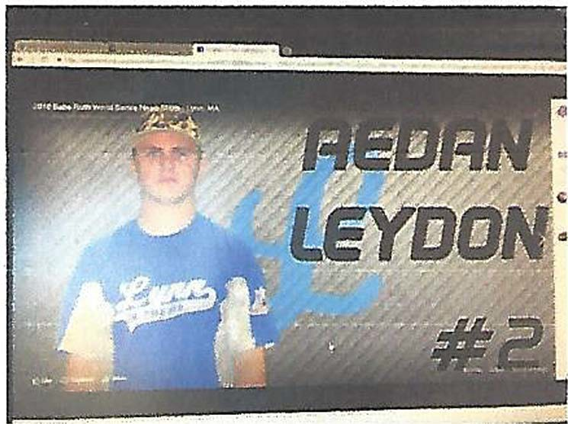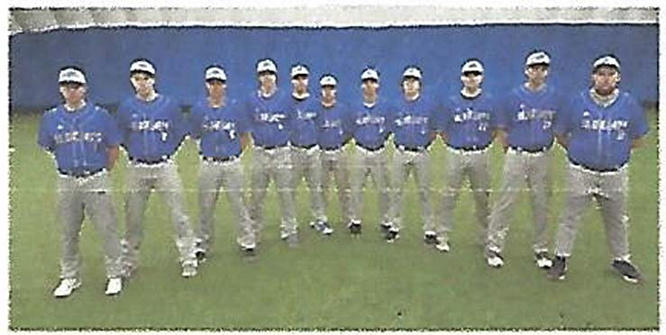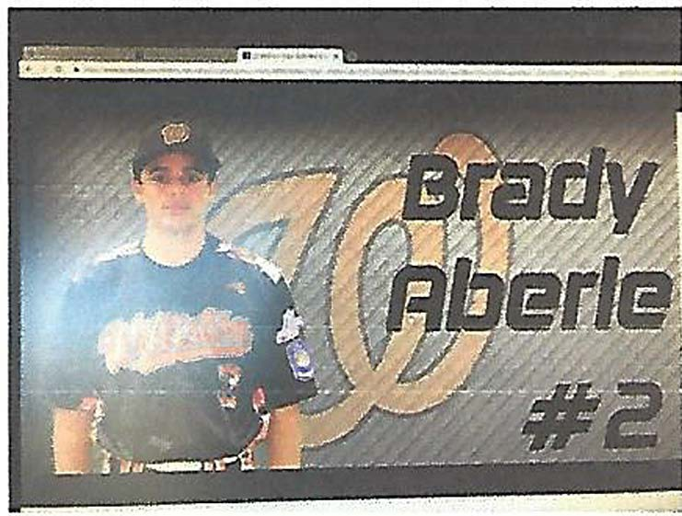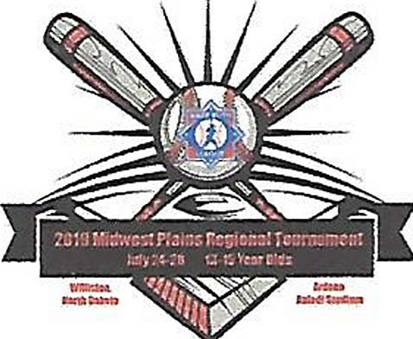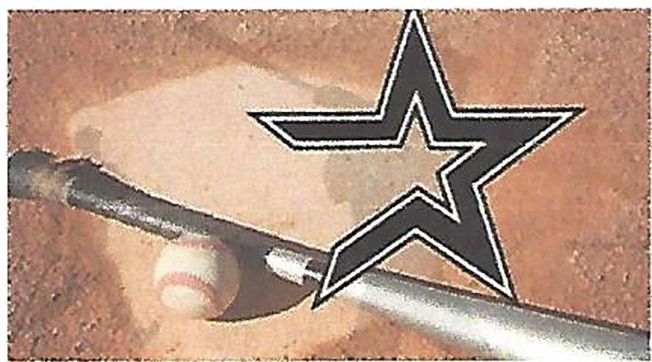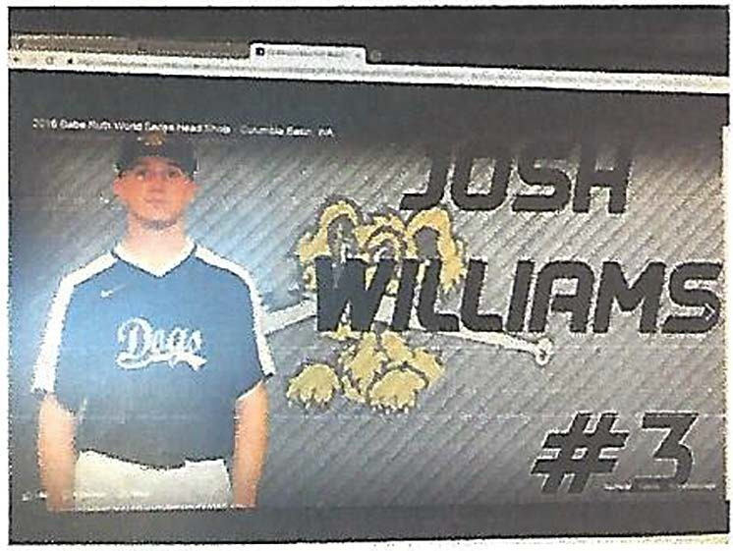Individual Photos for the Videoboard:
- Please send a headshot of each player from the waist up
- When you take your photo, it is best to take it in front of a solid, blank canvas so we are able to Photoshop it to make our signs. Ex. If your jersey is dark, a white background works best.
If your jersey is white, a dark background works best.
- Please save each photo individually as a JPEG with the players
full name and jersey number.

Please send your team's logo, team name, and team photo as well so we can help promote and cheer on your team!

All photos can be sent to @.COM If you have questions please don't hesitate to ask. We are excited to have you as guests!

Samples have been provided below:


COMMUNITY HOTEL PROPERTIES Convention & Visitors Bureau

ll

iNSERT YOUR HOTEL NAMES - PHONE NUMBERS- ADDRESS

For any other accommodation help contact ________________________ at the CVB directly at 701- _ .

DISTRICT COMMISSIONERS CHECK LIST FOR ALL TEAMS ELIGIBLE FOR POST SEASON PLAY

  - Letter of League Eligibility (signed by State Commissioner).
  - Tournament team roster (signed by League President).
  - Birth Documents (Babe Ruth ID cards suggested, but not required). A notarized copy of the original birth certificate will be accepted.
  - Local League Rosters (Tournament team players and coaches highlighted).
  - Local League Schedule.
  - Coaches Certification Information (ID card or certificate). Tournament Managers and Coaches must complete coaching education and certification prior to the start of the first level of tournament competition.
  - Certificate of Insurance Coverage (Accident and Liability).
  - Insurance Claim Form (Signed by League President).
  - Consent for Treatment Forms (The one-page form will be used and kept in the Team Credentials Book).
  - Any applicable waivers.
  - A team photograph with all players identified by name and number (must be completed electronically).

These documents must stay in the possession of the Tournament Director during each tournament level. These same documents shall accompany the team as they advance in tournament competition.

