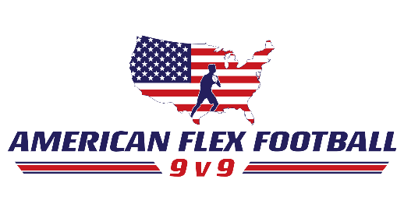
ROSTER AND PARTICIPATION AGREEMENT AND WAIVER FORM
In consideration for participation, each participant and his/her legal representative, WAIVE ALL CLAIMS for injury, accident or loss of any kind AND HEREBY RELEASE American Flex Football and all organizations, and their employees, members, agents, contractors, and representatives from any and all losses, claims, damages, and other liabilities arising from participation or attending such event. As further consideration to participation, each participant and his/her legal representative consent American Flex Football to take photographs and video of participants at event sites, and American Flex Football retains the right to use any such video or photos for publicity and advertising. This agreement and waiver shall apply and extend to any and all events held from 9/01/2018 through 8/31/2019
Team Name
Head Coach

Player | Parent/Guardian Signature
1
2
3
4
5
6
7
8
9
10
11
12
13
14

