Checklist for Required Information Needed
• Registration – Hard copy needed for Participant Cards
• Register online, pay in full by July 31 or have payment plan in place
• Physical Form – Dated a􀅌er January 1 of current year
• Original Birth Certificate – Needed for Certifying Participant
Certificate will be returned after Certification
• Player / Parent Responsibility Form
• Parent / Participant Volunteer & Fundraising Contract

BLITZ FOOTBALL / CHEER
2023 REGISTRATION FORM

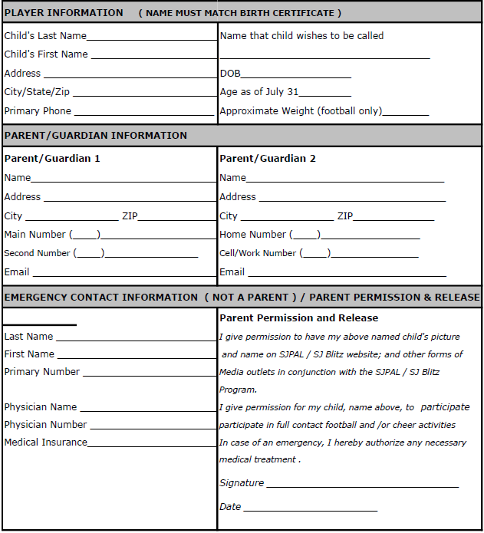



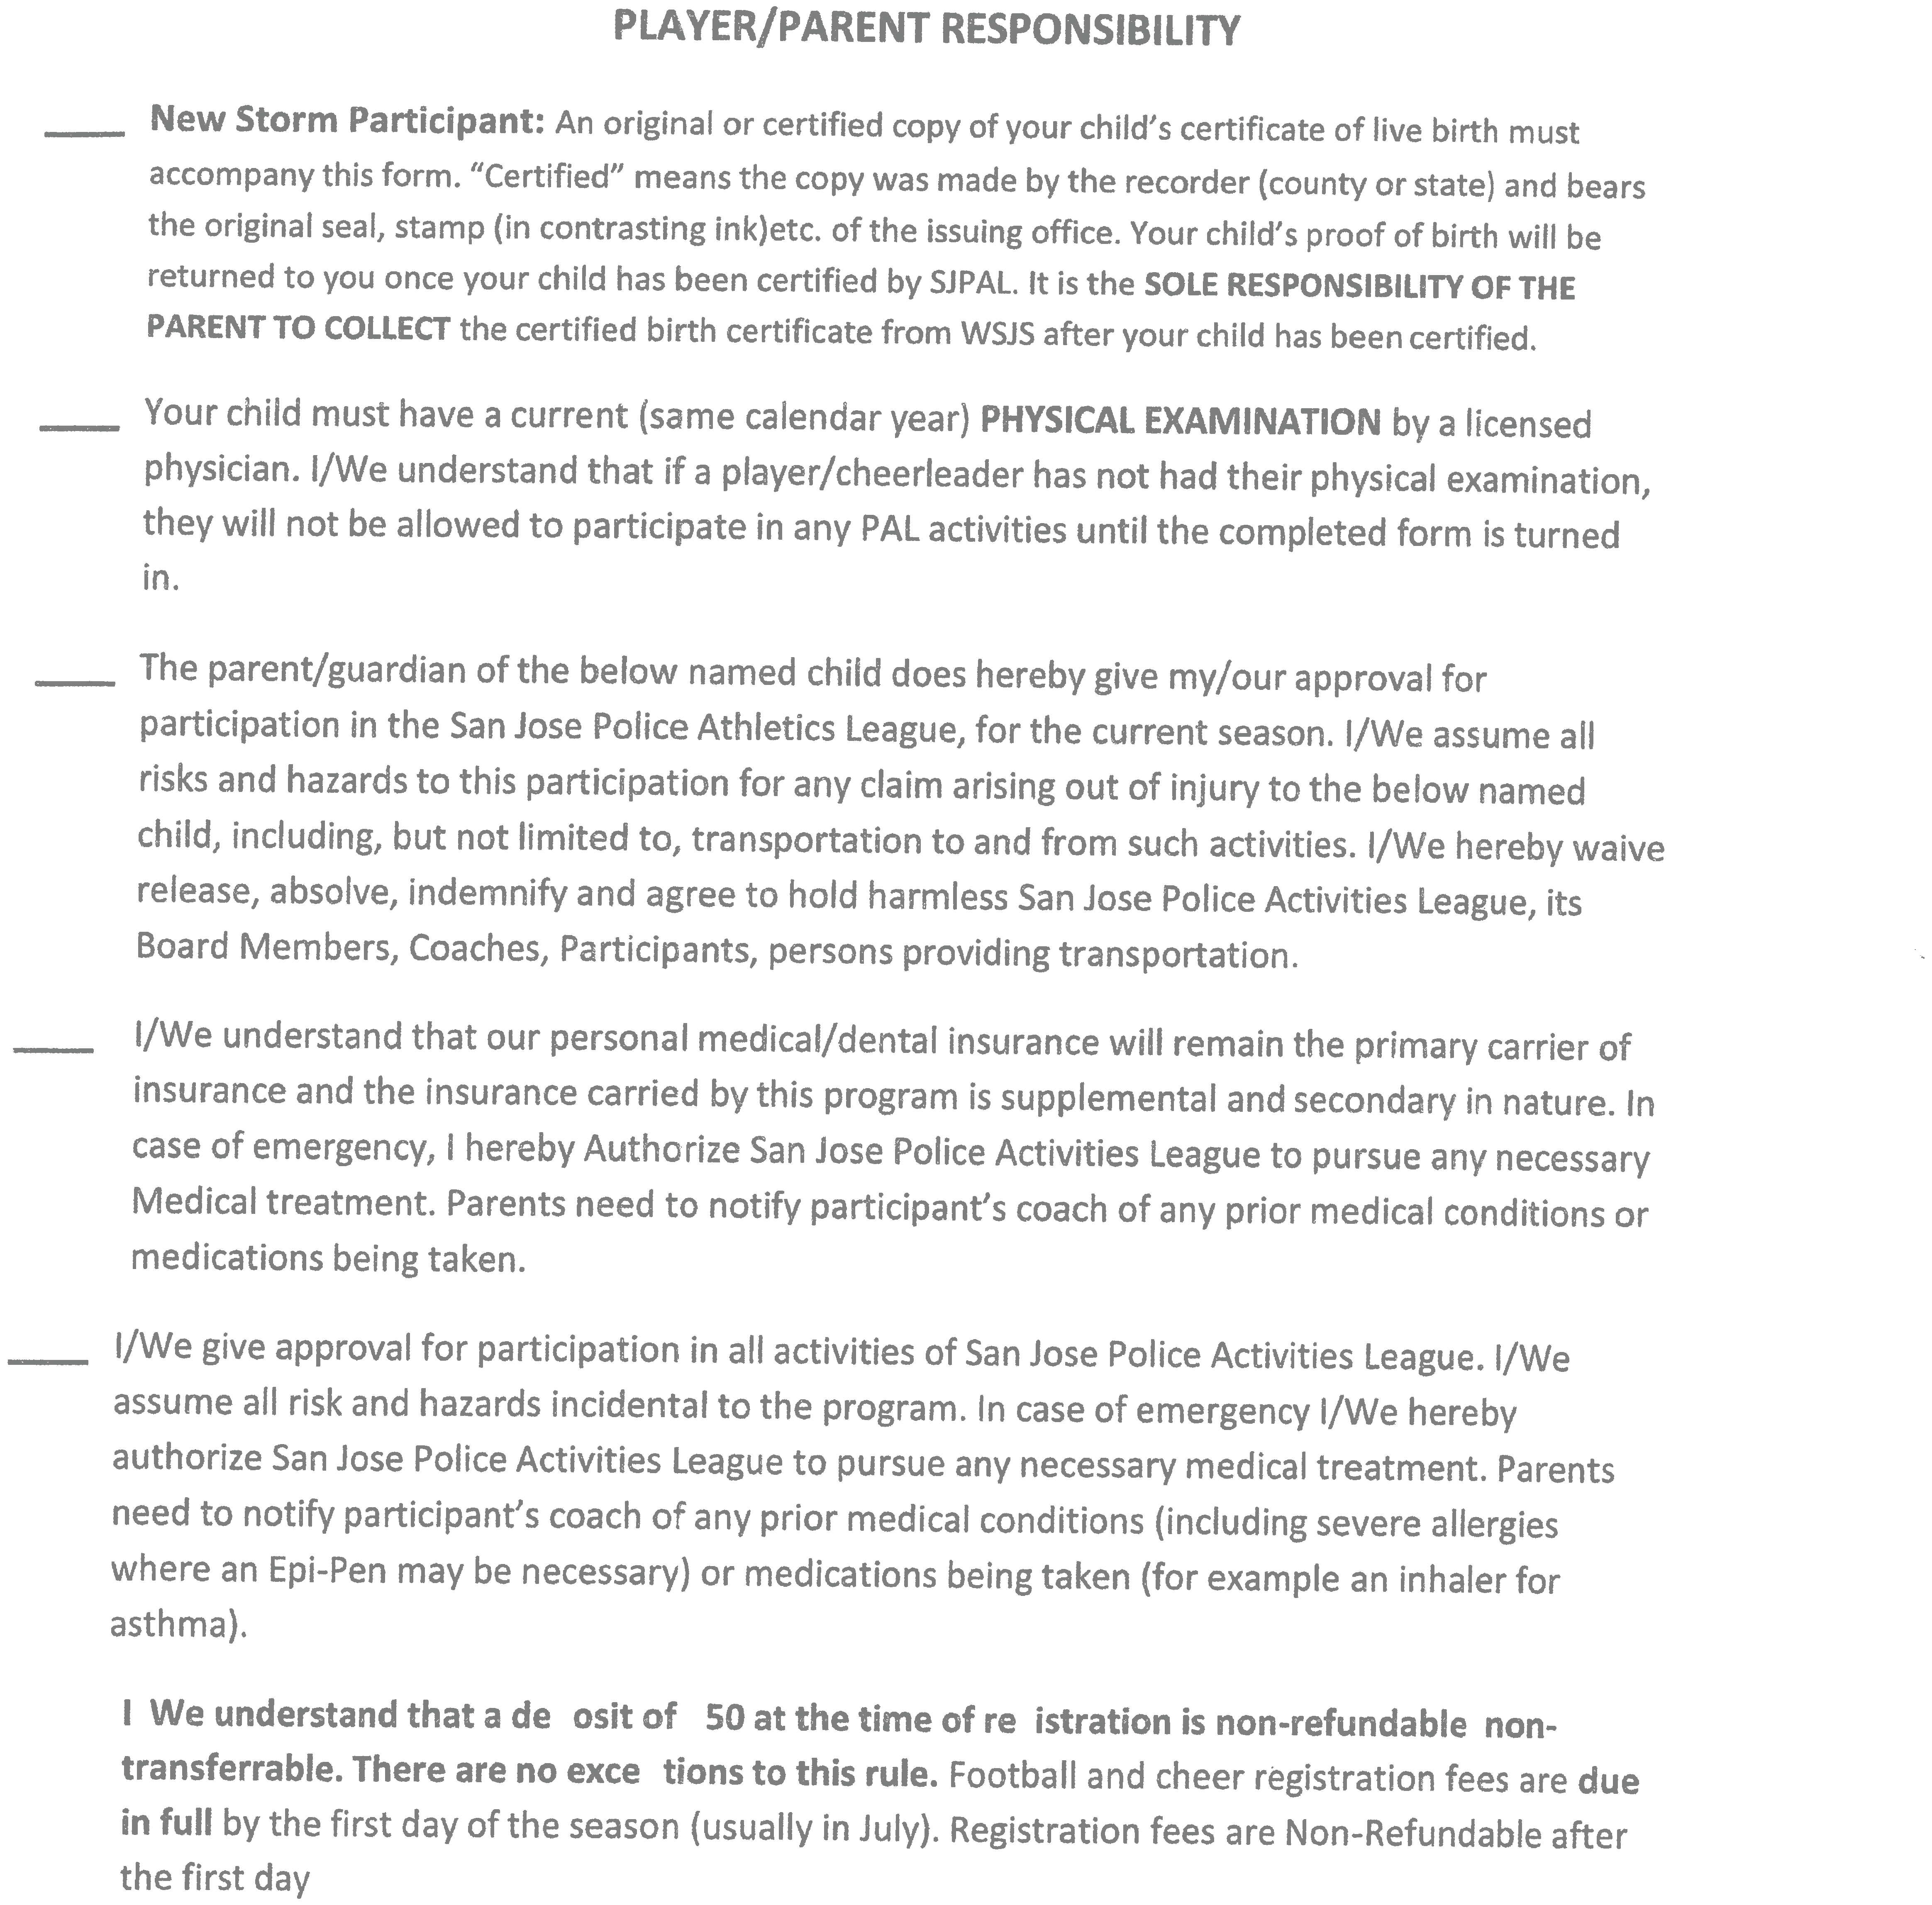





Blitz
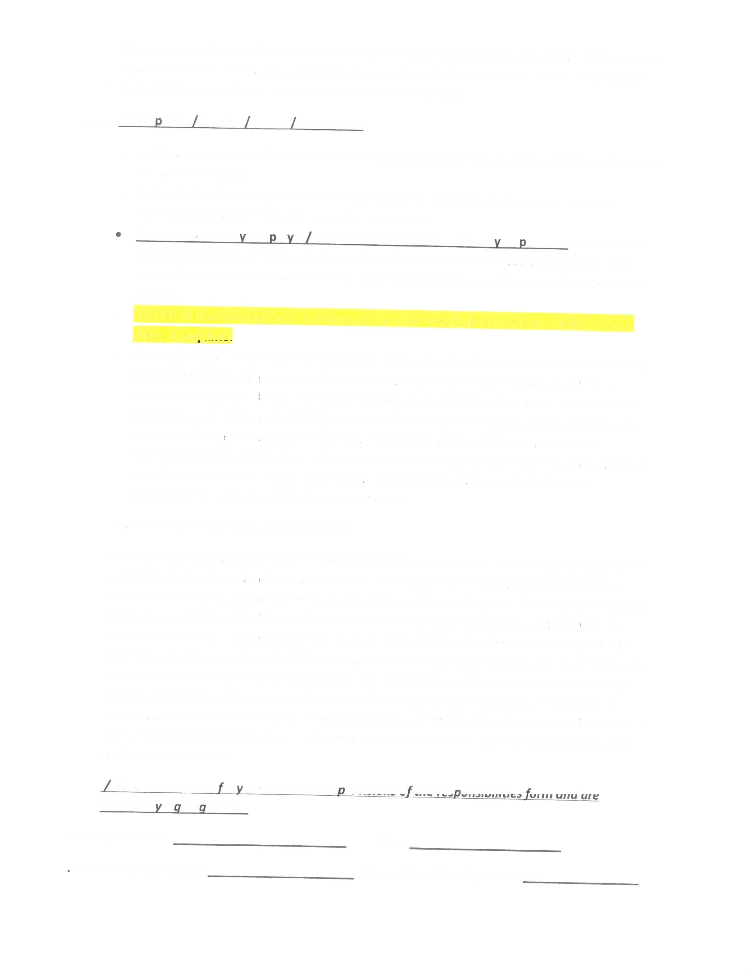



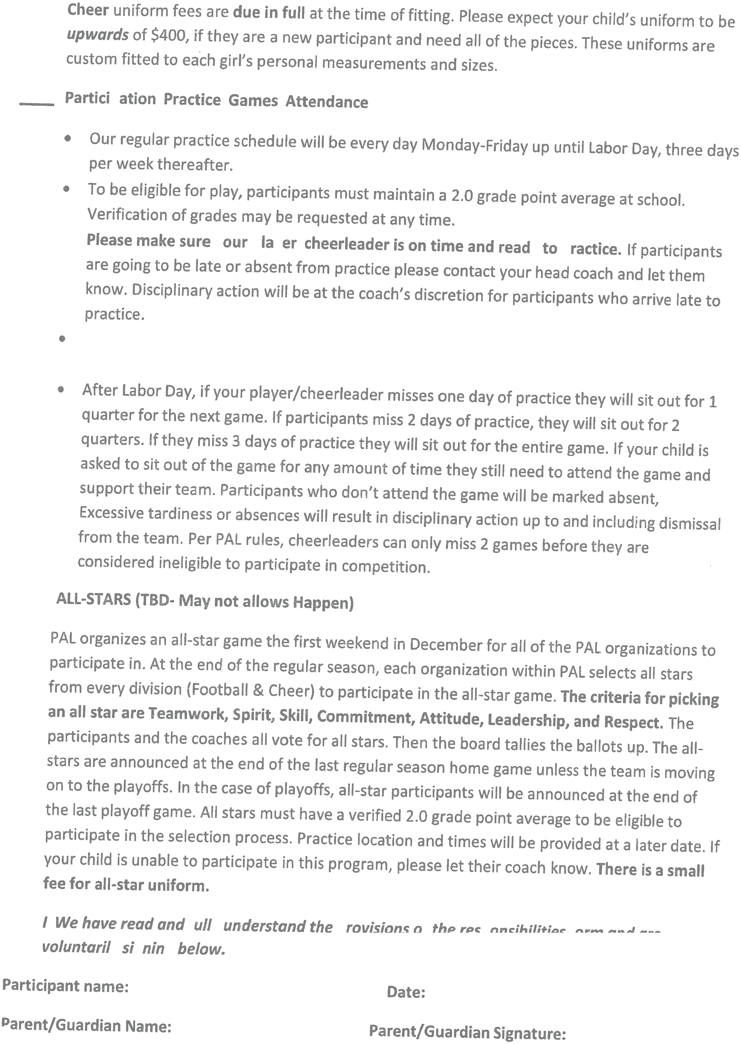




always happen)





