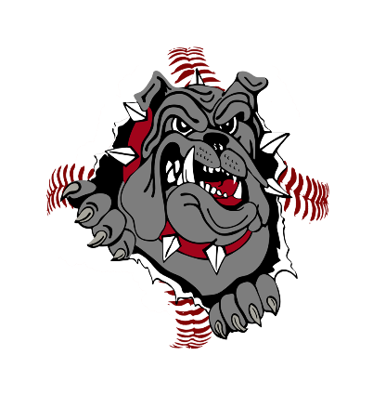
BANNER SPONSORSHIP PROGRAM
Dear Prospective Business Sponsor,
Brooklyn Park Baseball is gearing up for another exciting season, and we are seeking local businesses to partner with us through our Banner Sponsorship Program. Brooklyn Park Baseball is a highly regarded association that fosters a love of the game for players ages 4–18. We take pride in being one of the most affordable programs in the area—made possible by our concession stand and the generous support of sponsors like you who help offset our operational costs.
We have several major projects underway, including the installation of new batting cages at Northwoods (scheduled for 2026) and continued fundraising for field lighting. Each weekday evening from May through early July, Brooklyn Park Baseball hosts four games, creating excellent visibility for our sponsors. This year, we will also host six weekend tournaments with team participation ranging from 12 to 80 teams per event. Along with a fall ball season from August-October with games each weekend. We anticipate welcoming more than 2,700 players to our fields in 2026. Northwoods has also become a popular site for club tournaments—last year we hosted four such events.
Our goal is to continue growing, and with the support of local businesses, we can further enhance our facilities and programming. Sponsorship banners will be displayed on the outfield fences at Northwoods Baseball Field, offering outstanding exposure throughout our busy season.
The financial support of our sponsors is vital to our success. Your contribution directly benefits our players and community by helping us maintain and improve our fields, purchase essential equipment, and keep registration fees accessible for families. Brooklyn Park Baseball is a registered 501(c)(3) nonprofit organization, which means every dollar donated is tax-deductible.
We kindly ask you to consider becoming a sponsor of the Brooklyn Park Baseball program. Sponsorships run for one year (March 1–February 28), and your company banner will be proudly displayed from April through August.
To become a valued sponsor, please complete the attached enrollment form. We truly appreciate your time and consideration. Should you have any questions, please feel free to contact any of the individuals listed below.
Thank you for supporting youth baseball in Brooklyn Park!

Jeremy Crawford Tammy Hoff Isaac Sieling
Fundraising/Sponsorship Director President Vice President
612-382-8072 612-735-3834 612-240-9827

What is included with your sponsorship? | Single | Double | Triple | Home Run | Grand Slam
Name and Logo on Brooklyn Park Baseball website | X | X | X | X | X
Social media recognition | X | X | X | X | X
1-year banner at Northwoods Fields (new banner included) |  | X
2 year banner at Northwoods Fields (new banner included) |  |  | X | X | X
Sponsor a house team (company name on jerseys) |  |  |  | X
Naming rights to a midseason or end-of-season tournament |  |  |  |  | X
Sponsorship Costs: | $250 | $1,000 | $1,500 | $2,500 | $5,000

Please complete the company name and contact information below:
Company Name: _____________________________________________________________________________________
Address: _____________________________________________________________________________
Contact Name: ______________________________________ Contact number: ____________________
E-mail address: ________________________________________________________________________
Website URL: __________________________________________________________________________
Send graphics for banners to:
Please make checks payable to: Brooklyn Park Baseball Association
Send Payment to:
BPBA
PO Box 43206
Brooklyn Park, MN 55443

