
How to Download and Use SportsEngine
Stratford Youth Soccer is now using SportsEngine to help organize soccer games, practices and team communications. The app offers an easy tool for coaches to effectively communicate with their team and keep everyone up to date on changes occurring during the season.

- Download the SportsEngine app.

- Enter the email address and password you used to register on SportsEngine.

- This should bring up your Team. If it doesn’t you can search for your team by following the steps below:
  - Click on the + button in the bottom right hand corner.
  - Click ‘Team Search’ and type in SYS, this will bring up a list of all SYS Teams for 2022 – choose the Team you’d like to follow.
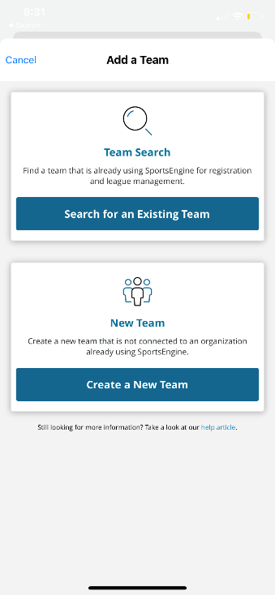
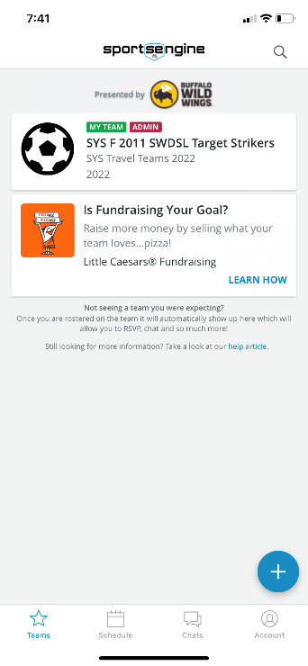
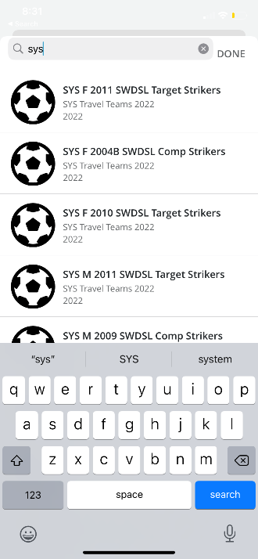

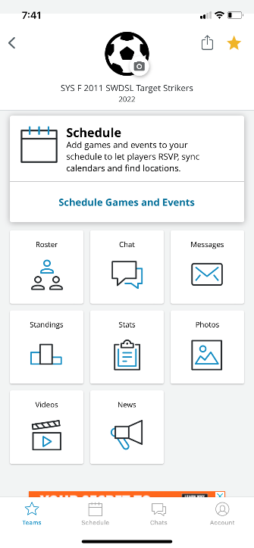
- From the Home Screen you can see the Team Roster which displays each player, their parent/guardian’s name and contact information, a Chat option, a Group Message, see Standings, Stats and share Photos and Videos.

- You can update your information by clicking the ‘Account’ button in the bottom right hand corner, here you can add/edit your contact information. You can update your child’s information under ‘Household Information’ by clicking on their name. If you want to add another parent/guardian as a contact, click the pencil in the bottom, right hand corner – here you can edit profile, add or remove Guardian etc.

- Your coaches will add the game and practice schedule in the app, here you can RSVP if your player is attending the event, see where the game/event is taking place and the time.

