LeagueApps Parent User Guide

Welcome to the LeagueApps Parent User Guide! We have switched registration platforms for a couple main reasons:
- Easy online registration and payment collection
- Credit card storage - easily save your card for future use
- Mobile friendly
We're sure there will be some hurdles as we all learn the new system, so we appreciate your understanding during the transition. Below are some helpful links with screenshots to help you get accustomed to the new platform.
Please do share any feedback and let us know if any questions/issues come up. We're committed to making the transition as smooth as possible.
How do you access LeagueApps Support? Visit support.leagueapps.com.
Table of Contents
1. How to register
2. How to login after registering
3. How to maneuver around your dashboard
- How to add additional members to your family account
- How to view your invoices
- How to update your credit card on file
- How to view your Schedule
- How to Sync your Schedule to your Personal Calendar
4. How to access additional LeagueApps Support

1. How to register
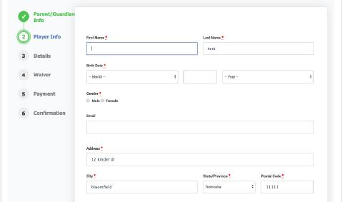
You will be prompted to create an account during your first registration process.
Step 1: Create a Parent Account or Login
A. To Create a Parent Account (One parent will register the family. You will be able to add additional family members after the initial set-up. See step 3A of this User Guide):
- Create a Username and Password
- Enter the following parent details: Parent First Name, Parent Last Name, Parent Email, Gender, and Residential Address.
- Click Create my account & go to next step
B. To Login every time you register in the future:
- Enter your Username and Password on the sidebar below Already have an account?
- Click Log In
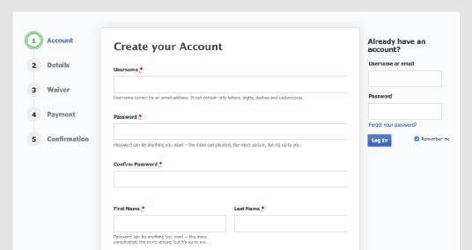
Step 2: Create a Child Account or Select Child
A. To Create a Child Account:
- Click Add a player now and enter the following child details: First Name, Last Name, Gender, Birth Date, Email*, and Address.
- Click Create
- Review the program selection under Select a Program and click Register Child Name
B. To Select a Child every time you register in the future:
- Click on the child’s name you’d like to register below Choose a player
- Review the program selection under Select a Program and click Register Child Name
*Child Emails may only be entered for players over the age of 13 due to COPPA compliance.

Step 3: Select Registration Role
A. Click on the Role you’d like to register as (ie. Player, Coach, etc.)

Step 4: Fill out Registration Terms & Waiver
- Select payment method under Registration Terms (if applicable)
- Enter all required registration questions under Player Information
- Check that you have read and agree to the waiver(s) (if applicable)
- Click Register for Program Name

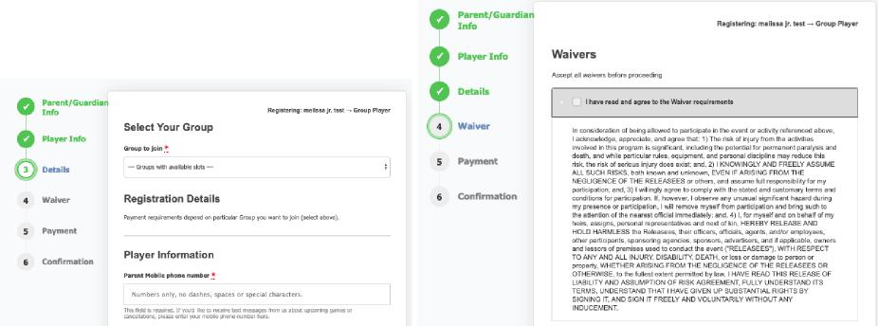
Step 5: Enter Payment Details
- If a deposit is allowed, click on the amount you want to pay (optional)
- Enter billing details
- Enter credit or debit card details
- Click Pay securely for your registration
- How to login after registering
Visit: https://360volleyball.leagueapps.com/login
- How to maneuver around your dashboard
To visit your dashboard, https://360volleyball.leagueapps.com/dashboard

- How to add additional members to your family account
To add additional members to your family account, (ie. additional parents, children,
grandparents, guardians, etc.) visit “My Family Account” on your sidebar or click here (https://360volleyball.leagueapps.com/groupAccountDashboard)
- How to view your invoices
To view your invoices, click here (https://360volleyball.leagueapps.com/invoices) or select “Invoices” on your dashboard sidebar.
- How to update your credit card on file
To update your credit card on file, click here
(https://360volleyball.leagueapps.com/addEditStoredPayments) or select “Payment Settings” on your dashboard sidebar.
- How to view your Schedule
To view your player’s schedule of games and events, click on “My Schedule” on your dashboard sidebar or click here (https://360volleyball.leagueapps.com/schedule)
- How to view your Sync your Schedule to your Personal Calendar
Visit the “My Schedule” on your dashboard sidebar or click here (https://360volleyball.leagueapps.com/schedule). Click the “Subscribe to Calendar” button. Choose the host of your personal calendar and click Add.
4. How to access additional LeagueApps Support
Visit support.leagueapps.com!

