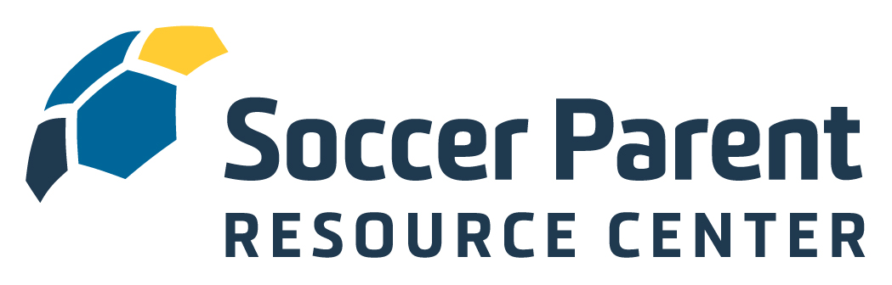

Welcome to the Soccer Parent Resource Center!

Dakota Alliance Soccer Club understands the importance of engaging and educating soccer parents and has therefore secured a club-wide membership to the SoccerParentResourceCenter.com, the parent education platform from the Soccer Parenting Association. You now have complete and free access to the interviews, articles, webinars, videos, courses and amazing community of level-headed parents at the SoccerParentResourceCenter.com.

To activate your free membership, simply click this link into your browser:
REGISTRATION LINK HERE

The mission of the Soccer Parenting Association is to inspire players by empowering parents.

- We believe youth soccer parents will be difference makers when it comes to improving the game.
- We believe when parents seek information about how to best support their player, great things will happen.
- We believe a collaborative environment between coach, parent, club, and player is in the best interest of player development.
- We believe a strong and supportive community of level-headed and like-minded parents and coaches will inspire players.

Like you, I am a soccer parent. I am also a former player, collegiate coach, and active youth soccer coach, speaker and coach educator. I am positive that the information you now have access to on the SoccerParentResourceCenter.com platform will help your child thrive and feel inspired on the field and in life.

I look forward to connecting with in the Community Forum. If you have any questions, suggestions, or ideas for articles, please don’t hesitate in reaching out.

Let’s Keep Going,

Skye Eddy
Founder, Soccer Parenting Association
Skye@SoccerParenting.com

