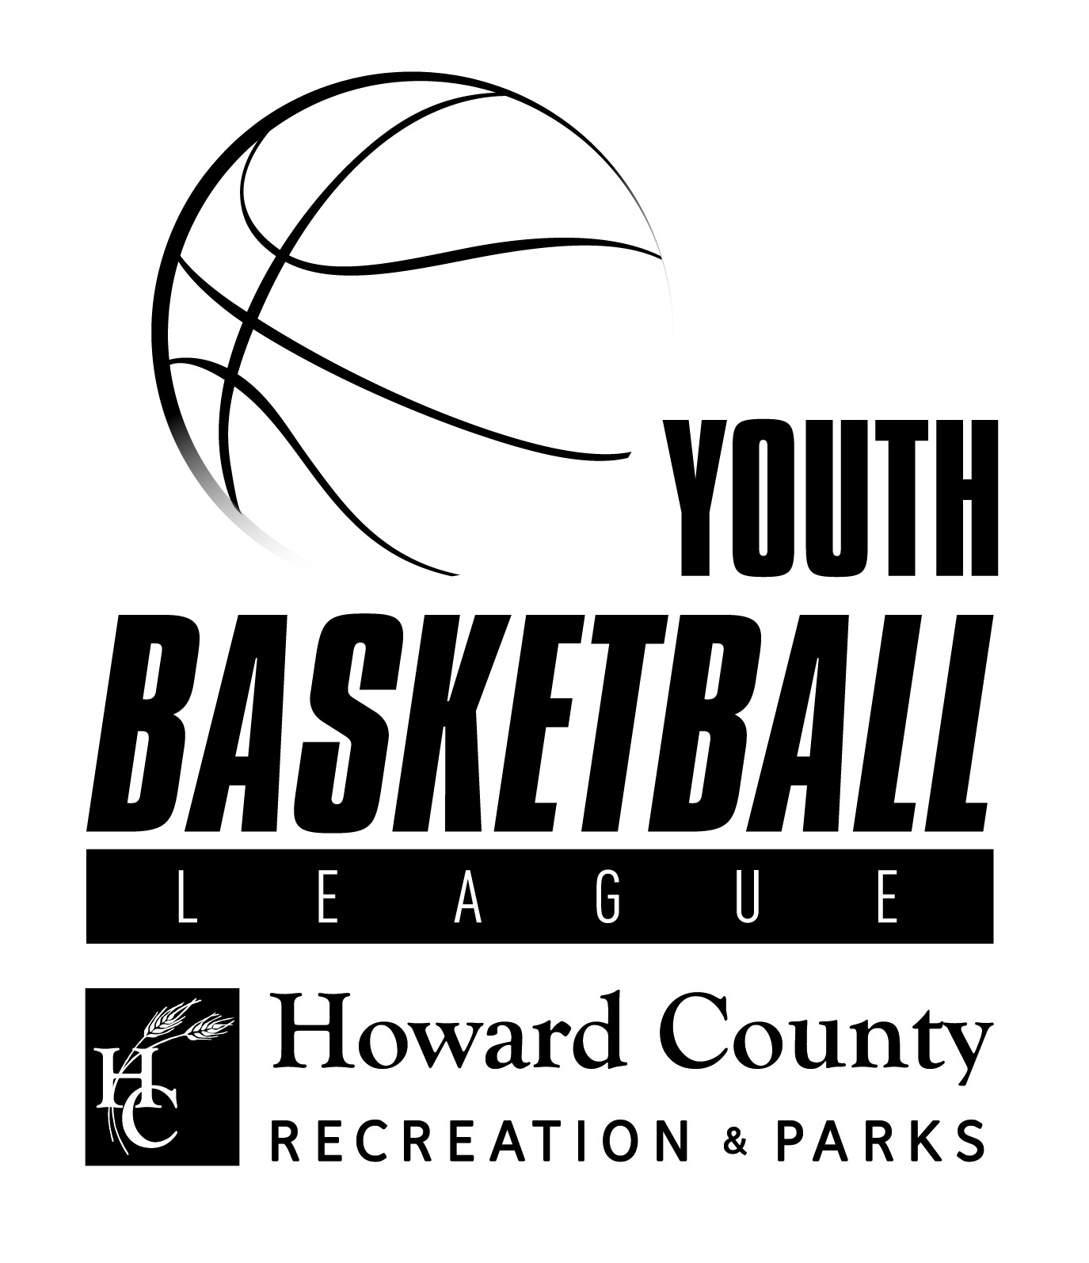

FREQUENTLY ASKED QUESTIONS (FAQs)

YBL Objective

The YBL provides a “GoodSports” environment for boys and girls to have fun playing basketball while learning the fundamentals of the game. The YBL focuses on skill development, sportsmanship, basketball knowledge, teamwork, and fun! The YBL is for novice to experienced players who wish to learn while playing in a recreational atmosphere. Every player is guaranteed to participate in each game.

Who may participate?
YBL is a recreation league that is open to all children 5-17 years with divisional separations as follows:

- 5-6 year olds – Co-ed
- 6-7 year olds – Co-ed
- 7-8 year olds – Co-ed
- 9-10 year olds – Boys
- 11-12 year olds – Boys
- 13-14 year olds – Boys
- 9-11 year olds – Girls
- 12-14 year olds - Girls
- High School Division - Grades 9th-12th – Girls & Boys
- Winter Alliance Division – Grades 6th – 8th - Girls & Boys
(For more information on the Alliance Division, see page 5)

Team selection differs between divisions. The 5-8 year old divisions do not hold a Skills Assessment. Players are placed on teams by the League Coordinator based on location and practice night availability. The 9-14 year old divisions and the High School division’s players will have a Skills Assessment prior to the start of the season. The Skills Assessment is used to place players on evenly skilled teams. For more information on the Skills Assessment, please see page 3.

Generally Asked Questions:

- What are the differences between the Instructional Basketball League (IBL) and the Youth Basketball League (YBL)?
The Instructional League meets once per week for 8 weeks and concentrates on building the fundamentals of basketball. The YBL meets twice a week for 8-10 weeks (depending on season and age group), which includes one practice and one game per week. The YBL focuses on skill development, as well as providing a more “game-like” situation.

- Would you recommend the IBL or the YBL for a ‘beginner’?
Beginning players are welcome in both Leagues. The IBL focuses more on skill development and general basketball instruction, such as basketball rules, where the YBL focuses on continuing to build fundamental skills and adds a limited competitive nature of the game.
- What is the difference between the YBL age divisions?
- The 5-6 division does not keep score and plays on micro-courts with the baskets lowered to 7ft with a 27.5” basketball. Coaches act as officials but violations are not called.
- The 6-7 division does not keep score and plays on micro-courts with the baskets lowered to 8ft with a 27.5” basketball. Coaches act as officials but violations are not called.
- The 7-8 division does not keep score and plays on micro-courts with the baskets lowered to 9ft with a 27.5” basketball. Coaches act as officials and the weekly progression plan below will be implemented.
Advanced 7 & 8 Progression Plan
Week 1 (through game 1): Intro, fundamentals, basic team principles.
Week 2: Offensive principles - Moving the ball, moving without the ball, picks, cuts.
Week 3: Defensive principles - Help defense, man-ball, positioning without reaching.
Week 4: Cover traveling in practice, stop play in the game for blatant travels.
Week 5: Cover double dribbles in practice, stop play in the game for blatant double dribbles.
Week 6: 1/2 court pressure allowed for the final 5 minutes of each half.
Week 7: Lining up for jump balls and free throws covered at practice. Game will start with a jump ball, we still will not shoot free throws. Just too time consuming for the game.

- The girls divisions (9-11 & 12-14) do keep score and play full court, officiated games on 10ft baskets with a 28.5” basketball.
- The 9-10 boys division does keep score and plays full court, officiated games on 10ft baskets with a 28.5” basketball.
- The 11-12 & 13-14 boys divisions do keep score and play full court, officiated games on 10ft baskets with a 29.5” basketball.
- All divisions have game rule modifications, which can be accessed through the YBL website.

- What is the average ability level of the YBL Players?
The majority of YBL Players have beginner to intermediate experience.
- Does the YBL accept Team Registration?
No. In an effort to keep the League fair and competitive, the YBL only accepts individual registrants. However, in the Winter Season, the Alliance Division does accept team registration. For more information on the Alliance Division, please see page 5.
- Do you accept special requests?

Due to the overwhelming number of special requests in past seasons, the Youth Basketball League does not accommodate special requests. During the registration process, please let registration staff know if your child is not able to practice on a specific night of the week. Balance of teams will be the first priority and to help the league accomplish this goal, every player MUST attend the mandatory skills assessment (ages 9+).

- Can my child play up an age division?

No. HCRP promotes allowing the child to grow physically and mentally and to allow time for that child to develop his/her fundamental skills in his/her age-appropriate group. Moving a child up before they are mentally ready is often overlooked. A child that is not mentally ready to manage the stress of playing up might actually lose his/her interest and leadership ability if he/she starts to struggle with self-confidence and frequent failure. The same goes for a child that has not mastered the fundamental skills learned in his/her age group.

- What kind of jersey is provided by the league?

The YBL will provide a reversible jersey top for each player. This will be distributed by your team’s head coach by your first game. For the 5-14 year old and High School divisions, each player gets to keep his/her jersey.

- What does my child need to bring to practice?

Your child will perform best in athletic wear: athletic shorts, a t-shirt, and flat soled athletic shoes. Please note: players do not need to wear their jerseys to practice, but are welcome to do so. Please bring an individual water/sports drink bottle for your child. Players can bring their own basketballs to practices if desired; however, the YBL will provide basketball for practices and games.

- What does my child need to bring to games?

Your child will need his/her jersey, athletic shorts, shoes, and a water bottle for each game; everything else will be provided.

- What is the Skills Assessment?

The Skills Assessment is for ages 9-14 and High School. The Skills Assessment is NOT a try-out. No player is ever ‘cut’ during the assessment. The Skills Assessment is considered the “First Practice of the Season” and is a key factor in keeping the league play balanced. The Skills Assessment is typically an hour and a half long per age division. The YBL Coaching Staff lead the players through fundamental skill work, drills, and scrimmages while assessing each player’s skill level. Details about the skills assessment will be emailed out prior to league start.

- Does my child have to attend the Skills Assessment?

The Skills Assessment is a crucial factor in placing each child on his/her team. It also provides additional time on the court for skill development and growth.

- Is the YBL for boys or girls or co-ed?

The 5-6, 6-7, and 7-8 divisions are co-ed. The 9-10, 11-12, and 13-14 divisions provide a co-ed and a girls option. The High School Division is split between boys and girls.

- What is the schedule/details for practice and games?

Division | Practice Days/Times | Game Days/Times | Possible Locations | Basket Height | Basketball Size
5-6  Co-ed | Monday – Friday  (5-8pm) | Saturdays  (8am-1pm) | HCRP Facilities & Various HCPSS | 7 ft. | 27.5”
6-7  Co-ed | Monday – Friday  (5-8pm) | Saturdays  (8am-1pm) | HCRP Facilities &  Various HCPSS | 8 ft. | 27.5”
7-8  Co-ed | Monday – Friday  (5-8pm) | Saturdays  (8am-1pm) | HCRP Facilities & Various HCPSS | 9 ft. | 27.5”
9-11 & 12-14  Girls | Monday – Thursday  (6-10pm)  M-F in Winter | Fridays  (6-10pm)  Saturdays in Winter (8am-5pm) | HCRP Facilities & Various HCPSS | 10 ft. | 28.5”
9-10  Boys | Monday – Thursday  (6-10pm)  M-F in Winter | Fridays  (6-10pm)  Saturdays in Winter (8am-5pm) | HCRP Facilities & Various HCPSS | 10 ft. | 28.5”
11-12  Boys | Monday – Thursday  (6-10pm)  M-F in Winter | Fridays  (6-10pm)  Saturdays in Winter (11am-6pm) | HCRP Facilities & Various HCPSS | 10 ft. | 29.5”/28.5”
13-14  Boys | Monday – Thursday  (6-10pm)  M-F in Winter | Fridays  (6-10pm)  Saturdays in Winter (12-6pm) | HCRP Facilities & Various HCPSS | 10 ft. | 29.5”/28.5”
High School  Girls  Boys | Practices not always included; Vary season to season | Saturdays for Fall, Winter, & Spring  Weekdays for Summer | HCRP Facilities & Various HCPSS | 10 ft. | 29.5”/28.5”
Alliance  (Boys & Girls Teams)  Winter Only | No practices provided | Fridays | HCRP Facilities | 10 ft. | 29.5”/28.5”

- Will all players receive playing time?

Yes. HCRP believes every child should receive quality time on the court during practices and games. This time is crucial to each child’s fundamental development and socialization. The YBL game rules state that each child suited up for the game must play 8-10 minutes per half.

- What is the Winter Alliance Division?

The Alliance Division only runs during the Winter Season (December – early March). This division is for organizational teams or school teams at the intermediate to experienced level to compete against other teams in the Greater Howard County area.

- What level of play is the Winter Alliance Division?

Overall, the Alliance Division is a higher level of play than recreation.

- Who can play in the Alliance Division?

Community Sports Organizations, Independent Clubs (meets the multiple teams stipulation), and HCDRP Sport Advisory Boards. All teams have to submit a team application to be eligible for consideration by the Competition Committee. HCRP will be accepting applications starting in September. Please contact Ray Hall at arhall@howardcountymd.gov for an application.

- Is the Winter Alliance Division for boys or girls?

Yes. The Alliance Division will have divisions for both boys’ teams and girls’ teams for grades 6th through 8th grade.

What are some important policies we should be aware of?

- A player is not considered registered until the registration fee has been paid in full.
- Players cannot attend the Skills Assessment unless registered for the league.
- Special requests are not accepted. This includes requests for specific coaches, teammates, times, and locations.
- The YBL follows the National Federation of High School Basketball Rule Book.

The NFHS prohibits wearing jewelry during games/practices. Rule 3.5, Article 8 “. . . Jewelry is prohibited. Religious and medical–alert medals are not considered jewelry. A religious medal must be taped and worn under the uniform. A medical-alert medal must be taped and may be visible.”

The NFHS prohibits wearing of hard items in the hair during games/practices. Rule 3, Section 5, Article 4d “…Rubber, cloth or elastic bands may be used to control hair. HARD items, including, but not limited to, BEADS, barrettes and bobby pins, are prohibited.”

Both rules are in place for the safety of all our YBL Players and to alleviate any potential harm that could happen during physical activity. This is to be followed during practices and games.
The Game Officials will make the final decision on this rule, or any rule during play of a Game

- Gum chewing is discouraged during practice/game for safety reasons.
- Teams are required to pick up trash and belongings around their benches after each practice/game.

Some other important facts parents should know include:
- Spectators must view the game from the designated bleacher areas. Spectators are prohibited from the playing court, team bench areas, and sidelines.
- Spectators are prohibited from tobacco and alcohol use.
- Spectators are prohibited from using vulgar, lewd, or obscene language or gestures towards officials, coaches, players or other spectators.
- Spectators are encouraged to promote good sportsmanship and positive support for all YBL players and coaches.
- Spectators are to follow the Code of Conduct located on the YBL Website.

Inclement Weather:
HCRP Inclement Weather Policy – HCRP will strive to ensure safe and accessible HCRP Facilities throughout the Winter Season. All HCRP Facilities and Programs will be cancelled/closed if the Maryland State Police Snow Emergency Plan is in effect and will remain closed until it has been lifted. In the event of inclement weather, please call the facility information line for details about the program.
Meadowbrook Athletic Complex (MAC) – 410-313-4452 (option 2)
Roger Carter Community Center (RCCC) – 410-313-4452 (option 3)
North Laurel Community Center (NLCC) – 410-313-4452 (option 5)
Gary J. Arthur Community Center (GJACC) – 410-313-4452 (option 1)
Howard County Public Schools (HCPSS) – 410-313-6827
For HCRP Facilities, if you hear the standard greeting, the program will run as scheduled. For HCPSS, if after-school and evening programs are cancelled, there is no practice.
Concussion Protocol:

Please see YBL website for more information and forms: Youth Basketball (hcrpsports.org).

How can we help?

The YBL encourages volunteers and is always in need of head coaches and assistant coaches each season.

How do I become a coach and what are the coaching requirements?
All YBL Coaches must complete the HCRP Coaches Registry Requirements, which include:
- Complete the Volunteer Site Application (www.HoCoVolunteeer.org)
- Attach the following to your Volunteer Profile:
  - Head shot from the shoulders up. This photo is placed on your Coaches Registry badge that is required to be worn while coaching.
  - Certificate from the Coaching Essentials course at www.ASEP.com. Volunteers can request a code to take the course directly from the Volunteer website free of charge.
  - Certificate from the “Concussion in Sports” course at www.NFHSLearn.com.
  - Work permit if the applicant is under the age of 18.
  - All applicants over the age of 18 must undergo a Background Check (staff will undergo CJIS fingerprinting upon hiring and have a background review in subsequent years). In order to complete the background check, applicants will receive an email directly from SSCI National Background after completing their Volunteer Application and attaching an ASEP certificate to their profile. The background checks are completed on-line on a secured site.
  - Returning volunteers will need to request an update to their registry status, including a background review, on an annual basis if they plan to continue coaching with our programs.
  - Information on the Coaches Registry can be found online at Howard County GoodSport Coaches and Administrators Registry (hcrpsports.org) .

Does the YBL provide financial assistance for players/families?

Yes. For more information about financial aid and scholarship opportunities please contact Howard County Recreation & Parks by visiting http://www.howardcountymd.gov/RecandParksForms.htm or by calling 410-313-4659.

HCRP Refund Policy

League Refund Policy: a 20% administrative fee is deducted for all refund requests more than four (4) weeks prior to league starting; a 50% refund if withdrawal requested more than two (2) weeks prior to league starting; no refunds are given less than two (2) weeks prior to the start of the league.

Who should I contact for more information?

For more information for the 5-8 year old divisions, please contact Kelly Jones at 410-313-1162 or kejones@howardcountymd.gov.

For more information for the Winter Alliance Division, please contact Ray Hall at 410-313-1689 or arhall@howardcountymd.gov.

For more information for the 9-14 year old divisions or the High School divisions, please contact Matt Knoerlein at 410-313-1163 or mknoerlein@howardcountymd.gov.

Thank you for your support of the Youth Basketball League and its players. We hope that you and your family have a fun, safe, and positive experience this season!

Sincerely,

Howard County Recreation & Parks & the YBL!
Updated 2/11/2021

