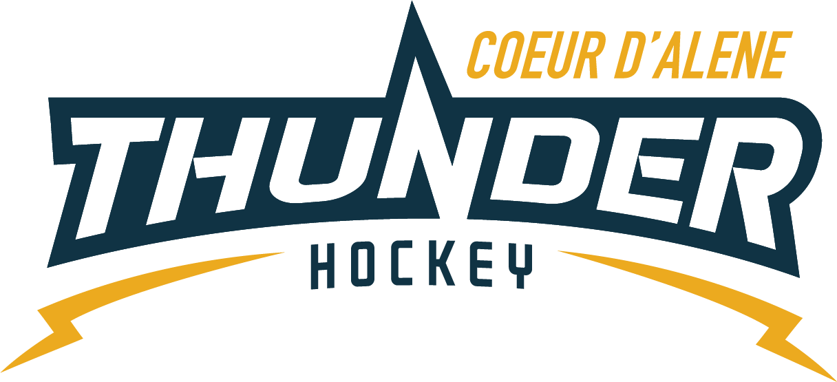

CDAHA

Meeting minutes
Location: Frontier Date: February 23 2022
Attendees: Bob Nelson, Katie Lovitt, Megan Smith, Elliot Taub, Matt Creighton, Will Higgins, Josh Leppert, Bart Barrett,

Absent -, ,Matt Fisher
Guest –, , Lexie Laracco, Mary Borjessan, Chad Borjessan, Matt Cheney, Casy Solovan, Nick Baslimo, Kami Winfrey
- Call to order
Matt Creighton , Vice President called meeting to order 2/23/22 6:32PM
- Roll call
As stated above -
- Approval of minutes from last meeting
Minutes approved motioned by – Bob Nelson second by Megan Smith passes unanimous
- New Items
- Treasurers Update
  - See attachments
  - Estimated to finish at current run rate of 76k
  - Spent a lot of money back into the association –pucks, ice, dryland and more
  - Still have coaches budget outstanding for hockey items only
  - Robby Glantz clinic for registered CDAHA coach included
  - Proposed cut travel goalie registration cost by 40%
  - Motion by BOB second by Will for goalies on teams starting for the 2022-2023 receive a 40% discount and must be full time goalie on a rostered full time REP team – PEE WEE, BANTAM, MIDGET,GIRLS-
Wil, Katie, Bob, Megan, Josh, in favor
Bart, Elliot Abstain
Motion Passes
  - Old timers would like to donate 300.00 – Will will work with donor directly

Coaching Committee Update
      - no update yet – from Joe
      - Josh is working on survey monkey waiting on Joe for information
      - Coaches meeting before end of season – get survey monkey out before end of season
- Gear Committee Update
  - Contact April on dates
  - Mites last day of practice would be March 9th or the 23rd Squirts 2 weeks later – when do we cash checks if gear is not collected – recommended to cash checks if gear is not brought back
  - Add Leased jersey and practice jersey collection into blast and Bob will take it
  - Mites have games in mid / late march so they might have some gear come back on the 23rd
  - Everything comes back for inventory before summer check out
  - Need to find a new gear committee person
  - Would like more gear – and we will probably take over the old Hockey Armor shop and have all gear and check out gear from there. If that does not work we can put a connex box on property.
- Discipline Committee Update
  - Incident in the Pee Wee locker room
  - No safe sport locker room monitors and recognized the gap and risk. MUST have a sign up and be ready and prepared for the demands of the season to protect our youth and association.
  - Figure out as a BOD and association volunteer requirements – should all members go through safe sport training as a requirement
  - Use it as a learning opportunity to make our association better – safe sport and background check might be reimbursement – or credit towards
  - Ultimately the coaches and BOD is responsible –
  - Table the plan for the next meeting
- Safe Sport Update
  - Covered above
- Scheduler update
  - Everything scheduled and done
  - Kami is staying on as scheduler and working with Matt to maintain ICE and plan for CDAHA
  - Need new ref scheduler
  - Thank you Kami!!!
- Elections
  - Motion by Bart in order to balance elections and get 3 3 3 cycle one of the positions of the board needed to make the balance – Bob seconds – All in favor passes
  - Now we need to decide what and whom extends – to be decided by the open 4 emailing Matt if they are interested
  - April to blast the 3 open seats terms and the process to submit applications to president and secretary at least 3 weeks before election date
  - Elections shall commence 4/1/2202 per the ByLaws
- Spring and Summer Plans
  - 3 v 3 pond hockey season (40) looking to start in May – June and then back in Aug and September – Jermey, Joe and Matt, Will can run it and send it out for volunteers
  - Girls and INGHF will offer development and try hockey for free once per month
  - Would like to grow to 450 from 315 which is up from 260

- State – noting to update good luck to Midgets and Bantam
- Graduating Midgets
  - Joey, Liz, Zoe, -
    - Motion by Megan for custom gifts for a maximum $100.00 for each kid estimate at 3 kids Bob seconded
Matt will send Megan names and numbers
All approved
Elliot Abstained
Passed
- Retiring BOD members
  - Thank you to Bart – Megan – Bob Elliot -
- Any other business
  - Feedback from mite parents about concerns on which tournaments they are in and how competitive they are
  - Discussed helping coaches and parents select and understand the growth and ADM model, goals of USA hockey, parents and association around the options for parents
  - Help support and answer questions regarding the program , future and how things work in general
  - Need more communication for clarification especially new members

  - Minutes submitted by: Elliot Taub
Minutes approved by: BOD
- Next Meeting
  - Tues March 8th 15 2022 6:30PM
  - Bart motions to adjourn – Bob seconded

