RAIDER BASEBALL
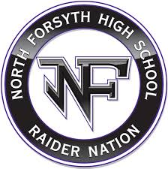
SPONSONSORSHIP FORM

NAME: _______________________________________
□ Black Sponsor - $3,000.00
3’X5’ Sign on Right Field Billboard
Game Day Recognition, ALL HOME
GAMES
½ Page Program Ad
Website Ad: www.northforsythbaseball.com

COMPANY: ____________________________________

ADDRESS: _____________________________________

CITY, ST, ZIP: ___________________________________
□ Purple Sponsor - $1,500.00
3’X5’ Sign on Right Field Billboard
Game Day Recognition, ALL HOME
GAMES
¼ Page Program Ad

PHONE: __________, EMAIL: ______________________

SPONSORSHIP SOLD BY: __________________________

RIGHT FIELD BILLBOARD CONCESSION STAND SIGN
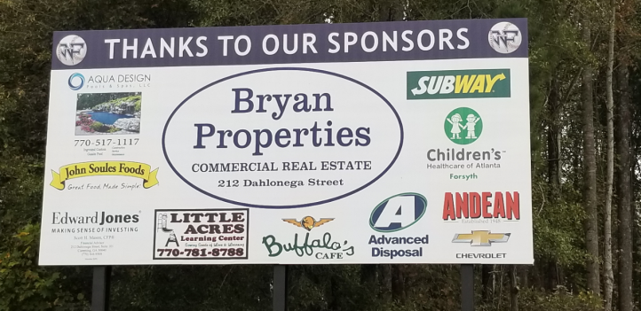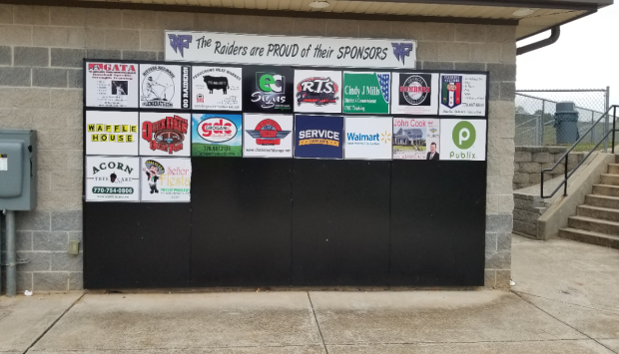
□ Billboard Sponsor - $750.00
3’X5’ Sign on Right Field Billboard
Game Day Recognition, ALL HOME
GAMES

Checks made Payable to: North Forsyth Dugout Club, Inc
3635 Coal Mountain Drive
□ Concession Sponsor - $300.00
18”X24” Sign on Concession Stand

Cumming, GA 30028

Any Questions Contact: Kiwp Blackburn, kiwp_14@bellsouth.net

