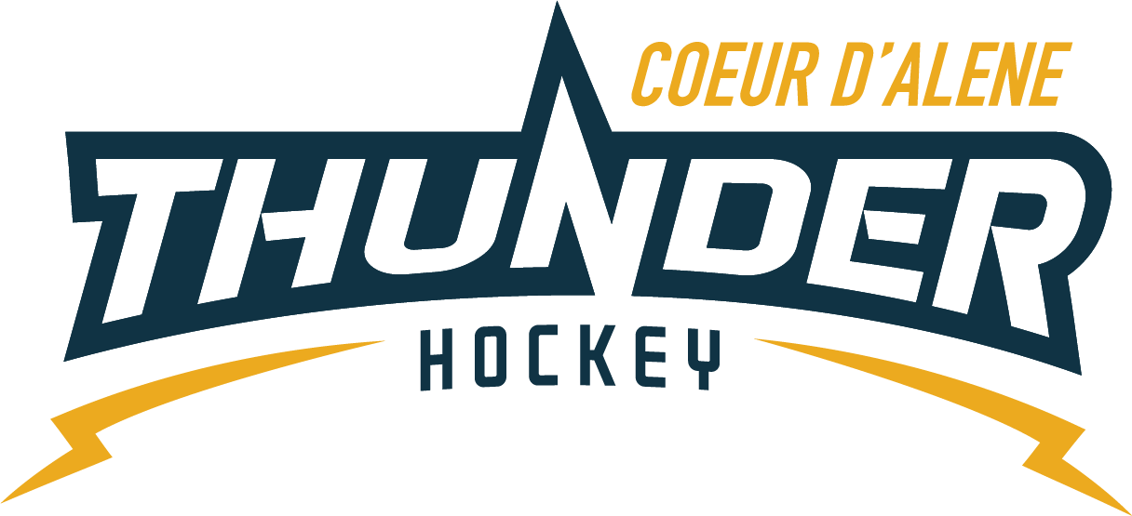

Meeting minutes

Location: Frontier
Date: January 03, 2023
Attendees: Matt Creighton, Meghan Smith, Katie Lovitt, Matt Fisher, Elliot Taub Jackie Peterson, ,April Hocking, Josh Leppert, Joe White
Absent: Will Higgins, Matt Peltz
Guest: Meyer

- Call to order
Matt Creighton, President called meeting to order at – 6: 12PM
- Roll call
As stated above
- Approval of minutes from last meeting
Motion to approve minutes – Matt Fisher
Second by - Megan
Passes unanimous
- Treasurers Update
    - Shooter tutors –
Concerned about shooter tutors – will fix the one and we will purchase the other one
- Will purchase 3 tarp
- Purchase 3 combo water filler and bottle filler with engraving that say donated by CDAHA Youth Hockey 1000 each
- Matt Creighton will ensure they are coordinated
  - Matt Fisher moves to spend at least $3500 for water bottle fillers with engraving “go Thunder” – Second by Megan all in favor
- Skating coach – paying through – CDAHA - Jackie will reach out for ensuring Heather is getting comped
- Graduating senior gifts this year – approximately 15 youth could be a senior night or skate or gifts senior list game night
Or coaches Friday –
2. Looking for scoreboards same as EWU and then look to purchase 2
- Committee Updates
  - Coaching Committee update (5) –Joe – NA
  - Gear Committee update (5) – Sean Meyer – NA
    - 5 LTP leaving and 5 coming in extra small sizes
    - Fixed skate sharpener
  - Discipline committee update (5) – Meghan
    - 5 referee reports for misconducts – all disciplinary hearings for players seems to be at the midget level letters to be sent out and give notice
  - Safe sport Committee update (5) – Matt P
    - No new updates volunteer doing good
    - Ask about USA signs and then other signage like in other rinks
  - Scheduler update (5) – Jackie
- Working on getting refs for mite tourney Matt Fisher

- New Business
- Moscow rink is small same size as before
- Coaches meeting no meeting in Dec so getting one scheduled for January is tough cant get coaches to show up when they are not having a practice night
- Maybe incentivize the coaches to show up with reimbursement -from the beginning of the season with a little more structured season maybe we can hosted the CEP class
- Maybe an in-house CEP training show that they are important incentivize after 3 meetings you qualify for $$$$$
- Head coaches must attend to get the benefit. Could their kid get on the ice while they are there coach training with stick and puck?
- ANNUAL MEETING
- Reset meeting with coaches Tuesday Night 1/24 @ 0630. CDAHA will pay for public skate during mtg for coaches kids
- Culture and Respect- witching hour… 4 suspensions this weekend. IAHA President call to Matt saying we are embarrassing HS hockey in Idaho. Teach people to be good people first, hockey second.
- Banners- Per Dan… trophy case coming down, can put up in our section of the wall. Make 8.5 x 11 recreations to hang in the area?
- Check in survey- Josh will put together, April to send out.
- Business.
No updates on old business
- Any other Business
Next Meeting Date: Next meeting Tentatively scheduled for 1/17/23 at 6pm at the rink

- Meeting Adjourned
Josh Motioned to adjourn at 800, second by Matt – all approved

