
SOCCER SUMMER CAMP CURRICULUM
MONDAY
9:00-9:15am – Introduction
- Welcome
- Coach Introductions
- Goals of camp: Improve mechanics, develop soccer IQ and boost confidence
- Talk to them about camp raffles at the end of the week and how to win a raffle ticket
- Rules – Rule 1 – “Have Fun” | Rule 2 “Mistakes are Great”
- Eyes, Ears, Marshmallows
- “Good Day|Great Day”

9:15-9:30am – Stretching (Static then Dynamic)
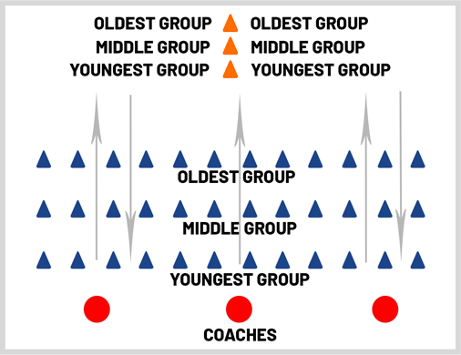

- Static – neck rolls, arm rolls, tricep extension, arm across chest stretch, hip rolls, hamstring stretch, touch toes
- Dynamic (moving) – butt kickers, high knees, karaoke, love shuffle, Frankenstein’s, open gates, sprints
  - Make sure to make it fun by having groups compete in counting – who is loudest? Have kids do “loudest whisper” “quietest scream” “count in different languages” “count in accents” and more

9:30-9:33am – WATER

9:33-9:50am – Ladder
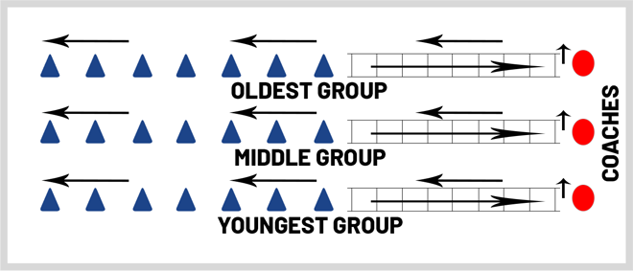

- Ladder exercises include: kangaroo hops, two feet in each square (individually), skier, flamingos, hopscotch (out/in), side shuffle both directions and Icky Shuffle
- Game – Ladder of Doom!
  - Round 1 – Each player has six seconds to get through ladder without touching it or they are eliminated (kangaroo hops)
  - Round 2 – Each player has five seconds to get through ladders without touching it or they are eliminated (skier)
  - Roud 3 – Each player has four seconds to get through ladder without touching it or they are eliminated (two feet in each square)
  - Etc.

9:50-9:53am – WATER

9:53-10:15am – Shipwrecked (https://www.youtube.com/watch?v=evDMydE8eAM)

10:15-10:25am – SNACK BREAK

10:25-11:10am – Fundamentals (three 15-minute stations)
- Dribbling
  - Dribbling Fundamentals
      - Knees bent, light on feet, eyes up, use inside and outside of foot
    - Toe Taps (https://www.youtube.com/watch?v=ndMkjRROeMk)
        - 3 sets x 20
    - Bells (https://www.youtube.com/watch?v=wEHDDBwENJA)
        - 3 sets x 20
    - Inside/Outside Touches (https://www.soccerdrive.com/soccer-drills/dribbling-skills-series - :11 second marker)
- Passing
    - Passing Fundamentals
      - Step into ball (non-kicking foot next to the ball), foot sideways (hockey stick shape), eyes up, drive through the ball
      - https://www.youtube.com/watch?v=fCanpKMKwUI
    - Partner Passing – 2-Touch (https://www.soccerdrive.com/soccer-drills/first-touch-skills-series)
    - Partner Passing – 1-Touch
    - W passing
      - https://www.youtube.com/watch?v=3KPh8U416kE&ab_channel=KSPerformance (feel free to stick with the first variation.)
- Shooting
    - Shooting Fundamentals
      - Step into ball, lock ankle with toe down, strike ball with laces (big bone part of your foot)
      - https://www.youtube.com/watch?v=ECospNT9yCM
    - Dribble into a shot
      - Set up three lines. Kids will dribble up to a designated spot and shoot with their laces into the goal. Focus on them using the correct part of their foot. Have them use both feet.
    - Competition
      - Same drill but have the three lines compete against each other (first to x number of goals)
11:10-11:13am – WATER

11:13-12:00pm – Tournament Day 1 (Evaluations)
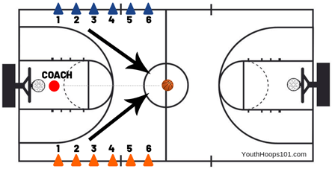
Cone Scrimmage Game- https://www.youtube.com/watch?v=ImLdkaheVAY&t=372s (8:06 mark) – obviously do the same thing but for soccer.
Line players up from youngest to oldest in your group so that they are competing against the same skill level. At the end of the game – create FOUR (4) equal teams with as much parity as possible for the remainder of the week.

12:00-1:00pm – LUNCH (half-day dismissal at 12:00pm)
  - First 30-minutes everyone must sit – final 30 minutes can be used to play on the courts.

1:00-1:20pm – Minions (https://www.youtube.com/watch?v=N5wJYF9fgp4&t=9s – 8:55)

1:20-1:40pm – Free Dribbling (https://www.youtube.com/watch?v=N5wJYF9fgp4&t=9s – 3:21)

1:40-1:45pm – WATER

1:45-2:20pm - Flying Numbers (https://www.youtube.com/watch?v=N5wJYF9fgp4&t=9s - :13)

2:20-2:35pm – SNACK BREAK

2:35-3:05pm - Hawaii (https://www.youtube.com/watch?v=XWIP0VbJtKs&list=PLaSL84U3HNjBkMP37GcY8DUPGN39pZ3ey – 1:45)

3:05-3:10pm – WATER

3:10-3:35pm – Scrimmage

3:35-3:40pm - WATER
3:40-3:55pm – Cool Down Stretch

TUESDAY – WEAR YOUR FAVORITE JERSEY TO CAMP DAY

9:00-9:10am – Welcome
- Welcome
- Sports story/game from previous night?
- What does hydration mean and why is it important?
- Rules – Rule 1 – “Have Fun” | Rule 2 “Mistakes are Great”
- Eyes, Ears, Marshmallows
- “Good Day|Great Day”

9:10-9:25am – Stretching (Static then Dynamic)
- Static – neck rolls, arm rolls, tricep extension, arm across chest stretch, hip rolls, hamstring stretch, touch toes
- Dynamic (moving) – butt kickers, high knees, karaoke, love shuffle, Frankenstein’s, open gates, sprints
  - Make sure to make it fun by having groups compete in counting – who is loudest? Have kids do “loudest whisper” “quietest scream” “count in different languages” “count in accents” and more

9:25-9:28am – WATER

9:28-9:47am – Ladder
- Ladder exercises include: kangaroo hops every 3 squares, three feet in each square (individually), skier backwards, flamingos, hopscotch on one foot (out/in), side shuffle both directions and Icky Shuffle backwards
- Game – Team vs. Team
  - Have each team compete against each other! First person done WITHOUT touching the ladder wins their team a point.
    - Round 1 – Kangaroo
    - Round 2 – Skier
    - Round 3 – Two feet in each square
    - Round 4 (Bonus Round) – each team nominates one participant to compete for the championship. Whoever wins the race wins the entire game for their team – Icky Shuffle

9:47-9:50am – WATER

9:50-10:15am – Air|Land|Sea (https://www.youtube.com/watch?v=y07Su0b9_GM)
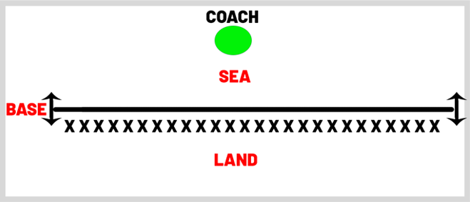
- Land – behind line
- Sea – in front of line
- Air – Jump straight up
- Tornado – 180 degree turn
- Earthquake – crotch down with hands over head
- Base – On Line
- Griddie

10:15-10:25am – SNACK BREAK

10:25-11:10am – Fundamentals (three 15-minute stations)
  - Dribbling
    - Lateral Roll
      - https://www.soccerdrive.com/soccer-drills/dribbling-skills-series (1:56 marker)
    - Inside/Outside Touches (with both feet)
      - https://www.soccerdrive.com/soccer-drills/dribbling-skills-series (1:01 marker)
    - Gates Dribbling
      - Set up gates on field – Player scores a point for each gate they dribble through
    - Crocs in the River https://www.soccerdrive.com/soccer-drills/crocs-river-u6-soccer-activity

  - Passing
    - Bowling Pin Game
      - Set up six cones to look like bowling pins. Teams will pass the ball towards the pins and try to knock down as many as possible. First team done wins.
- Defense
    - Angles
      - Explain that instead of running directly behind a player, use an angle to catch a player
    - Cat & Mouse
      - Set up two cones 10 feet apart from each other (with one cone being five yards behind the other cone as well)
        - The cone that is in front will be the “mouse” group. They will start with a soccer ball and dribble to the net as fast as possible (they CANNOT shoot)
        - The cone that is further back will be the “cat” group. When the whistle blows, they will use an angle to get in front of the mouse and steal the ball
        - Set up 3 lines. Kids will dribble up to a designated spot and shoot with their laces into the goal. Focus on them using the correct part of their foot. Have them use both feet.
        - Competition
          - Same drill but have the three lines compete against each other (first to x number of goals)

11:10-11:13am – WATER

11:13-12:00pm – Tournament Day 2
- Team 1 vs. Team 2
- Team 3 vs. Team 4
Two nine-minute halves for each game. Start with Team 1 vs. 2, then after 9 minutes go to Team 3 vs. 4. Do the same thing for the second half of each game. Write down scores.

12:00-1:00pm – LUNCH (half-day dismissal at 12:00pm)
  - First 30-minutes everyone must sit – final 30 minutes can be used to play on the courts

1:00-1:20pm – 2 vs. 1 To Goal (https://www.youtube.com/watch?v=N5wJYF9fgp4&t=9s – 5:00)

1:20-1:25pm – WATER

1:25-1:45pm – Gates Dribbling & Passing (https://www.youtube.com/watch?v=N5wJYF9fgp4&t=9s – 6:11)

1:45-1:50pm – WATER

1:50-2:35pm – 2 vs. 2 to Cross Goals (https://www.youtube.com/watch?v=XWIP0VbJtKs&list=PLaSL84U3HNjBkMP37GcY8DUPGN39pZ3ey – 3:15)

2:35-2:50pm – SNACK BREAK

2:50-3:20pm – 4 vs. 4 to Small Goals (https://www.youtube.com/watch?v=XWIP0VbJtKs&list=PLaSL84U3HNjBkMP37GcY8DUPGN39pZ3ey – 4:37)

3:20-3:25pm – WATER

3:25-3:45pm - Scrimmage

3:45-4:00pn – Stretch

WEDNESDAY – CRAZY SOCKS DAY

9:00-9:10am – Welcome
- Welcome
- Sports story/game from previous night?
- What off the court things should we be doing to be high level athletes
  - Eating the correct foods, hydrating, sleeping
- Rules – Rule 1 – “Have Fun” | Rule 2 “Mistakes are Great”
- Eyes, Ears, Marshmallows
- “Good Day|Great Day”

9:10-9:25am – Stretching (Static then Dynamic)
- Static – neck rolls, arm rolls, tricep extension, arm across chest stretch, hip rolls, hamstring stretch, touch toes
- Dynamic (moving) – butt kickers, high knees, karaoke, love shuffle, Frankenstein’s, open gates, sprints
  - Make sure to make it fun by having groups compete in counting – who is loudest? Have kids do “loudest whisper” “quietest scream” “count in different languages” “count in accents” and more

9:25-9:28am – WATER

9:28-9:47am – Ladder
- Ladder exercises include: kangaroo hops every 3 squares forward – 1 back, , skier backwards, flamingos, hopscotch on one foot (out/in), side shuffle both directions and Icky Shuffle backwards, Firestarters, Riverdance
- Game – No Mercy
  - Essentially a combination of Ladder of Doom and Team vs. Team. First person at each ladder races; first person to finish WITHOUT touching the ladder moves on to next round. Anyone that touches ladder is automatically eliminated. Play until one person remains.

9:47-9:50am – WATER

9:50-10:15am – Kansas|California|New York
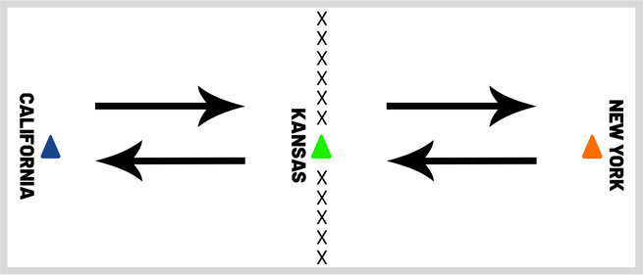

All campers start in line with the “Kansas” cone. The coach will yell one of the three states (California, Kansas or New York); campers must run to that state and stop directly in line with that cone. Last two campers to the correct state are eliminated each round. If campers are on a state (i.e. Kansas) and coach yells “Kansas” anyone who leaves the state is eliminated. Coaches can say multiple states in which campers must run to each state in the correct order.

10:15-10:25am – SNACK BREAK

10:25-11:10am – Fundamentals (three 15-minute stations)
  - Dribbling
    - Dancing Ball https://www.youtube.com/watch?v=zoYtwkme5HI (6:47)
    - Space Wars https://www.youtube.com/watch?v=zoYtwkme5HI (:06)
  - Passing
    - Minions https://www.youtube.com/watch?v=zoYtwkme5HI (4:25)
  - Shooting
    - Shot on Goal After Diagonal Dribbling
      - https://www.youtube.com/watch?v=xSe0kmfaXQg
    - Four Goals
      - https://www.youtube.com/watch?v=oIIT8-EUHbk (10:30 marker – does not need to be 4 on 4)

11:10-11:13am – WATER

11:13-12:00pm – Tournament Day 3
- Team 1 vs. Team 3
- Team 2 vs. Team 4

12:00-1:00pm – LUNCH (half-day dismissal at 12:00pm)
  - First 30-minutes everyone must sit – final 30 minutes can be used to shoot on hoops.

1:00-1:20pm – Rondo 5 vs. 2 (https://www.youtube.com/watch?v=XWIP0VbJtKs&list=PLaSL84U3HNjBkMP37GcY8DUPGN39pZ3ey :10)

1:20-1:25pm – Water

1:25-1:45pm – Triangle Goal Game (https://www.youtube.com/watch?v=N5wJYF9fgp4&t=9s – 10:01)

1:45-2:30pm – Half-Court Soccer (https://www.youtube.com/watch?v=XWIP0VbJtKs&list=PLaSL84U3HNjBkMP37GcY8DUPGN39pZ3ey – 7:31)

2:30-2:45pm – Snack Break

2:45-3:15pm – Hot Box (https://www.youtube.com/watch?v=XWIP0VbJtKs&list=PLaSL84U3HNjBkMP37GcY8DUPGN39pZ3ey – 9:16)

3:15-3:20pm – Water

3:20-3:45pm – Scrimmage

3:45-4:00pm – Cool Down Stretch

THURSDAY – CRAZY/FUN HAIR STYLE DAY

9:00-9:10am – Welcome
- Welcome
- Sports story/game from previous night?
- What should we focus on during game? How do overcome obstacles?
- Rules – Rule 1 – “Have Fun” | Rule 2 “Mistakes are Great”
- Eyes, Ears, Marshmallows
- “Good Day|Great Day”

9:10-9:25am – Stretching (Static then Dynamic)
- Static – neck rolls, arm rolls, tricep extension, arm across chest stretch, hip rolls, hamstring stretch, touch toes
- Dynamic (moving) – butt kickers, high knees, karaoke, love shuffle, Frankenstein’s, open gates, sprints
  - Make sure to make it fun by having groups compete in counting – who is loudest? Have kids do “loudest whisper” “quietest scream” “count in different languages” “count in accents” and more

9:25-9:28am – WATER

9:28-9:47am – Ladder
- Ladder exercises include: kangaroo hops, skier forward/backwards, flamingos, hopscotch individual feet, side shuffle both directions, Firestarters, Icky Shuffle, Riverdance backwards
- Game – Ladder of Doom!
  - Round 1 – Each player has three seconds to get through ladder without touching it or they are eliminated (kangaroo hops)
  - Round 2 – Each player has four seconds to get through ladders without touching it or they are eliminated (skier)
  - Roud 3 – Each player has five seconds to get through ladder without touching it or they are eliminated (two feet in each square)
  - Etc.

9:47-9:50am – WATER

9:50-10:15am – Cone Game (https://www.youtube.com/watch?v=GsFL_doSXxM)
The game begins with every camper on the sideline with a cone in front of them. The coach will take the kids through a series of directions such as “Hands up”, “Nose”, “Chin”, “Toes”, “Shin”, etc. When the coach says “Cone” all campers will grab their cone and put it above their head. The last person to get their cone above their head is eliminated. If a student touches the cone BEFORE hearing the word “Cone” they are also eliminated. Make this game fun by using words like “Collar Bone” to get the kids to accidentally touch their cone. Try to sneak the word “Cone” into the game to see who’s paying attention.

You can also play a camper vs. camper version as shown in the video link.

10:15-10:25am – SNACK BREAK

10:25-11:10am – Fundamentals (three 15-minute stations)
  - Dribbling
    - Clean Your Room https://www.soccerdrive.com/soccer-drills/clean-room
    - Zig Zag Drill (changing up dribbling styles)
    - Cone Maze
      - https://www.epysa.org/assets/947/15/u6%20season%20plan.pdf (Page 6)
  - Passing
    - Marbles
      - https://www.soccerdrive.com/soccer-drills/soccer-marbles
  - Defense
    - 2 vs. 2 Endlines
      - https://www.youtube.com/watch?v=MDF6tB5foI0 (1:57)

11:10-11:13am – WATER

11:13-12:00pm – Tournament Day 4
- Team 1 vs. Team 4
- Team 2 vs. Team 3

12:00-1:00pm – LUNCH (half-day dismissal at 12:00pm)
  - First 30-minutes everyone must sit – final 30 minutes can be used to shoot on hoops.

1:00-1:20pm – Wreck It Ralph (https://www.youtube.com/watch?v=N5wJYF9fgp4&t=9s – 11:39)

1:20-1:25pm – Water

1:25-1:45pm – 1 vs. 1 Endlines (https://www.youtube.com/watch?v=N5wJYF9fgp4&t=9s – 13:00)

1:45-2:30pm – Liverpool (https://www.youtube.com/watch?v=XWIP0VbJtKs&list=PLaSL84U3HNjBkMP37GcY8DUPGN39pZ3ey – 10:50)

2:30-2:45pm – Snack Break

2:45-3:15pm – Shrinking Field (https://www.youtube.com/watch?v=XWIP0VbJtKs&list=PLaSL84U3HNjBkMP37GcY8DUPGN39pZ3ey – 12:39)

3:15-3:20pm – Water

3:20-3:45pm – Scrimmage

3:45-4:00pm – Cool Down Stretch

FRIDAY – CAMPER FRIDAY

9:00-9:10am – Welcome
- Welcome
- Raffle (only time where both half-day and full-day kids are at camp)
- Sports story/game from previous night?
- Rules – Rule 1 – “Have Fun” | Rule 2 “Mistakes are Great”
- Eyes, Ears, Marshmallows
- “Good Day|Great Day”

9:10-9:25am – Stretching (Static then Dynamic)
- Static – neck rolls, arm rolls, tricep extension, arm across chest stretch, hip rolls, hamstring stretch, touch toes
- Dynamic (moving) – butt kickers, high knees, karaoke, love shuffle, Frankenstein’s, open gates, sprints
  - Make sure to make it fun by having groups compete in counting – who is loudest? Have kids do “loudest whisper” “quietest scream” “count in different languages” “count in accents” and more

9:25-9:28am – WATER

9:28-9:47am – Ladder
- Game – Team vs. Team
  - Have each team compete against each other! First person done WITHOUT touching the ladder wins their team a point.
    - Round 1 – Kangaroo
    - Round 2 – Skier
    - Round 3 – Two feet in each square
    - Round 4 (Bonus Round) – each team nominates one participant to compete for the championship. Whoever wins the race wins the entire game for their team – Icky Shuffle
- Make the younger groups ladder SHORTER today to even out the competition

9:47-9:50am – WATER

9:50-10:15am – Minions (https://www.youtube.com/watch?v=N5wJYF9fgp4&t=9s – 8:55)

10:15-10:25am – SNACK BREAK

10:25-11:00am – Hawaii (https://www.youtube.com/watch?v=XWIP0VbJtKs&list=PLaSL84U3HNjBkMP37GcY8DUPGN39pZ3ey – 1:45)

11:0-11:03am – WATER

11:13-12:00pm – Tournament Day 5 – Championship/Consolation Game
- Two teams with the worst records will play in Consolation Game
- Two teams with the best records will play in Championship Game

Have the consolation game go first – make the halves a bit longer today (12-minutes). Consolation game first half, Championship game first half, Consolation game second half, Championship game second half

12:00-1:00pm – LUNCH (half-day dismissal at 12:00pm)
  - First 30-minutes everyone must sit – final 30 minutes can be used to shoot on hoops.

1:00-1:30pm – Campers Choice Game/Dodge Ball (if you have a set)
1:30-1:35pm – WATER

1:35-2:25pm – Scrimmage

2:25-2:40pm – Snack Break

2:40-3:10pm – Campers Choice

3:10-3:15pm – Water Break

3:15-3:45pm – Campers Choice

3:45-4:00pm – Cool Down Stretch

