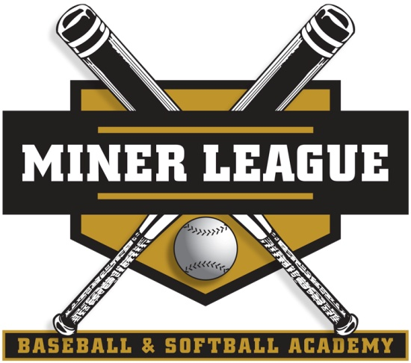
Presents:

Central Maine

Youth Baseball/Softball Summer Camp Series
Come join us this summer for a great camp! The camps are designed to train players of all ages and skill levels. Miner League has trained over (60) players both boys and girls that have gone on to play collegiate baseball/softball and professionally over the last 10 years in Southeast Georgia. With an experienced staff of local coaches and college players the camp will specialize in all aspects of the game: hitting, fielding, pitching and catching. We will play games as well. Players will be divided up depending on age and skill level. We will be offering both baseball and softball camps.
Please see below for details:



Head Instructor
Tony Miner
Owner of Miner League Baseball and Softball Training
Former Player in the Cleveland Indians Organization.
Assistant Coach Savannah State University 2007-2008 (Hitting and Infield Coach).
Coach at Savannah Country Day High School (Led team to first ever State Tournament bid in 1999
Member of the 1997 University of Southern Maine National Championship Team.
Two time First Team All-American and Three time Division III First Team All-New England.
1997 New England Collegiate Baseball Association Player of the Year.
1997 Little East Conference Player of the Year.
In 1999, named Sports Illustrated 25th Greatest Athlete of the Century from Maine.
Coached (8) USSSA State Championship Teams in (4) different age groups in Georgia.
“Perfect Game” Freshman National World Wood Bat Finalist.
8 Miner League Teams have combined for over 350 Tournament Championships over the last 8 years.
Trained over 60 baseball/softball players who have gone on to play at the collegiate and professional level.

Summer Camp Details:

    - Who: Boys/Girls Ages 6-14
    - What: Baseball and Softball
    - When: June 25th-June 29th (Registration Deadline June 21st)
    - Where: Pleasant Hill Baseball Fields, Pleasant Hill Road, Sabattus Maine.
    - Time: 9:00am-3:00pm
    - Cost: $145.00
    - Register by May 28th and pay $125.00.
    - (Limited Spots Available)
To register or for more info on the camp please call Tony Miner at 912-658-5516.

“Potential Is Nothing without Practice”
Hope to see you at the Ball Park!

Youth Summer Baseball Profile/Registration Form

Name_________________________________________________

Age (Please check one) 7_____ 8_____9______10______ 11____12_____ 13_____14______

Date of Birth____________________

Address_______________________________________________________

City__________________ ST_______ Zip_________________

Phone (H) ________________________ (C) _________________________

School_____________________________________

Name of Parents______________________________/________________________________

Emergency Contact______________________ Emergency #________________

Medications or Allergies_____________________

E-mail address_____________________________________________________

Please Print Clearly

Players will need to bring lunch each day during the camp. Miner League will provide drinks and snacks during the camp.

Players will need to make sure they have their equipment (gloves, cleats, helmet, bat and sunscreen as well).

Parents will need to sign insurance waiver forms the first day of the camp during registration.

Please make checks payable to Tony Miner: Send registration form and payment to: Chad Drouin, Sabattus Rec President, 9 Centre Road Wales ME 04280

I am looking forward to training your kids this summer!

Thank You!

