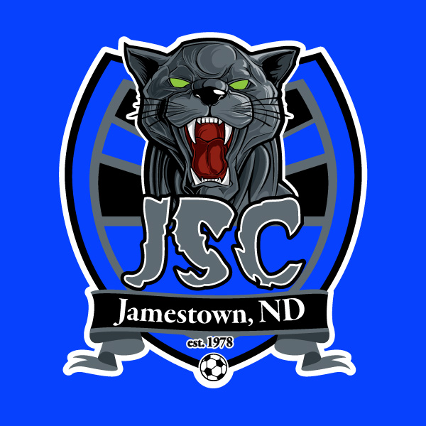

Jamestown Soccer Club Parent’s Code of Conduct
The parents/guardians of players of the Jamestown Soccer Club shall conduct themselves in a manner that is of the highest standards while at training, games, tournaments or any other function or soccer event.
As a parent/guardian of a player for the Jamestown Soccer Club, I hereby pledge to provide support, care and encouragement for my child and promise to uphold the following Code of Conduct:
- I will encourage good sportsmanship by demonstrating positive support for all players, coaches, officials and opposing player, coaches and teams.
- I will place the emotional and physical well-being of my child ahead of any personal desire to win, remembering that the game is for the children and not for the adults.
- I will insist that my child play in a safe and healthy environment.
- I will provide support for coaches, trainers and officials who are working with my child to provide a positive, enjoyable experience for all.
- I will demand a drug, alcohol and tobacco free sports environment for my child and all children, and agree to assist by refraining from their use at any, and all JSC activities, including tournaments.
- I will do my best to make this activity fun for my child and all participating children.
- I will ask my child to treat all players, coaches, and officials with respect.
- I will help my child enjoy their sports experience within my personal constraints by assisting with JSC functions, being a respectful fan, providing transportation or whatever I am capable of doing to support my child and JSC.
- I agree to spectate in designated areas. This includes standing behind the goal.
- I will not approach the coaches with an impending issue before; during or after a training and/or practice session and games unless prior, mutually agreed upon arrangements have been made.
- I will not coach any player or interfere with any coaching activities during the training/ practice sessions or games; this includes telling any player what to do when they have the ball (pass, shoot, etc.)
- I agree not to criticize or make any disparaging comments about any player, coach or official during training/practice sessions or games.
- I agree not to criticize Jamestown Soccer Club in a public forum; instead, I will submit my concerns in writing directly to either the Director of Coaching, or Board of Directors.
- I will make every effort to ensure that my child:
  - Attends practice/training when scheduled or will provide 24-hour notice of impending absence.
  - Is at practice and ready to start at the scheduled time.
  - Is at each game 30-45 minutes prior to the scheduled start time. (Coach’s discretion)
  - Notifies the coach at least 24 hours in advance, if the player will miss a game.
- I am also responsible for the behavior of any guest that I may bring to any team activity.
As the Parents/Guardians of a child registered through Jamestown Soccer Club, I agree to the Parents Code of Conduct and understand that my failure to uphold any of these statements may result in disciplinary action by the Board of Directors, Coaches, or Director of Coaching. Consequences can include, but is not limited to, the forfeiture of my (our) right to attend and watch my child participate in any training, game, tournament, or any other Club function or event.

Parent(s) Signature__________________________________________ Date____________________

