The fielding position basics:
When fielding the ball there is a triangle formation that is developed when the proper position is done.
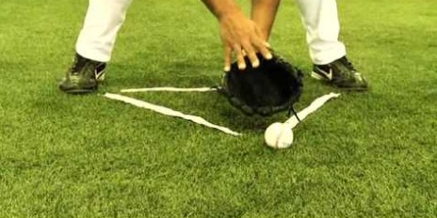
Throwing hand placement is key to receiving the ball properly which puts the player in the proper position to quick transfer of a ball from glove to hand.
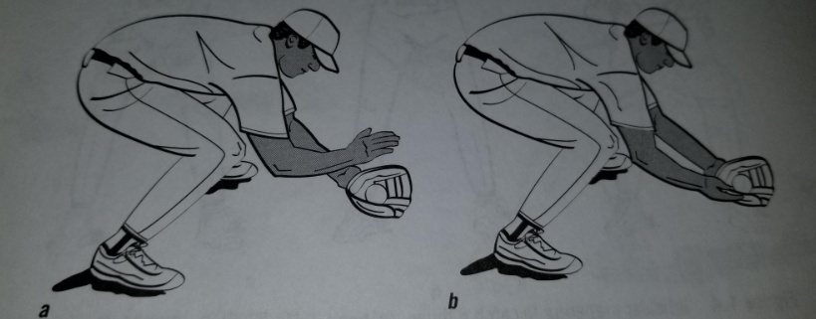
The glove and throwing hand position when fielding a ground ball.
a: Throwing hand is palm down above the glove.
b: Throwing hand is palm up to the side of the glove.

Here is a good video describing the fielding by Trosky Baseball:

Infielding Quick Tips - Infield Posture

