Infield drill #4
Players are to focus on good posture, footwork, and quickness.
Ground ball drill
This drill is to set up markers to help players have an idea where to setup, throw, and the follow through location.
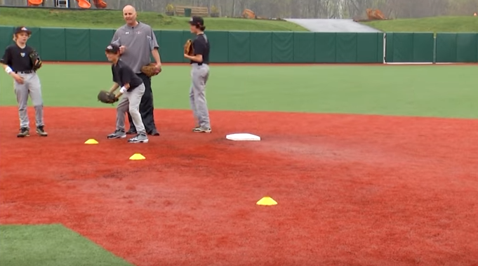
Each player has a ball, (ball is not hit or thrown to them, the goal is work on good footwork and a good throw). The player sets up in the a ready position with the ball already in hand.
Then they will shuffle and throw to first base
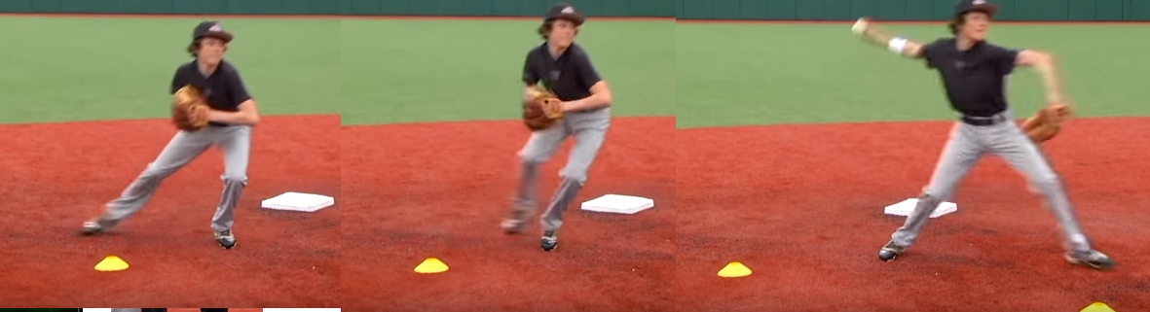
After the throw, the player should continue his movement to the last cone or marker. The first basemen will throw it back to them once they have got to the last cone. The goal with the follow through is to teach the player that there momentum and direction of that momemtum is key to accurate throws.
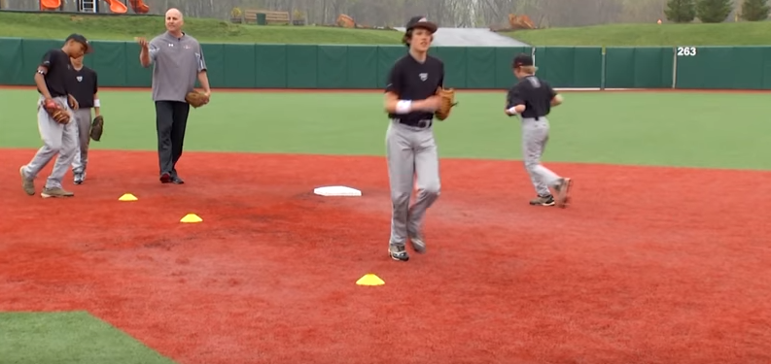
The next rounds are to be done with the coach rolling the ball to them. Remember the key to this drill is proper footwork when throwing the ball to the location they are attempting to throw to in the infielding. Rolling the balls to the players allows less pressure on fast rolling balls hit from the bat, and allows the player to concentrate on their footwork to fielding the ball, taking up the proper triangle fielding stance, balls to their glove side, or to their throwing hand side.

