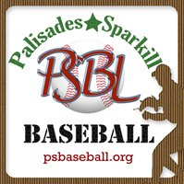

Player Code of Conduct Agreement
I pledge to be responsible for my participation by following the Player Code of Conduct for Palisades-Sparkill Baseball League. (PSBL)

- I agree to practice good sportsmanship at all times, to win without boasting, lose without excuse and never quit.

- I agree to attend and participate in all scheduled games and practices when reasonably possible.

- I will never throw a bat or equipment in anger and I agree to be aware of safety and will follow team and league rules to ensure safe play.

- I agree to my coach’s authority and will participate and communicate positively with my coach and teammates.

- I agree to treat fellow players, opponents, fans and umpires with respect.

- I agree to exercise self-control at all times, refraining from foul language and setting a positive example for others to follow.

- I agree to support and encourage my teammates, and to always try my best to try and keep a positive attitude.

My signature verifies that I have read, understand and agree to abide by this Code of Conduct. Consequences may include removal from practice/game, suspension and/or removal from our league.

Player Name/Signature | Date

