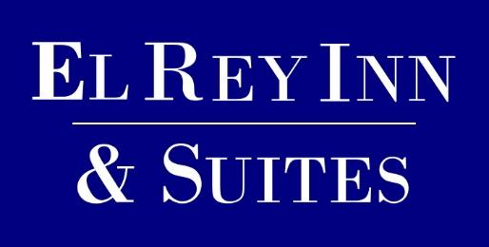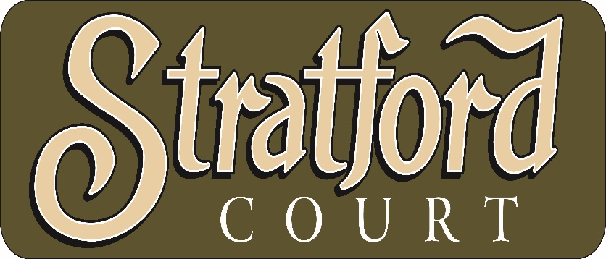
80 South Main Street 18 South Main Street
Cedar City UT 84720 Cedar City UT 84721
435-586-6518 435-586-2433

15% off Any Room
For USG Wrestlers

Free breakfast included
Call Direct to either hotel to make your reservations

