Bunting drill 2 (The sacrifice):
This drill should be done with 3-4 players at a time. The coach talks about the importance of the sac bunt, runner on 1st, 1st and 2nd, or on third base, review scenarios above before talking. The coach instructs the bunters that the goal is to hit the balls to one side first between the cones, and then to the other side between the cones next.
Reps: Each round 5 bunts to each side.
Bonus game: Who can bunt the most through the cones from the 10 bunts.
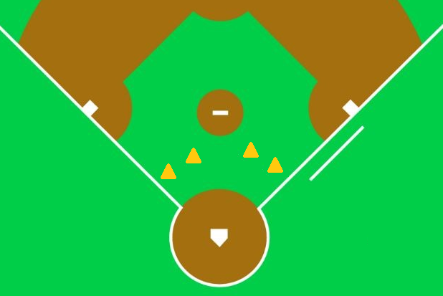

Bunting drill 2 (The bunt for a hit, drag bunt):
This drill will go through the same cones but now the bunter does not show the bunt until the pitcher is about to release the ball. This bunt drill will have the hitter setup a little more on the outside of the hitter's box. The reason for this, is the bunter should be moving to the run position when contact is made, meaning the back foot should at the front of the batter's box when contact is made. The bunter should practice not coming out of the batter's box until contact is made.
The coach should talk about when the best situation are to do a bunt for hit. Situations like if the 1st or 3rd baseman are playing back. When bunting is done and the bunter is thrown out at first, it is usually done when the runner is within 2 steps away from 1st (when they are hustling to 1st), so if the either corner players is playing back an extra 1-2 steps (like mid way between the infield grass and outfield grass) would be considered a good time to do it.
Bonus: Right hand bunters have advantages on a push bunt toward the second baseman (known as the Bermuda Triangle) when a left hander is pitching, because the pitcher will have their momentum going away from the ball, 2nd baseman is playing back, and 1st isn't sure he should field it. This bunt goes into a spot where most of the time, the runner will be crossing first before anyone gets the ball. This bunt thinking is for the advance player, typically high school, possibly 14U.

