Coach talks: Coaches should discuss the importance of these drills with focus on quick feet, quick hands, and keeping low in a good fielding position. Encourage the players to really pop into the throwing position.
The coach should encourage quick ball transfer from fielding hand to throwing hand throughout these drills.
Backhand Drill 1: Player sets up with butt low, bent over and shifting weight more to their throwing arm side. This drill does not use the players glove and is done with bare hands. Player crosses the arms with the throwing arm on top with a ball in hand, the fielding hand in crossed on the bottom in position to make a back hand fielding action. The ball is dropped and the fielding hand scoops the ball off the bounce and extends the arm through. Note this drill is quick and posture doesn't move. The players should do 10 times before players take a quick 10 second break. 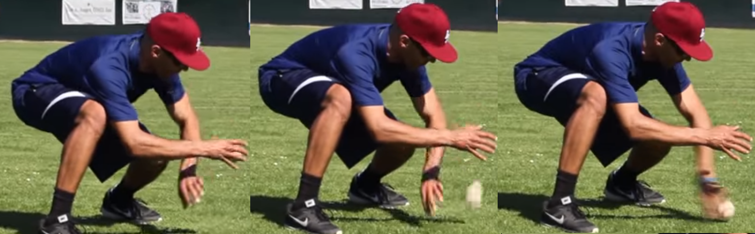
------------------------------------------------------------------------------------------------------------------------------------------
Backhand drill 2: Player sets up in a low fielding position, this time the player tosses the ball in the air out to his side, ball's height should be no higher than the player's head and then shuffles over to catch the ball on off the bounce with a backhand. After the player fields the ball, then shuffles again into a strong throwing position. 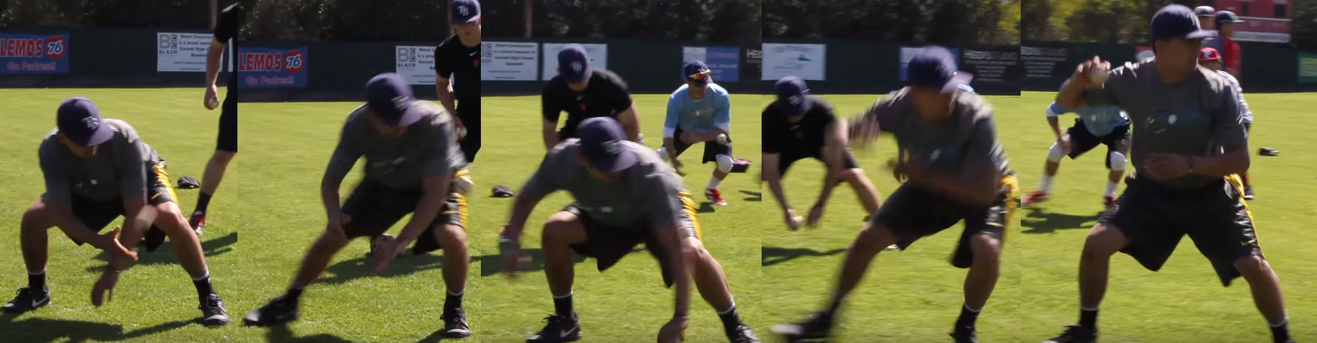
------------------------------------------------------------------------------------------------------------------------------------------

Forward hand drill 1: Player sets up in a low fielding position, but this time with their throwing side leg out in front. The player will take the ball in their throwing hand and drop the ball to the ground. The player then will forward scoop the ball up off the bounce. The players should do 10 times before players take a quick 10 second break.
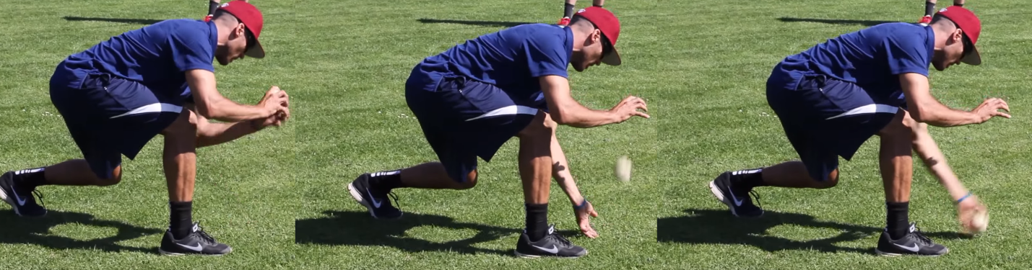
------------------------------------------------------------------------------------------------------------------------------------------
Forward hand drill 2: The player will setup as in the previous drill, but this time will lob the ball out in front of them, not more higher than the player's head and then attacks the ball on the bounce with throwing side leg and forward hand scoops the ball off the bounce and then follows through with fielding leg to a shuffle in a strong throwing position. Note, the player should never practice the strong throwing position with a straight up and down back. They should focus on keeping the upper body with a slight bend (as in their fielding position but is now elevate to throw).
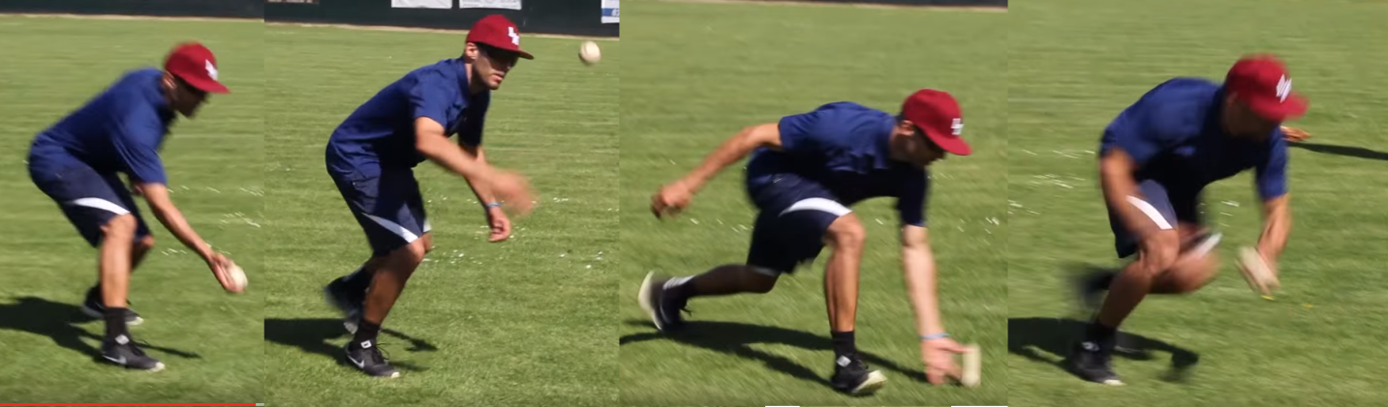
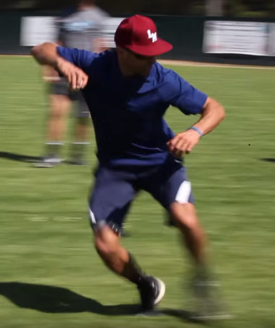
------------------------------------------------------------------------------------------------------------------------------------------
Coach throw drill 1: This drill is to help drive the previous drills into the players. Coach now sets players up about 20-30 feet back. The players are to practice on running up on the ball and scoop on the short-hop. Coach now lobs ball in the middle of them and the player. Coach should instruct the player that the first rounds will either be the backhand scoop or the front hand scoop. The coach should have the players focus on taking the ball on the short-hop and then follow through with the shuffle to throw the ball to the bag. Each Round should go through each kid at least 5 times.
-----------------------------------------------------------------------------------------------------------------------------------------
Coach throw drill 2: This drill takes the previous drill to the next level. The coach should set up another coach another 20-30 feet away to catch. The players will do the previous drill but this time will throw to the coach. This drill moves fast when the coach takes the ball bucket with him and puts the balls in the bucket after catching them.

Note: Coaches practice good habit with saying "Belt to Hat" when players are not throwing the ball in between the belt or hat. When a throw goes outside this area, say "Belt to Hat" in a reminding way so players will be reminded to focus on throwing in this zone.

The link to show this drill is below:

Infielding Quick Tips Glove Work II

