Infield Drills Series - Footwork

Round 1: Players shuffle baseline distances (about 90 ft distance). Players should keep the legs bent and down in a good athletic position throughout the entire distance when shuffling. Note this is quick shuffle down and back.
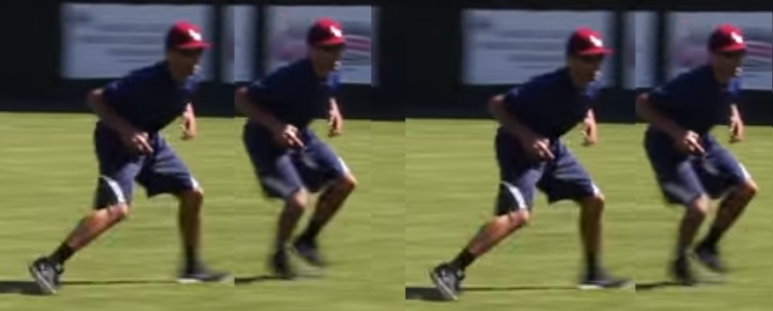
Round 2: Players go through and shuffle again, but this time, touch the ground is added with their gloves on to imitate a ground ball fielding action. Players reach down and touch the ground at the time of the shuffle when both feet are apart in the shuffle. Players should avoid bouncing up and down by continuing to keep the body low with their legs doing the work. Note this is a quick shuffle down and back.
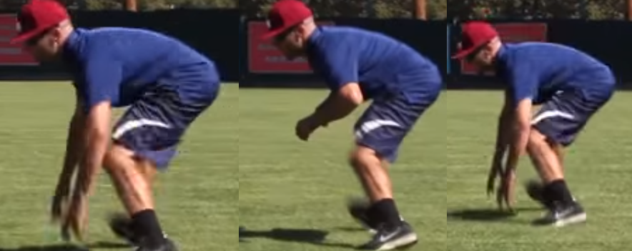

Round 3: Players setup in a fielding position. Player steps back with on foot and puts their glove in the position to catch a ground ball and then goes back to the original position. Then the player steps back with the other foot and puts their glove into position for a ground ball. Note this drill is quick with back and forth. Players should be encourage to push themselves to move fast as they can.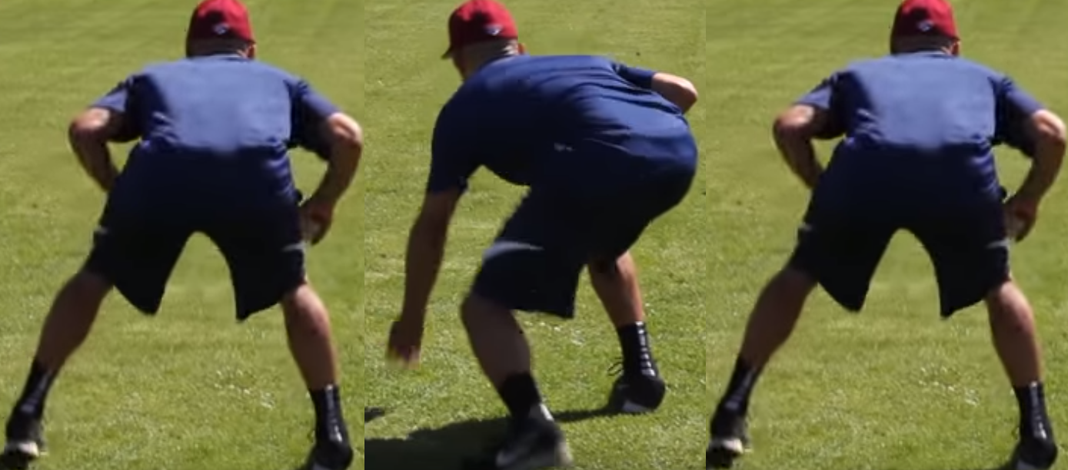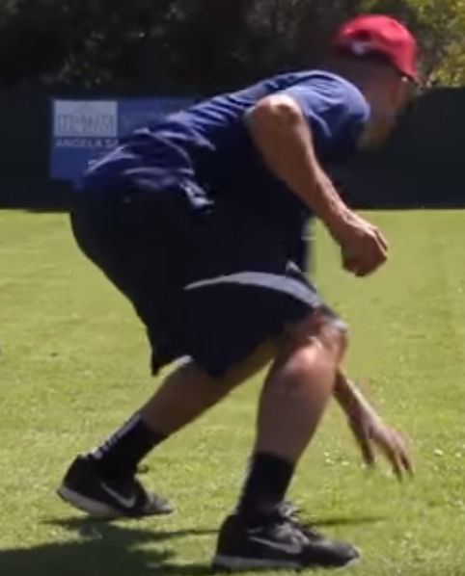

Round 4: Take the previous drill and have the players move backwards with a two shuffle on each side, distance of the base path (about 90 feet). This is a conditioning drill to help promote quick feet and to teach the players to keep low on ground balls. The player should not have their glove come off the ground during the whole distance. Note this is a quick and should have the players encourage to continue pushing themselves to move as fast as possible.

These drills can be seen at the following link:

Infield Drills Series - Footwork

