6-4-3 Double Play Underhand Drill
This drill focuses on a good underhand throw to second from middle infielders. The players start at Shortstop and coach is 20-30 feet in front of them. Coach rolls the ball to the player, one at a time. Players should focus on a low fielding posture with the glove low and out in front of their body. The player will field the ball and then move toward second with an underhand toss to coach who is covering the base. The underhand thrower should continue their momentum to second with hand left in the air after releasing the underhand throw.
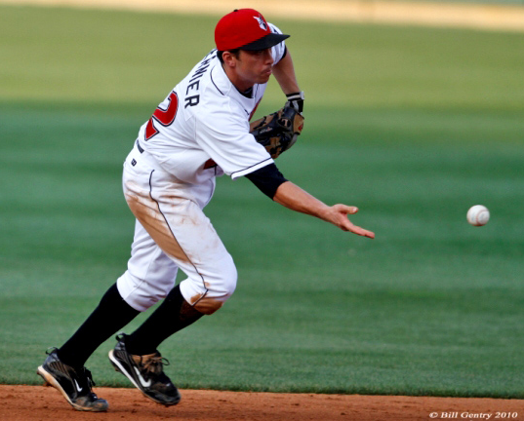
This drill should be done with 5-6 players at a time and should rotate at a quick pace. This drill should be ran for a good 10 minutes continuously.

A good example of this is seen on the following links:

Ripken Baseball Fielding Tip - Start of the 6-4-3 Double Play

6-4-3 & 4-6-3 Double Play Part 1

6-4-3 & 4-6-3 Double Play Part 2

6-4-3 Double Play Drill 2
This is the same drill as above but now is the focus for pitchers on the mound and first baseman. 5-6 players on first and 5-6 players as pitchers. Pitchers go through the motions of pitching, with a finish in a fielding position, the coach is on the foul line area to roll ground balls to first. The ball should be rolled to pull the first baseman away from fist. The pitcher should run to first in an arching direction to first, the goal of the pitcher is to be running the foul line when the ball is underhanded to them. The first baseman is to field the ball and underhand the ball to the first coming to first. The underhand to the pitcher should happen as soon as possible to allow the pitcher time catch the ball and then find the bag to step on. This drill should be ran a good 10 minutes continuously.

