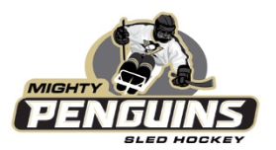

February 1, 2018

Dear Friends,

Mighty Penguins Sled Hockey is a fun, therapeutic and competitive program for physically disabled children and adults. We aim to develop character, sportsmanship and physical fitness – while promoting and encouraging both educational and cultural experiences. Mighty Penguins Sled Hockey, Inc. is a 501c(3) non-profit charity. Your contribution is tax deductible with our EIN 27-5095701.
Mighty Penguins Sled Hockey is a fun, therapeutic and competitive program for
The Mighty Penguins are hosting a 2nd Annual “Chill Out” Band Bash fundraiser on April 8, 2018 at Jergel’s Rhythm Grill in Warrendale, PA. The event will feature three bands, a Chinese auction and presentation information on our players and the organization. We rely on the generous support of local businesses, corporations and donations to continue to operate. Every dollar raised goes directly to supporting our amazing athletes in the following ways:

$750 Provides a sled for 1 Mighty Pens player $75 Provide 1 player a pair of sticks
$340 Provides an hour of ice time $45 Covers 1 player’s USA Hockey registration
$100 Outfits 1 player in protective gear $25 Purchases a dozen pucks

We are seeking sponsors to help us make the fundraiser a huge success!

Gold Sponsorship $1,000
- 4 tickets to the Band Bash
- Most prominent placement of Name/logo on promotional materials
- Acknowledgement at event and in Mighty Pens website event blog

Silver Sponsorship $500
- 2 tickets to the Band Bash
- Name and/or logo on promotional materials
- Acknowledgement at event and in Mighty Pens website event blog

Bronze Sponsorship $250
- 2 tickets to the Band Bash
- Name on promotional materials
- Acknowledgement at event and in Mighty Pens website event blog

Power Play Sponsorship $50 includes name on event promotional materials.

THANK YOU on behalf of the Pittsburgh Mighty Penguins sled hockey organization and our amazing athletes.

Sincerely,

Melissa McCormick
Mighty Penguins “Chill Out” Band Bash Co-Chair
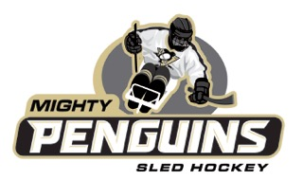

Sponsorship Registration Form
Mighty Penguins “Chill Out” Band Bash
Jergel’s Rhythm Grill
April 8, 2018

Sponsor commitment forms must be received by March 23, 2018. Please send form and check payable to:

c/o Mighty Penguins Sled Hockey
Attn: Amy Brown/Joe McCormick
UPMC Lemieux Sports Center
8000 Cranberry Springs Drive
Cranberry Township, PA 16066

Please email your logo to: info@penguinssledhockey.org

Company/Sponsor name: _________________________________

Sponsorship Level (please circle):

$1,000 (Gold) $500 (Silver) $250 (Bronze) $50 (Power Play)

Address:

Contact: Phone:

Email: ____________________________________

We encourage our sponsors to come out to the event! Any questions can be directed to Melissa McCormick @ meljonews@hotmail.com or amy.brown@penguinssledhockey.org.

